ME 2

Elevator 2

Personal Effectiveness Equation 2

Strengths 2

Weaknesses 2

Manager Duties 2

Further questions to ask interviewer 2

Closing 2

INTERVIEW 2

General 2

Portfolio 2

Interview Techniques 2

Top 5 things in next job 2

8 behaviors in team and individual assessments 2

How to succeed? 2

IT Audit 2

AGILE AUDIT 2

AWS 2

AWS Technology 2

AWS Audit 3

SAP 3

SAP Modules 3

SAP Security 3

SAP NetWeaver 3

SAP NetWeaver Security 3

SAP Network Ports 3

SAP Risks 3

SAP Deployment 3

SAP R/3 4

SAP Server Components 4

Network 4

SAP NetWeaver Application Server for ABAP 4

TCP/IP Ports 4

R and Data Analytics 5

ITGC Security Risks (11) 5

Application Controls (5) 5

Application Controls SANS (7) 5

Application Risks 5

Project Management 5

Conflict with a co-worker 5

1 How do you rescue program/projects? 5

2-1 Senior stakeholders with different opinion 5

2-2 Handle conflicts 5

2-3 Negotiation techniques 6

2-4 Building blocks for Stakeholder management 6

3-1 What is your management style? 6

3-2 What makes you a world-class leader? 6

4 Challenges of migration projects, e.g. M&A projects? 6

5 How do you hold team members accountable? 6

6 How do you handle unhappy stakeholders or clients? 6

7 How do you handle excessive work demand? 6

8 What do you think challenge you in this position? 6

9 How do you handle very poorly performing project staff? 6

10 Your 3 recommendations to manage PMO? 6

11 How do you motivate? 6

12 How do you negotiate? 6

13 Leading organizational change management 6

Change Management 6

Promoting Behavior Changes 6

Types of Resistance to changes 6

14 How do you resolve personal conflict? 6

15 How do you create alignment among partners? 6

16 How do you manage stakeholders? 6

17 How I support new staff? 6

18 What I did when I screwed up? 6

19 What did you do when the project is behind schedule? 6

20 What did you do when the project is over budget? 6

21 Basic Requirements for controlling project 6

22 Auditing Projects 6

Software architecture audit model 6

Project Lifecycle Documents (10) 6

Project Survival Test 7

23 SDLC 7

36 Deliverables subject to Change Control 7

24 Project Management Transition 7

25 Project Management and ITIL 7

26 Program Management 7

27 Portfolio Management 7

28 Contract Management 7

29 Architecture 7

30 DATA management 7

Data Issue resolution 8

Merits of ETL and ELT 8

Credit scorecard development 8

Data Quality Management Project example 8

31 Best Practices and Standards 8

32 RFI/RFP 8

33 Service Management, ITIL, IT Governance 8

40 Other PM topics in this document 8

41 Techniques to manage timelines 8

42 Techniques in conducting project meetings 8

Various types of project meetings 8

43 Techniques to conduct technical reviews 8

44 Issues & Risk Management 8

45 Quality assurance 8

46 Quality Management 8

47 Quality processes in SDLC Phases 8

48 Communication Plan 8

49 Project charter 8

50 Techniques to estimate change requests 8

Techniques to negotiate change requests 8

51 Business requirements 8

Requirement types 9

Elicitation Importance 9

Requirements Elicitation 9

Requirements Communication 9

Requirements planning and management 9

52 Techniques to analyze process 9

53 Risk Management 9

PM Risk TOOLS 9

Agile PMI-ACP 9

Agile elements 9

User story 10

Definition of “Done” 10

Facilitation 10

Team Management 10

Principles for leading 10

Coaching 10

Emotional Intelligence 10

Planning 10

Budgeting 10

Estimation 10

AGILE charting 10

Value-Based Analysis 11

On Quality 11

Retrospectives 11

Success, Anti-Pattern 11

Experiences 11

Action Verbs 12

Fighting Resistances to Changes 12

1 Resistance: Initiative significant change for customers 12

2 Resistance: Rationale hard to understand & communicate 12

3 Resistance: Employees must change behavior to succeed 12

4 Resistance: Significant knowledge & skill required 12

5 Resistance: Expected resistance from affected employees 12

6 Sponsorship: Accountable managers not support change 12

7 Sponsorship: Implementation involves many people 12

8 Sponsorship: Sponsors not grasp time, $, HR reqmnts 12

9 Sponsorship: Sponsors not provide resources 12

10 Sponsorship: Coordinate various business groups 12

INTERVIEW QUESTIONS 12

NASA Shared Voyage 14

Anecdotes 14

AIG AUDIT 14

FCU 14

PWC 14

Key Reports 14

Accuracy & Completeness Procedures 14

Full/False Accept/Reject Testing 14

Using a data extract, reperform the report/query 14

Perform an independent code review 14

System Interfaces 14

Interfaces Considerations 14

Interface – Interface Job Testing 14

Interfaces – Testing Completeness 14

Interfaces – Testing Accuracy 14

Automated Controls Considerations 14

Testing Automated Controls 14

Testing Automated Reconciliations 15

Reconciliations Considerations 15

Testing Automated Reconciliations 15

Inshoring SOX functions 15

RPA 15

SOX Controls 15

SOC for Service Organizations 15

SOC 1 ICFR 15

SOC 2 Trust Services Criteria 15

SOC 3 Trust Services Criteria for General Use Report 16

AUDIT SKILLS 16

IIA standards 16

Standard 1210 – Proficiency 16

Standard 2010 – Planning 16

Standard 2030 – Resource Management 16

Standard 2100 – Nature of Work 16

Standard 2110 – Governance 16

Standard 2130 – Control 16

Standard 2200 – Engagement Planning 16

Standard 2201 – Planning Considerations 16

Standard 2210 – Engagement Objectives 16

Standard 2220 – Engagement Scope 16

Standard 2230 – Engagement Resource Allocation 16

Standard 2240 – Engagement Work Program 16

Standard 2310 – Identifying Information 16

Audit Metrics 16

Frequency 16

Environment 17

Output 17

Quality 17

Efficiency 17

Impact 17

Audit Acquisitions 17

Life Cycle 17

Strategy 17

Due Diligence 17

Deal Approval and Close 17

Integration 17

Audit Agile Projects 18

Audit AI 18

Audit Big Data 18

Stakeholders 18

Risk and Control 18

Program governance 18

Technology availability and performance 18

Security and privacy 18

Data quality, management, and reporting 18

Audit Cloud 19

Security Controls 19

Auditing SAAS 19

Context 19

Risks 19

Service Layer 19

IT Functions 19

Incident Management 20

ISACA Audit Cloud 20

1. PLANNING AND SCOPING THE AUDIT 20

2. GOVERNING THE CLOUD 20

2.1 Governance and Enterprise Risk Management (ERM) 20

2.2 Legal and Electronic Discovery 20

2.3 Compliance and Audit 21

2.4 Portability and Interoperability 21

3. OPERATING IN THE CLOUD 21

3.1 Incident Response, Notification and Remediation 21

3.2 Application Security 21

3.3 Data Security and Integrity 21

3.4 Identity and Access Management 22

3.5 Virtualization 22

Audit Cyber Security 22

NIST Cybersecurity Framework 22

CSF vs. COBIT 22

Three Lines of Defence 23

1st Line of Defense (Management Controls) 23

2nd Line of Defense (Risk Control & Compliance Oversight) 23

3rd Line of Defense (Independent Assurance) 23

Red Flags Signal Potential Governance Gaps 23

Cybersecurity Risk Assessment Framework 23

Cybersecurity Vulnerabilities, Threats and Risks 23

Cybersecurity Audit Objectives 23

AUDIT APP CONTAINER 23

Audit DEVOPS-CI/CD 24

Analytics for Internal Audit 24

BADIR Framework 24

Common Methodologies 24

Data Source 25

ML + Analytics Techniques 25

IA Transformation 25

Audit Opportunities 25

Case Study Payroll - Fraud detection case study 25

Case Study Accounts Payable - Process insights case study 25

Case Study Unstructured data analysis case study 26

Access monitoring analytics 26

Contract audit analytics 26

Payment stream analytics (AP, T&E, Procurement Cards) 26

Master file analytics (Vendor, Customer, Employee) 26

Unstructured data analytics (i.e., email and text based files) 26

MICROSOFT AGILE (FORBES) 26

➊Pursue “Agile at Scale,” not “Scaling Agile” 26

➋Take Care of Planning and Coordination 26

➌Get the Right Balance of Alignment and Autonomy 26

➍Master The New Role of the Manager 26

➎Handle Dependencies At The Team Level 26

➏Ensure Continuous Integration 26

➐Keep On Top Of Technical Debt 26

➑Embrace DevOps and Continuous Delivery 26

➒Continuously Monitor Progress 26

➓Listen To Customer Wants, But Meet Their Needs 26

➊Deal With Directions from Above 27

➋Use Self-forming Teams To Encourage Team Ownership 27

➌Recognize that The Team is the Product 27

➍Build Quality From The Beginning 27

➎Use Coaching Carefully 27

➏Ensure Top Level Support 27

ISACA AUDIT IF 28

COBIT 28

PCI-DSS 29

AWS PCI-DSS WORKBOOK 29

ON-BOARDING 31

CIBC Control 32

CIBC 20 Services (Financial) 32

CIBC Processes (FCU) 32

CIBC 26 Processes (OPC) – 113 Sub-processes 32

Audit Lifecycle 34

STAR AUDIT 35

STAR PROGRAM/PROJECT MANAGEMENT 36

# ME

(203) 726-1711

TN-VISA (2015-08-27)

I-140, H1-B (2017-10-17 to 2020-09-06)

## Elevator

🞟I am an {seasoned/accomplished/expert} information security compliance project manager. I specialize in this field because I have seen compliance become a business enabler ⬩I enjoy being at the forefront of my organization’ security endeavor. I am proud being the 3rd line of defence because I have seen compliance become a business enabler (HOOPP, CBOC) ⬩I have accumulated throughou the years a vast wealth of experiences, professional qualifications and competencies so that I can navigate through complex systems, ambiguity; so that I can manage multiple project assignments; and so that I can interact with subject matter experts to understand how key code elements address specific risk (ITD test) ⬩I like leading and championing for positive change ⬩I am ready to apply my risk and compliance expertise in of internal controls to help grow <your company> ⬩As a management consultant, I learned fast and can be effective on day one (PWU Consultant). I consciously seek to comprehend people, process, technology, goals. I stay alert thru self-challenges and by stepping out of own comfort zone and by being thoughtful, well-researched actions ⬩I have experience working with acquisitive companies ⬩I enjoy working in a dynamic environment ⬩I delivered complex business solutions through partnership with stakeholders from multiple disciplines – from front office to risk, treasury, accounting, operations and technology ⬩I have over 20 years of experiences in financial services, capital markets, retail and insurance ⬩I am passionate about technology and am able to focus on key issues and the details that come with it ⬩Ability to interact confidently with all levels, to set objectives, and to drive results ⬩I can provide consultative support to business partners to identify opportunities for control improvements with the objective of mitigating risk and improving compliance and operational performance. In this capacity ⬩I specialize in the realization of organizational strategies by implementing best practices in project and finance management to deliver portfolios, programs and projects. ⬩I developed a reputation as somebody who creates value by bridging business and technology considerations into a holistic view of the process at hand. ⬩Experience in: technology consulting, system auditing, privacy, cyber-security, e-commerce, e-money licensing, digital or online advertising, cloud, online payment regulations, anti-money laundering, online media and entertainment, online content licensing royalty management, software development, supply chain systems and processes, hardware manufacturing, financial processes and systems, mergers and acquisitions, large project systems integration, risk management, or data analytics Experience with internet technology from a technical, regulatory, or commercial perspective ⬩Hands-on with technology, budgeting, planning, system design, testing

## Personal Effectiveness Equation

**Attitude-Ability + Alliances-Assignments**

#### Strengths

**ABILITY** ➊Learn from experience ➋Big picture ➌Recognize expertise **ATTITUDE** ➊Collaborative ➋Intellectual curiosity ➌Promote healthy context **ASSIGNMENT** ➊Beyond comfort zone ➋Hands-On ➌Value/Impact **ALLIANCE** ➊Teamwork ➋Recognition ➌Communicative

#### Weaknesses

➊**Quantitative** but numbers do not capture the totality of human experience and the essence of what it is to be human ➋**Details-oriented** insist in examining every angle of Rubik's cube -> can be distracted. Now start a day with clear objectives, agenda. Think in perspectives, future ➌**Perfectionist** Expected top performance. Now take into account people perspectives. Develop empathy to better motivate. Develop plan to account for deviations. Slow/Fast thinker. Appoint right person for job instead of best all-rounder

#### Manager Duties

Accomplishes staff results by 🞟Communicate job expectations 🞟Plan, monitor, appraise job results 🞟Coach, Counsel, Discipline employees 🞟Develop, coordinate, enforce systems, policies, procedures, productivity standards

#### Further questions to ask interviewer

Is this a new position? How long has this position existed? What significant changes do you foresee in the near future? How is your organization structured? How many portfolios? How many professionals? How is information shared? How is performance measured? What are my main responsibilities? Who will I report to? Who will report to me? How do I fit in the department? What is the organization's main goal? What are the organization's long term plans? What provisions are there for skills acquisition? What career progressions within the organization does this job entail? How does this organization differ from its competitors? What does a typical day in the post entail? What additional information can I provide about my qualifications? What are the next steps in the selection process?

#### Closing

Would you like a list of references? - What are the next steps? - When can I expect to hear from you? - Are there any other questions I can answer for you? Thank you again for having me here today. From the information that you have been sharing with me, I am even more excited over this opportunity at … As you can see, my experience has been with finance, and my skills risk management, financial instruments, business analysis, quantitative modeling and IT architecture.

# INTERVIEW

## General

#### Portfolio

**12+** strategy process change projects at CIBC, SCOTIA, AIG and for Price Waterhouse: **5** vendor-solution implementation + **5** outsourcing + **2** development projects (from vendor)

**Jul14:** IT Best Practices & Mentoring CBOC LITCOM

**Apr14**: [Lead Engagement](#_PROJECT_ENGAGEMENT_(Apr14) ALGORITHMICS, NCB EVOQ

**Oct13:** [Scotia Bank NFF](#_SCOTIA_NFF_(oct13-apr14)), [Collection System Replacement](#_SCOTIA_Collections_(jan14-feb14)), Retail loan, Family of Cards

**May13**: Control Solutions AGNICO-Eagles Mines JD Edward, [IT Ops consolidation](#_AGNICO-EAGLE_C3_(may13-oct13))

**Nov10**: HOOPP Back office automation, [Upgrade](#_HOOPP_Upgrade_(jan11-dec11)), Methodology

**Jun09**: CIBC Risk Strategic Initiatives RSI (CAD 80M)

**Jan07:** SIERRA

⬩Jan09: (Sierra) [MANULIFE](#_(MANULIFE_Derivatives_Accounting) Der. Actng GAAP "Other Than Temporary Impaired" (OTTI) ⬩Jun08: (Sierra) CIBC – SOX Secure End User Computing SEUC (Middle, ***Wealth***) ⬩Jan07: (Sierra) CIBC Mellon Fin Sys Renewal Project FSRP Treasury, BI/MIS/DW ⬩Oct07: (Rescue) Balanced Scorecard/BI BC Corp Acctng Services (public sector), ⬩Jan08: (Rescue) Russell-Mellon Enterprise Investment Platform (***Wealth***) ⬩Mar08: (Rescue) MTO Road User Safety Revenue Mgt System (public sector) ⬩Jan09: (Rescue) Travel Insurance Coordinators TIC merges Trent Health

**Mar05**: CIBC – Internal Control Repository (CAD 20M)

**Nov00**: XEG - SME, State organizations

**Jun96**: AIG – PMO set up, Harvester, India, VN, China (USD 100M)

**Oct93**: AIDC - Treasury system, financial repository (AUD 5M fee income)

**Oct90**: PWU WESTPAC DCPK Front/back office for FOREX (AUD 3M)

**Aug86**: ND COMTEC - integrated graphic system revenue (CAD 2M)

**Aug84**: ESSO Exploration (DB of 20 North Sea fields 200K barrels oil equivalent per day)

#### Interview Techniques

**REMEMBER** SMILE - EYE CONTACT - CONNECT - CLARIFY - REFLECT - REPEAT - BE SILENT - EMPATHISE - PHYS. DISTANCE - I-STATEMENT - HOWEVER, MY FORMER - THANK YOU “I hope we'll have the opportunity to work together in the future” **SAR** •Situation •Action required to find solution •Share Result  **STAR** (Interview) = Situation, Task, Action, Result *- what is the problem, what did i do, who did i talk to, how did i do that, how do i know that it was well done – focus on last 3 good projects* - **RAID** (Risk) = Risk, assumption, issue, dependency - **BOSCARD** (Charter) = Background, opportunity, scope, constraints, assumptions, risks, deliverables - **BATNA** – **INVEST** (change request) = independent, negotiable, valuable, estimatable, small, testable **–** **SMART** (goals) = specific, measurable, attainable, relevant, timely

#### Top 5 things in next job

➊Satisfaction ➋Advancement ➌Location ➍Management Culture ➎Pay

#### 8 behaviors in team and individual assessments

➊Express authentic appreciation ➋Address shared interest ➌Appropriately include others ➍Keep all your agreements ➎Express reality-based optimism ➏Be 100% committed ➐Avoid blaming and complaining ➑Clarify roles, accountability and authority

#### How to succeed?

Define using other party's languages -Communicate understanding -Get confirmation -State objectives -Set communication channels: steering committee, forum, email, telephone, project plan -Dedicated team with specific/strategic tasks –Plan, allocate resources (20% high potential, 40% strategic, 30% core, 10% support) -Customer feedback –SLA

## IT Audit

#### AGILE AUDIT

**Agile concepts**: •Audit Increment planning” build a backlog of key risks and controls •Execute each sprint (2 week intervals) •After each sprint have a sprint review meeting with L4 to discuss results and initiate. After each sprint have tollgate to discuss stopping or continuing with audit •After each sprint and before next Sprint have Lessons learned session to discuss went well in sprint and what needs enhancements from next sprint •Holding daily scrum meetings (10 minutes) to discuss progress from yesterday, plan for current day and if any escalation is required

#### AWS

##### AWS Technology

AWS **Python SDK BOTO3** supports AWS cloud services, including Elastic Compute Cloud, DynamoDB, AWS Config, CloudWatch and Simple Storage Service SERVICES •**Elastic Compute Cloud (EC2),** a service for provisioning computing resources on demand •**Elastic Load Balancing (ELB)** distributes traffic to a bunch of servers behind it. Highly available by default.•**Simple Storage Service (S3),** online storage for opaque data •**Elastic Block Store (EBS),** persistent disk-like storage for EC2 instances, in 2008 •**Elastic MapReduce (EMR),** a service providing Hadoop-like clusters for running MapReduce (and later Apache Hive and Apache Pig) jobs, in 2009 •**Relational Database Service (RDS),** a service for managing relational database server instances running in AWS, also in 2009 ELEMENTS ⬩**Instance types:** heavy compute capability, vast storage, economy, or simply general-purpose use ⬩**Availability zones** independent within a region, but faster interconnections ⬩**Temporary instance** can disappear after some time ⬩**Images** what instances are running: operating system type and version, the software packages that are available, and applications that are installed. These considerations are all bundled up into images ⬩**CIDR** (Classless Inter-Domain Routing) IAM ⬩Config Asset Mgt [ (Network Asset Mgt [Database Asset Mgt (Data) ] ) ] ⬩IAM policy ⬩AWS root account SECURITY ⬩**Security groups** AWS service to control network traffic like a firewall. Security groups can be attached to services like ELB, EC2, and RDS. With security groups, configure load balancer so that it only accepts requests on port 80 from the internet, web servers only accept connections on port 80 from the load balancer, and MySQL only accepts connections on port 3306 from the web servers. If you want to log in to your web servers via SSH, you must also open port 22. ⬩Control Traffic: Allow ICMP[1], SSH ⬩VPC (Virtual Private Cloud) ⬩IGA (Internet gateway) ⬩NAT (Network Address Translation) gateway RESOURCE PROVISIONING ⬩**CloudFormation – Elastic Beanstalk – OpsWorks** ⬩**CloudFormation Elements**: **Template** = JSON/YAML formatted file used as blueprint to build AWS resources; declaration of AWS resources that make up a stack **Stack** = collection of resources to build; Create, update and delete a collection of resources by creating, updating and deleting stacks. **Changeset** = user proposed set of changes to the running resources in Cloudformation stacks. Users get to see how the change set will impact running resources before implementing it ⬩**Cloud Template 9 components**: ➊Version ➋Description ➌Metadata ➍Parameters ➎Mappings ➏Conditions ➐Transform ➑**RESOURCES** ➒Outputs

##### AWS Audit

➊**GOVERNANCE** ⬩Understand Structure, Roles, Responsibilities ⬩Establish AWS Directives ⬩Define/ Understand Network Boundaries ⬩Establish Complete/ Accurate Inventory ⬩Classify IT Inventory ⬩Accountability for IT Asset Acquisitions ⬩"Manage External Providers" ⬩"Protect AWS Root Accounts" ➋**NETWORK CONFIG & MGT** ⬩Maintain Security Architecture & Network Traffic Baselines ⬩Environment Segregation ⬩Restrict Administrative Access ⬩Maintain Valid VPC Peering Connections ⬩"Network Redundancy Between Enterprise & AWS" ⬩"Securely Integrate Enterprise Systems to AWS" ⬩Considerations: SIEM (security information & event management) automated/ manual? **TOOLS** a) AWS root account, b) AWS Management Console, c) AWS Command Line Interface (CLI), d) AWS Software Development Kits (SDKs), e) PowerShell) ➌**ASSET CONFIG & MGT** ⬩"Utilize Baselined AWS Resources" ⬩Change Management ⬩"Identify/ Remediate Asset Vulnerabilities" ⬩"External Penetration Testing" ⬩"Identify/ Remove Unnecessary Assets" ⬩"Define Data Retention Requirements" ➍**LOGICAL ACCESS CONTROLS** ⬩Secure Root Account Access ⬩Establish Role-based Access ⬩Segregate Duties ⬩Restrict Administrative Toolsets ⬩Remove Access ⬩Assess Access Roles & Permissions ⬩Delegate Access to External AWS Accounts ⬩"Control Access to Cryptographic Keys" ⬩"Enforce Session Timeouts" ⬩System Use Notifications ➎**DATA ENCRYPTION CONTROLS** ⬩Define Encryption Requirements ⬩Encrypt Data by Classification ⬩Secure Remote Connectivity ⬩"Detect Misconfigured Encryption" ⬩Considerations: S3-Bucket, RedShift-cluster, DynamoDB-table 🡺 Min. AES 256-bit level encryption ➏**SECURITY INCIDENT RESPONSE** ⬩Maintain Plan ⬩Practice Plan ⬩Crisis Communications ⬩"Enterprisewide Visibility Through Automation" ⬩"Centralized & Secured Storage of Security Events" ⬩"Communicate with External Enterprises" ⬩"Create Roles to Manage AWS Incidents" ➐**SECURITY LOGGING & MONITORING** ⬩"Define Monitoring Requirements by AWS Application" ⬩Configured Logging Requirements ⬩Log Storage ⬩Restrict Log Access ⬩Monitor Log Status ⬩"Set Log Retention" ⬩"Review Logs for Events of Interest" ⬩"Manage Logging Failure" ⬩Accurate Log Timestamps ⬩"Assess Adequate Logging Coverage" ⬩"Detect Attempted Privilege Abuse" ➑**DISASTER RECOVERY** ⬩Disaster Recovery Plans ⬩Business Continuity Plans (BCPs) ⬩High Availability ⬩Alternating Responsible Personnel ⬩Validate Backups ⬩Manage Vendor Lock-in Risk

#### SAP

##### SAP Modules

🞟SAP Advanced Planner and Optimizer (APO) 🞟SAP Analytics 🞟SAP Advanced Business Application Programming (ABAP) 🞟SAP Apparel and Footwear Solution (AFS) 🞟SAP Business Information Warehouse (BW) 🞟SAP Business Explorer (Bex) 🞟SAP BusinessObjects Lumira 🞟SAP BusinessObjects Web Intelligence (Webi) 🞟SAP Business Partner Screening 🞟SAP Business Intelligence (BI) 🞟SAP Business Workflow 🞟SAP Catalog Content Management 🞟SAP Cloud for Customer (C4C) 🞟SAP Cost Center Accounting (CCA) 🞟SAP Convergent Charging (CC) 🞟SAP Converged Cloud 🞟SAP Design Studio 🞟SAP PRD2(P2) 🞟SAP Enterprise Buyer Professional (EBP) 🞟SAP Enterprise Learning 🞟SAP Portal (EP) 🞟SAP Exchange Infrastructure (XI) (renamed as SAP Process Integration (SAP PI)) 🞟SAP Extended Warehouse Management (EWM) 🞟SAP FICO 🞟SAP GRC (Governance, Risk and Compliance) 🞟SAP EHSM (Environment Health Safety Management) 🞟Enterprise Central Component (ECC) 🞟SAP ERP 🞟SAP HANA (known as High-performance Analytics Appliance) 🞟SAP Human Resource Management Systems (HRMS) 🞟SAP SuccessFactors 🞟SAP Information Design Tool (IDT) 🞟SAP Internet Transaction Server (ITS) 🞟SAP Incentive and Commission Management (ICM) 🞟SAP IT Operations Analytics (ITOA) 🞟SAP Jam 🞟SAP Knowledge Warehouse (KW) 🞟SAP Manufacturing 🞟SAP Materials Management (MM) 🞟SAP Master Data Management (MDM) 🞟SAP Plant Maintenance (PM) 🞟SAP Production Planning (PP) 🞟SAP Profitability and Cost Management (PCM) 🞟SAP Project System (PS) 🞟SAP Rapid Deployment Solutions (RDS) 🞟SAP Service and Asset Management 🞟SAP Supply Network Collaboration (SNC) 🞟SAP Solutions for mobile business 🞟SAP Sales and Distribution (SD) 🞟SAP Solution Composer 🞟SAP Strategic Enterprise Management (SEM) 🞟SAP Test Data Migration Server (TDMS) 🞟SAP Training and Event Management (TEM) 🞟SAP NetWeaver Application Server (Web AS) 🞟SAP xApps 🞟SAP Sales Cloud (previously: CallidusCloud) 🞟SAP Supply Chain Performance Management (SCPM) 🞟SAP Supply Chain Management (SCM) 🞟SAP Sustainability Performance Management (SUPM) 🞟SAP S/4HANA 🞟SAP Master Data Governance (MDG) 🞟SAP S/4HANA Cloud

##### SAP Security

⬩**Cloud Security**: identity, encryption, key management, authorization, assessment, logging, and monitoring) ⬩**Contract Considerations**: Event Log, Testing & Assessment, Breach Response, Certifications, SOD, Data Privacy ⬩Network & Application Segmentation ⬩Immutable Servers ⬩Blast Radius ⬩Network Visibility (rely on application security) **Cloud Security Operations** ⬩Patching and Change Management ⬩Incident Response **Security Services Integration** ⬩**HANA Cloud Platform (HCP)** ⬩Identity Management (ABAP Standard Roles, SAP NetWeaver Portal Role, Application Roles) ⬩Federation and Token-based Authentication ⬩Encryption ⬩Key Store ⬩Management Plane **Application Security** ⬩Assessment-Monitoring-Logging and Auditing-Penetration Testing

##### SAP NetWeaver

SAP NetWeaver components: ⬩SAP Business Information Warehouse (data warehouse, business intelligence) ⬩SAP Business Intelligence (analytics, reporting tools) ⬩SAP Enterprise Portal ⬩SAP Exchange Infrastructure ⬩SAP Knowledge Warehouse ⬩SAP Master Data Management ⬩SAP NetWeaver Process Integration

##### SAP NetWeaver Security

➊**Authentication & Single sign-on ⬩**SAP Single Sign-On ⬩SAP Cloud Platform Identity Authentication ➋**Authorization and Role Management** ⬩User & Role Administration of Application Server ABAP ⬩User Management of the Application Server Java ➌**Secure Communication** ⬩Network Security (SAP SW Ports) ⬩Transport Layer Security (SSL) ⬩ Unified Connectivity (UCON) for secured Remote Function Calls (RFCs) ⬩ Digital Signatures and Encryption ⬩Web Services Security (Security Assertion Markup Language SAML, WS-Security) ➍**Secure Operations** ⬩System Security ⬩Logging & Monitoring – AS ABAP (Audit Log, Audit Information System (AIS), Read Access Logging (RAL)) ⬩ Logging and Monitoring – AS Java (Audit Log, Tracing & Logging) ⬩Virus Scan ⬩ Secure Storage (ABAP) ➎**Secure Development** ⬩ABAP ⬩JAVA (password, encryption) ⬩User Interface: Cross-Site Scripting (XSS)/ SQL Injection/ Input Validation/ Canonicalization/ Directory Traversal/ URL Encoding and Manipulation/ Cookie Manipulation/ Clickjacking

##### SAP Network Ports

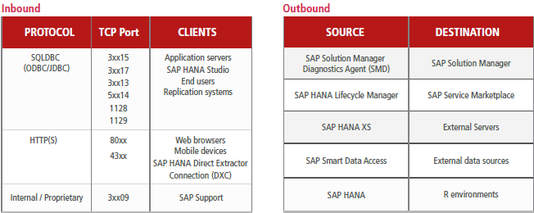

##### SAP Risks

**Financial Risks** ⬩Financial Reporting ⬩Accounting Guidelines ⬩Financial Market Regulations ⬩Financial Misstatements ⬩Internal Compliance ⬩Treasury ⬩Currency ⬩Liquidity ⬩Cost of Financing ⬩Investment / Debt ⬩Derivative Instruments ⬩Cash Management ⬩Controlling ⬩Budgeting ⬩Financial Planning and Forecasting ⬩Cost Center Reporting **Organization & Governance** ⬩Corporate Governance ⬩Organizational Structure ⬩Processes ⬩Process Execution ⬩Internal Controls System **Operational Risks** ⬩Intellectual Property Rights **Procurement** ⬩Vendor Selection Other ⬩Vendor Monitoring Other ⬩Vendor Dependency Other ⬩Policy Other **Infrastructure Operations** ⬩Security Governance Other **Facilities and Physical Security** ⬩Planning and Construction Other ⬩Loss of Infrastructure Other ⬩Unauthorized Access Other ⬩Impairment of Personnel Other ⬩Facilities and Physical Security Other **Information & IT** ⬩Confidentiality Other ⬩Availability Other ⬩Technology Other ⬩Integrity Other ⬩Information & IT Other

##### SAP Deployment

⬩HANA Enterprise Cloud (HEC) ⬩HANA One (database as a service) **DEPLOYMENT** ➊On-premises (as appliance) ➋In the cloud: AWS/ Azure/ Google Cloud Platform/ IBM Softlayer/ Huawei FusionSphere/ HP Helion/ SAP HANA Enterprise Cloud (Perbyte farm, private managed cloud)/ SAP Cloud Platform (HANA Cloud Platform, PaaS) ➌"Tailored Data Center Integration (TDI)" (re-use H/W components: storage, network) **LICENSING** ⬩Runtime License (to run SAP applications: SAP Business Warehouse powered by SAP HANA and SAP S/4HANA) ⬩Full Use License (to run both SAP and non-SAP applications; used to create custom applications – Editions: Base Edition: Core database features and development tools but no support SAP applications - Platform Edition: Base edition plus spatial, predictive, R server integration, search, text, analytics, graph engines and additional packaged business libraries - Enterprise Edition: Platform edition plus additional bundled components for some of the data loading capabilities and the rule framework - Express edition; streamlined version on laptops, free of charge.

##### SAP R/3

|  |  |
| --- | --- |
| **SAP R/3 REVENUE BUSINESS CYCLE**   * Master Data Maintenance * Sales Order Processing * Shipping, Invoicing, Returns and Adjustments * Collecting and Processing Cash Receipts   **SAP R/3 EXPENDITURE BUSINESS CYCLE**   * Master Data Maintenance * Purchasing * Invoice Processing * Processing Disbursements   **SAP R/3 INVENTORY BUSINESS CYCLE**   * Master Data Maintenance * Raw Materials Management * Producing and Costing Inventory * Handling and Shipping Finished Goods   **SAP R/3 BASIS APPLICATION AND TECHNICAL INFRASTRUCTURE**   * SAP R/3 Architecture * SAP R/3 Basis Application Infrastructure * Audit Implications   **AUDITING SAP R/3 REVENUE BUSINESS**   * Master Data Maintenance * Sales Order Processing * Shipping, Invoicing, Returns and Adjustments * Collecting and Processing Cash Receipts | **AUDITING SAP R/3 EXPENDITURE BUSINESS**   * Master Data Maintenance * Purchasing * Invoice * Processing Disbursements * Testing Techniques   **AUDITING SAP R/3 INVENTORY BUSINESS**   * Master Data Maintenance * Raw Materials Management * Producing and Costing Inventory * Handling and Shipping Finished Goods   **AUDITING SAP R/3 BASIS APPLICATION INFRASTRUCTURE**   * Installation Management Guide * Organization Model * Critical Number Ranges * Modifying Critical Tables * ABAP/4 Workbench/ Transport System * Customizing and Executing ABAP/4 Programs * ABAP/4 Development in Production * Data Dictionary Changes * Queries Company Code Setting * Computer Center Management System * Profile Generator and Security Administration * Case Study |

##### SAP Server Components

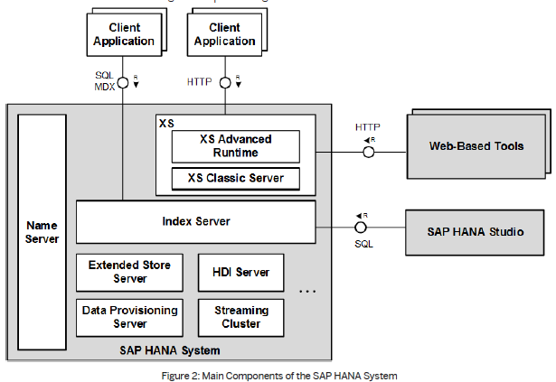

|  |  |  |  |
| --- | --- | --- | --- |
| Server Component | OS Process | Service Name | Description |
| **Index server** | hdbindexserver | indexserver | The index server contains the actual data stores and the engines for processing data. |
| **Name server** | hdbnameserver | nameserver | The name server owns the information about the topology of the SAP HANA system. In a distributed system with instances of the SAP HANA database on multiple hosts, the name server knows where components are running and which data is located on which server. |
| **XS advanced runtime** | 1. hdbxscontroller 2. hdbxsexeagent 3. hdixsuaaserver | 1. xscontroller 2. xsexeagent 3. hdixsuaaserver | As of SAP HANA 1.0 SPS 11, SAP HANA includes an additional run-time environment for application development: SAP HANA extended application services (XS), advanced model. SAP HANA XS advanced model represents an evolution of the application server architecture within SAP HANA by building upon the strengths (and expanding the scope) of SAP HANA extended application services (XS), classic model. The SAP HANA XS advanced runtime consists of several processes for platform services and for executing applications. |
| **SAP HANA Deployment Infrastructure (HDI) server** | hdbdiserver | diserver | HDI handles the deployment of design-time artifacts into SAP HANA. |
| **XS classic server** | hdbxsengine | xsengine | SAP HANA Extended Application Services (SAP HANA XS) is the application server for native SAP HANA-based web applications. It is installed with the SAP HANA system and allows developers to write and run SAP HANA-based applications without the need to run an additional application server. SAP HANA XS is also used to run web-based tools that come with SAP HANA, for instance for administration, lifecycle management and development. SAP HANA XS classic is the original implementation of SAP HANA XS.  This server can run as a separate server process or embedded within index server. |
| **Extended store server** | hdbesserver | esserver | The extended store server is part of the SAP HANA dynamic tiering option for SAP HANA. It provides a high-performance disk-based column store for very big data up to the petabyte range. |
| **Data provisioning server** | hdbdpserver | dpserver | The data provisioning server is part of the SAP HANA smart data integration option for SAP HANA. It provides capabilities such as data provisioning in real time and batch mode, real-time data transformations, data quality functions, adapters for various types of remote sources, and an adapter SDK for developing additional adapters. |
| **Streaming cluster** | hdbstreamingserver | streamingserver | The streaming cluster is part of the SAP HANA smart data streaming option for SAP HANA. Smart data streaming extends SAP HANA with capabilities of SAP Event Stream Processor for consuming data streams and complex event processing. |
| **Accelerator for SAP ASE** | hdbetsserver | etsserver | The SAP ASE server is part of the SAP HANA Accelerator for SAP ASE option for SAP HANA. It provides SAP Adaptive Server Enterprise (ASE) users the ability to use SAP HANA on SAP ASE data, for real-time analytics, |
| **SAP HANA remote data sync** | hdbrdsyncserver | rdsyncserver | The remote data sync server is part of the SAP HANA Real-Time Replication option for SAP HANA. SAP HANA remote data sync is a session-based synchronization technology designed to synchronize SAP SQL Anywhere remote databases with a consolidated database |

#### Network

##### SAP NetWeaver Application Server for ABAP

|  |  |  |  |
| --- | --- | --- | --- |
| Service | Port Number / Service Name (*<NN>*=instance number) | Default | Range |
| Dispatcher | 32*<NN>*  sapdp*<NN>* | 3200 | 3200-3299  sapdp00-sapdp99 |
| Gateway | 33*<NN>*  sapgw*<NN>* | 3300 | 3300-3399  sapgw00-sapgw99 |
| Internet Communication Manager (ICM) HTTP | 80*<NN>* | 8000 | Free |
| ICM HTTPS | 443*<NN>* (convention for multiple instances) | Not active | Free |
| ICM SMTP | 25 | Not active | 25 (no other port generally supported by SMTP) |
| Message Server | 36*<NN>*  sapms*<SID>* | 3600  sapmsC11 | Free  sapms*<any SID>* |
| Message Server HTTP | 81*<NN>* | 8100 | Free |
| Message Server HTTPS | 444*<NN>* (convention for multiple instances) | Not active | Free |
| Start service HTTP | 5*<NN>*13  sapctrl*<NN>* | 50013 | 50013-59913 |
| Start service HTTPS | 5*<NN>*14 | 50014 | 50014-59914 |

##### TCP/IP Ports

|  |  |  |  |
| --- | --- | --- | --- |
| Protocol | TCP/  UDP | Port  No | Description |
| File Transfer Protocol (FTP)  (RFC 959) | TCP | 20/21 | FTP server can easily be set up. Provides the ability to easily relocate files from one system to another. FTP control is handled on TCP port 21 and its data transfer can use TCP port 20 as well as dynamic ports depending on the specific configuration. |
| Secure Shell (SSH)  (RFC 4250-4256) | TCP | 22 | Primary method to manage network devices securely at the command level. Used as a secure alternative to Telnet which does not support secure connections. |
| Telnet  (RFC 854) | TCP | 23 | Primary method to manage network devices at command level. Unlike SSH, Telnet simply provides basic unsecured connection. Many lower level network devices support Telnet and not SSH. Caution when connecting to a device using Telnet over a public network as the login credentials will be transmitted in the clear. |
| Simple Mail Transfer Protocol (SMTP) | TCP | 25 | Two functions: to transfer mail (email) from source to destination between mail servers and used by end users to send email to a mail system. |
| Domain Name System (DNS)  (RFC 1034-1035) | TCP/  UDP | 53 | Used on public internet and private networks to translate domain names into IP addresses, for network routing. Hieratical with main root servers that contain databases that list the managers of high level Top Level Domains (TLD) (eg .com). These different TLD managers then contain information for the second level domains that are typically used by individual users (for example, cisco.com). A DNS server can also be set up within a private network to private naming services between the hosts of the internal network without being part of the global system. |
| Dynamic Host Configuration Protocol (DHCP)  (RFC 2131) | UDP[2] | 67/  68 | Used on networks that do not use static IP address assignment (almost all of them). Can be set up with a poll of addresses that are available for assignment. When a client device is turned on it can request an IP address from the local DHCP server, if there is an available address in the pool it can be assigned to the device. This assignment is not permanent and expires at a configurable interval; if an address renewal is not requested and the lease expires the address will be put back into the poll for assignment. |
| Trivial File Transfer Protocol (TFTP)  (RFC 1350) | UDP | 69 | TFTP offers a method of file transfer without the session establishment requirements that FTP uses. Because TFTP uses UDP instead of TCP it has no way of ensuring the file has been properly transferred, the end device must be able to check the file to ensure proper transfer. TFTP is typically used by devices to upgrade software and firmware; this includes Cisco and other network vendors’ equipment. |
| Hypertext Transfer Protocol (HTTP)  (RFC 2616) | TCP | 80 | Commonly used protocols on most networks. HTTP is the main protocol that is used by web browsers and is thus used by any client that uses files located on these servers. |
| Post Office Protocol (POP) version 3  (RFC 1939) | TCP | 110 | POP version 3 is one of the two main protocols used to retrieve mail from a server. POP was designed to be very simple by allowing a client to retrieve the complete contents of a server mailbox and then deleting the contents from the server. |
| Network Time Protocol (NTP)  (RFC 5905) | UDP | 123 | Used to synchronize the devices on the Internet. Even most modern operating systems support NTP as a basis for keeping an accurate clock. The use of NTP is vital on networking systems as it provides an ability to easily interrelate troubles from one device to another as the clocks are precisely accurate. |
| NetBIOS  (RFC 1001-1002) | TCP/UDP | 137/138/139 | Not a protocol but used in combination with IP with the NetBIOS over TCP/IP (NBT) protocol. NBT has long been the central protocol used to interconnect Microsoft Windows machines. |
| Internet Message Access Protocol (IMAP)  (RFC 3501) | TCP | 143 | IMAP version3 is the second of the main protocols used to retrieve mail from a server. While POP has wider support, IMAP supports a wider array of remote mailbox operations which can be helpful to users. |
| Simple Network Management Protocol (SNMP)  (RFC 1901-1908, 3411-3418) | TCP/UDP | 161/162 | Method of network management. Many abilities: ability to monitor, configure and control network devices. SNMP traps can be configured on network devices to notify a central server when specific actions are occurring. These are used when an alerting condition is happening: the device will send a trap to network management stating that an event has occurred and that the device should look for a source to the event. |
| Border Gateway Protocol (BGP)  (RFC 4271) | TCP | 179 | BGP version 4 is widely used on the public internet and by Internet Service Providers (ISP) to maintain very large routing tables and traffic processing. BGP is one of the few protocols that have been designed to deal with the astronomically large routing tables that must exist on the public Internet. |
| Lightweight Directory Access Protocol (LDAP)  (RFC 4510) | TCP/UDP | 389 | LDAP provides a mechanism of accessing and maintaining distributed directory information. LDAP is based on the ITU-T X.500 standard but has been simplified and altered to work over TCP/IP networks. |
| Hypertext Transfer Protocol over SSL/TLS (HTTPS)  (RFC 2818) | TCP | 443 | HTTPS is used in conjunction with HTTP to provide the same services but doing it using a secure connection which is provided by either SSL or TLS. |
| Lightweight Directory Access Protocol over TLS/SSL (LDAPS)  (RFC 4513) | TCP/UDP | 636 | Just like HTTPS, LDAPS provides the same function as LDAP but over a secure connection which is provided by either SSL or TLS. |
| FTP over TLS/SSL  (RFC 4217) | TCP | 989/990 | Again, just like the previous two entries, FTP over TLS/SSL uses the FTP protocol which is then secured using either SSL or TLS. |

#### R and Data Analytics

➊**Base R**: •R data types •vectors •calculations •logical •strings ➋**ggplot2**: deep structure behind visualizations ➌**dplyr** (data manipulation, wrangling •add variables to dataset •remove variables •subset data •sort data •summarize variables (means, medians, etc) •aggregate (grouping) •join datasets ➍**lubridate** (dates, times) •char to R date •extract month/day •change parts of a date ➎**stringr** •subset strings •“match and replace” •combine strings •change case •calculate length of string •trim whitespaces ➏**forcats** (categorical data) •create factor vars (categorical vars) •combine factor levels •recode/rename factor levels •reorder & reorganize factor levels ➐**readr** •read csv files •read tab-delimited files •handle “comments”/ data that needs be removed •name your variables 🡺 give access to external datasets ➑**tidyr** (reshape data)

#### ITGC Security Risks (11)

➊Transfer of SW changes nit controlled ➋SW changes not meet users requirements, impact negatively ➌New development not meet business requirements, not controlled ➍Inappropriate access to platform, program, data (logical access, recertification) ➎Non-compliant security settings (config, monitoring) ➏Inappropriate physical access to platform ➐Abuse of privilege access ➑Unaddressed security incidents ➒Unavailable backups ➓Uncontrolled job schedule ➊Inadequate monitoring of operational failures

#### Application Controls (5)

➊Input Controls ➋Procesing Controls ➌Output Controls ➍Integrity ➎Trail (audit, mgt)

#### Application Controls SANS (7)

➊Administration ➋Inputs, Processing, Outputs ➌Logical Security ➍Disaster Recovery Plan ➎Change Management ➏User Support ➐Third Party Services

#### Application Risks

**Techniques**: ➊Review nature, Timimg, extent ➋Business functions supported by application controls ➌Review time and resources **4 questions** ➊Organizationwide risks and audit concerns to be assessed/managed? ➋Business processes impacted by risks? ➌Systems to perform processes? ➍Where are processes performed? **Approaches** ➊Define universe (apps, databases, technology) vs risks/ controls ➋Determine risk factor associated with application control (design effectiveness/ number of supported processes, data classification – financial, private, confidential/ change frequency/ change complexity/ financial impact/ ITGC controls/ audit history) ➌Weigh risk factors ➍Detremine ranking scale ➎Assess risk ➏Create risk review plan 🢥 Risk backlog, burn-down

## Project Management

#### Conflict with a co-worker

**STAR=Situation**– Continuity report for finance report due for end of the year Reluctant co-worker **Task** Feasibility Budget **Action** Clarify requirements, work schedule **Result** Split report, Off-load analysis, testing - *I sat down with my co-worker at company x and asked what her issues were. Then I stated my concerns. We both discussed our most important issues and the ones we could compromise on. Once we identified and prioritized common goals, we decided together what to give up and what to keep. Both of us felt like we were gaining something and were instrumental in the compromise*

#### 1 How do you rescue program/projects?

**The first steps I took** ➊**Management level assessment** ⬩Sponsor, internal stakeholders and management say about the situation (**Diligence of eliciting requirements** Establish communication update plan for assessment period ➋**On the ground assessment** Unwind where the project is vs. where it should be - Ask for people thoughts on what is wrong ➌**Update stakeholders** ➍**Present plan based on assessment Project failure causes** **❶Poor Change Management** scope creep ❷**Poor Communications** 🡪 Communication plan ❸**Inadequate Resources** not committed resources, lack of support, no analysis and documentation of skill sets, conflicting resource delegation, turnover, dependence on heroes ❹**Poor Requirements** ambiguous priorities, imprecise information ❺**Poor Planning** Inaccurate Estimates, unrealistic timetable, missing key processes, poor estimates/ data ❻**Poor Risk Management** ❼**Poorly Defined Deliverables** ❽**Over Optimism** ❾**No Time for Project Management** ❿**Poor PM skill Rescue steps** ➊Improve stakeholder’s communications (what to expect) ➋Re-evaluate resources ➌Refine project & scope ➍Use right technology ➎Replace PM 🕮**Project Audit**🕮**Risk Management**

#### 2-1 Senior stakeholders with different opinion

➊Know senior management requirements (put themselves in boss’s shoes, be sympathetic to challenges, problems, and pressures of senior managers) ➋Analyze boss’s thinking patterns, act in ways that are consistent with that pattern (analytically or intuitively) ➌Listen, look for verbal and nonverbal components of boss’s message, just as a project ➍Take solutions as well as problems to boss & explore alternatives & make recommendations ➎Keep boss informed of progress and plans ⇨ boss can act as a mentor, give support ➏**Consult boss on policy procedures & criteria** help clarify management philosophy & establish boundaries related to administrative issues (to protect oneself) ➐**Avoid steamrolling** boss; be patient, allow time for thinking & evaluation will lead to better relationships and results

**Managing Up** ⬩Maintain Energy And Maximize Efficiency ⬩Being fully effective springs from building a reputation for being a *team player*, demonstrating a willingness to *accept responsibility*, bringing *new ideas to the job*, and being *productive* ⬩Managing is not the exclusive property of MBA graduates ⬩At times we are all managers, and we are all support staff ⬩Those who manage up have to think - and act -like managers ⬩A good manager is a student of cause and effect ⬩It's not good enough to be aware of what's happening around you; you must also know why it is happening ⬩If you are not helping, you are hindering ⬩Ask yourself: Did the work I performed today help achieve a goal?

**Meetings** Project meetings ⬩COBIT Governance & Management ⬩

#### 2-2 Handle conflicts

⬩**Set framework** (*stakeholder map*, *roles & responsibilities*, *communication plan*, *issue resolution*, *change management*, *risk management*) to communicate the options, the pre-requisites and the implications in a simple, structured and clear in order to reach a consensus-based pragmatic solution ⬩**3 types of conflicts** ➀**Goal-oriented conflicts** (associated with end results, performance specifications & criteria, priorities, objectives) CIBC-M Finance-Treasury, SCOTIA BA/Architect ➁**Administrative conflicts** (management structure, roles & reporting relationships, responsibilities & authority for tasks, functions, decisions, budget & cost, hr, schedule) CIBC RSI Staffing, Budget, Requirements, SOX Performance ➂**Interpersonal conflicts** (differences in work ethics, styles, egos, personalities of participants) ⬩**Resolutions** Conflict over ➊**Project priorities** (sequence of activities & tasks, goals incompatibility & differences in long-term/short-term) ⇨ Master plan compatible with long-term strategies ➋**Administration procedures** ⇨ Clarify roles, responsibilities, reporting relationships at project start ➌**Technical opinions & performance trade-offs** ⇨ Peer review & steering committees to review specifications & design ➍**Human resources, staffing, allocation/hiring project personnel)** ⇨ Work breakdown structure 🞧 responsibility matrix ➎**Cost & budget** ⇨ Budgets supported by detailed budget and cost estimates of subproject tasks & activities ➏**Schedules** ⇨ schedule integrating schedules for subprojects with staffing & other life constraints ➐**Personality** ⇨ Emphasize team building, create environment emphasizing respect, diversity, and equality See 14. *How do you resolve*

#### 2-3 Negotiation techniques

**⬩BATNA** (both parties alternatives & resistance point) - Prepare & plan, Subject knowledge, Patience & Listen ⬩**Principled negotiation** •**Positions**: one party’s (usually self-serving) solution to problem •**Issues**: elements/ subject matter of dispute to be negotiated •**Interest**: factors motivating parties to reach respective positions and underlying foundation for positions, including desires and concerns

#### 2-4 Building blocks for Stakeholder management

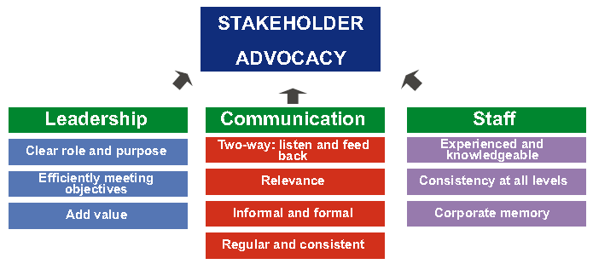

#### 3-1 What is your management style?

#### 3-2 What makes you a world-class leader?

Consultative, professional, respectual, hands-on, persistent

#### 4 Challenges of migration projects, e.g. M&A projects?

➊Familiarize with new environment ➋Determine correct migration, upgrade path ➌Determine new environment requirements (resources, system) ➍Plan testing ➎Allow time for performance tuning ➏Set up training environment ➐Plan for backup & recovery

#### 5 How do you hold team members accountable?

➊Handbook (scope, procedures) ➋Clear role ➌Measurable performance criteria ➍Meeting, communication

#### 6 How do you handle unhappy stakeholders or clients?

➊Involve stakeholder in prioritization of requirements ➋Ensure business sign-off of charter and requirements ➌Ensure minimum weekly face-to-face meeting on progress ➍Invite business to (some) project status meeting

#### 7 How do you handle excessive work demand?

➊Acknowledge team extra effort ➋Inform business of related risk ➌Review risk log and approach to remedy ➍Review plan/workflow to identify bottleneck

#### 8 What do you think challenge you in this position?

➊Engage stakeholder ➋Optimize team performance ➌Detect/ correct problems on time

#### 9 How do you handle very poorly performing project staff?

➊Diagnose poor performance ➋Enhance ability (Resupply, Retrain, Refit, Reassign, Release) ➌Improve motivation (performance goals, assistance, feedback)

#### 10 Your 3 recommendations to manage PMO?

➊Engage stakeholder ➋Optimize team performance ➌Continuous improvement

#### 11 How do you motivate?

➊Be realistic and specific ➋Create a safe environment (shield from org politics) ➌Be a role model ➍Know the team members ➎Recognize effort, progress, contributions ➏Celebrate ➐Empower ➑Link project success to corporate strategy – Get recognition from senior management

#### 12 How do you negotiate?

➊Know your opponent ➋Know the subject to negotiate ➌Know your BATNA

#### 13 Leading organizational change management

…on projects whose benefits relied significantly on high degree of behavioral changes

##### Change Management

➊Shared understanding of reality of change ➋Formulate the change ➌Plan the change ➍Implement the change ➎Manage change transition ➏Sustain change

##### Promoting Behavior Changes

➊Increase benefits ➋Decrease costs ➌Decrease the desirability of competing alternatives ➍Socially Desirable ➎Easily Done ➏Seek Sr. Management blessing

##### Types of Resistance to changes

➊**Technical resistance** ➀**Habit & Inertia** (bureaucratic traditions vs. new ways) ➁**Fear of the Unknown** ➂**Prior investment** (fear of waste)

➋**Political resistance** ➀**Resource allocation** (doing more with less) ➁**Leaders indictment** (full responsibility over the overloading of market risk system) ➂**Threats to powerful coalitions** (C-M Operations & IT)

➌**Cultural resistance** ➀**Old cultural mindsets** (CIBC/HOOPP gung-ho trading, AIG dominance) ➁**Sense of security** ➂**Climate for change** (pension not in the crosshairs)

🕮**Fighting Resistances to Changes**🕮**Change Management in Portfolio, Program, Project** 🕮**Organizational Project Management (OPM3)** 🕮**Change Management at Portfolio Level** 🕮**Change Management at Program Level** 🕮**Change Management at Project Level**

#### 14 How do you resolve personal conflict?

➊Be neutral third party ➋Establish rules of conduct ➌Meet both parties in calm & controlled setting ➍Control discussion ➎Understand perspectives ➏Reach working solution ➐Status Quo unacceptable

#### 15 How do you create alignment among partners?

➊Create stakeholder matrix ➋Seek common understanding of project objectives (Project Charter) ➌Define detailed RACI chart ➍Ensure representation within the team ➎Ensure adequate communication plan

#### 16 How do you manage stakeholders?

➊Identify ➋Prioritize ➌Understand their needs ➍Engage ➎Monitor engagement - Report project health

#### 17 How I support new staff?

**Program/project handbook** ➊Program Scope ➋Program Approach ➌Program Management, Control Process ➍High Level Program Plan ➎Project Governance ➏Change Management ➐Roles & Responsibilities ➑Weekly Status Report Process ➒Centralized Issues Log ➓Project Control Mechanism

#### 18 What I did when I screwed up?

➊Assess the damage ➋Admit your mistake immediately ➌Be direct and unambiguous ➍Take responsibility with humility ➎Take a step back and breathe ➏Don’t throw others under the bus ➐Devise an action plan ➑Do everything in your control to make it right ➒Prepare yourself for the consequences ➓Don’t be too hard on yourself

#### 19 What did you do when the project is behind schedule?

➊Work overtime➋Reallocate resources (critical path) ➌Double-check dependencies ➍Check time-constrained activities (sign-off, training) ➎Swap resources ➏Crash schedule (increase resources) ➐Fast track it (make sequential partially or totally parallel) ➑Prevent all scope change ➒Improve processes ➓Scale back the scope of work

#### 20 What did you do when the project is over budget?

➊Work unpaid overtime ➋Swap human resources ➌Eliminate or replace non-labor costs ➍"Zero tolerance" scope change ➎Use budget contingency ➏Scope back the work

#### 21 Basic Requirements for controlling project

➊**Plan** (realistic, credible, detailed enough to be executed, acceptable to those who must execute it, approved by those who are accountable (SRO/ Project Board) ➋**Process for monitoring/ managing** progress & resource usage ➌**PM organisation** (skilled people with sufficient authority & time to plan, monitor, report, take decisions & deal with exceptions ➍**Process for minor corrections & adjustments** (minor deviations & omissions) ➎**Commitment** to provide resources (SRO, Project Board, Stakeholders, resource ‘owners’) ➏**Explicit authority** to proceed by accountable (SRO/ Project Board)

#### 22 Auditing Projects

##### Software architecture audit model

|  |  |  |
| --- | --- | --- |
| **Architecture** | **Security** | **Tools** |
| ⬩Application architecture  ⬩Database architecture  ⬩Overall architecture | ⬩Application security  ⬩Web service security  ⬩Database security | ⬩NET framework  ⬩Visual Studio  ⬩3rd party |
| **Process** | **Efficiency** | **Performance** |
| ⬩Code management  ⬩Quality control  ⬩Methodology | ⬩Libraries  ⬩Frameworks  ⬩Factories | ⬩Availability  ⬩Maintainability  ⬩Scalability |

##### Project Lifecycle Documents (10)

➊**Feasibility Study** ➋**Specification** ➌**Cost effectiveness Analysis** ➍**Project Integration** ➎**Requirements** ➏**Internal Control** ➐**Testing** ➑**User Acceptance** ➒**Final Assessment** ➓**Project Context**

|  |  |  |  |  |
| --- | --- | --- | --- | --- |
| ***Feasibility Study (5)*** | ***Specifications (7)*** | ***Cost Effectiveness Analysis (4)*** | ***Project Integration (5)*** | ***Requirements (4)*** |
| ➊**Objectives** ➋**Solutions** ➀System demands ➁Solutions (variants) ➂Costs, risks, advantages ➌**Resources/ Funding** (demands on project & organisation) ➍**Feasibility** ➎**Readiness** (can concept phase begin/ project commissioning) | ➊**Objectives** ➋**Expectations** (users, stakeholders) ➌**Functionalities** ➍**As-Is** (what available) ➎**Project size** ➏**Project constraints** ➐**Technology requirements** | ➊**Total costs** (e.g. operational costs of data migration, capacity, training ➋**Assessed use for quantity, quality** ➌**Project cost effectiveness** | ➊**Integration** (corporate strategy + IT structures) ➋**Project overlap** ➌**Synergy** ➍**Conform to standards** ➎**Automatic/ manual interfaces** | ➊**Internal** (agreements, procedures, quality norms) ➋**External** (laws, regulations, directives, contracts) ➌**Specificity** (data protection, publication, procurement procedures, banks, best practices) ➍**Effect on processes/ infrastructure** (architecture, security) |
| ***Internal Control (4)*** | ***Testing (5)*** | ***User Acceptance (5)*** | ***Final Assessment (5)*** | ***Project Context (4)*** |
| ➊**Automatic controls** (data input validity check, automatic comparisons, error lists) ➋**Functions to be separated/ access permission** ➌**Measures to control** ➍**Measures for continuity in operations** (emergency plan)/ **preservation of data** (archive plan) | ➊**Purpose** ➋**Plan** (methods, tools, criteria, case studies) ➌**Resources** (availability, time constraints ➍**Test methods** ➎**Test results** | ➊**Acceptance definition** ➋**Data/ application ownership** ➌**UAT signoff** ➍**Test cases** ➎**Acceptance conditions** | ➊**Objectives achieved & requirements fulfilled** ➋**Final cost & variances** ➌**Cost effectiveness calculation** ➍**Post-implementation risk** ➎**Lessons learned** | ➊**Extensive user involvement** ➋**Performance appraisal** ➌**Extent of standardisation** ➍**Quality assurance systems & procedures** |

##### Project Survival Test

|  |  |  |  |  |
| --- | --- | --- | --- | --- |
| **REQUIREMENTS** | **PLANNING** | **PROJECT CONTROL** | **RISK MANAGEMENT** | **PERSONNEL** |
| ➊Clear, unambiguous **vision/ mission statement** ➋Realistic vision ➌**Business case** with business benefit and benefit metrics  ➍**User interface prototype** to demonstrate functionality ➎Detailed, written **specification** ➏Did the project team interview people who will actually use the software (end users) early in the project and continue to involve them throughout the project? | ➊Detailed, written **Software Development Plan**  ➋**Project task list** include creation of an installation program, conversion of data from previous versions of the system, integration with third-party software, meetings with the customer, and other "minor" tasks  ➌**Schedule and budget** estimates officially updated ➍Detailed, written **architecture and design** documents ➎Detailed, written Quality Assurance Plan that requires design and code reviews in addition to system testing ➏Detailed **Staged Delivery Plan** for implementation & delivery  ➐**Project plan** include time for holidays, vacation days, sick days, and ongoing training, and are resources allocated at less than 100% ➑**Project plan & schedule** approved by development, quality assurance, technical writing | ➊Single key **executive** with decision-making authority  ➋Project manager's **workload** adequate ➌Well-defined, detailed **milestones** ("binary milestones" 100% done or not done)  ➍Published **milestones** with status ➎**Feedback channel** for anonymous report of problems  ➏**Change management plan** ➐**Change Control Board** with authority to accept or reject proposed changes ➑Published **planning materials, status information** including effort, schedule estimates, task assignments, progress compared to the plan thus far available to every team member ➒Automated **revision control**  ➓Defect tracking software, source code control, PM software | ➊List of current risks to project  ➋List updated frequently  ➌**Project risk officer** to identify emerging risks  ➍Plan for managing subcontractors | ➊Team technical expertise  ➋Expertise with business environment in which the software will operate ➌Technical leader capable of leading project successfully ➍Enough people to do all the work required ➎Everyone work well together  ➏Each person committed to the project |

#### 23 SDLC

❶**Preliminary Analysis** organization's objectives, nature & scope of problem under study - alternative solutions - costs & benefits - preliminary plan with recommendations ❷**Systems analysis**, **requirements definition** project goals defined into functions/ operation of application - end-user information needs ❸**Systems design** features & operations in detail (screen layouts, business rules, process diagrams, pseudo-code, etc.) ❹**Development** Code writing, Integration & testing ❺**Acceptance, Installation, Deployment** ❻**Maintenance** changes, correction, additions, moves to different platforms, etc.

**DELIVERABLES** ➊**Requirements Management** change control ➋**Development Approach** SW development plan/project charter, development case/process plan, iteration plan/phase ➌**Issue Management/ Change Control** effort 🞧 cost impact of change 🞧 recommended solution ➍**Risk Management** identify, analyze, prioritize, identify risks (mitigate/retire early high risks, use requirements confirmation to mitigate scope/functional risk, architectural POC to eliminate technology risk) ➎**Quality Management** quality planning, assurance & control ➏**Configuration Management** evaluate, coordinate, approve/disapprove, implement changes in artifacts used to construct & maintain SW ⇨ define •set of artifacts (configuration items) under CM jurisdiction •naming of artifacts •entry/exit of controlled set •change rule •availability for use rule •CM tools➐**Test Management** test strategy & plan ➑**Project Acceptance** user acceptance process & sign-off ➒**Project Closeout**

##### 36 Deliverables subject to Change Control

|  |  |  |  |  |
| --- | --- | --- | --- | --- |
| ➊Change Control Plan ➋Change Proposals ➌Vision statement ➍Top 10 Risks ➎SW Development Plan (project cost, schedule estimates) | ➏User Interface Prototype ➐User Interface Style Guide  ➑User Manual/ Requirements Specification ➒Quality Assurance Plan ➓SW Architecture | ➊SW Integration Procedure ➋Staged Delivery Plan ➌Individual Stage Plans (miniature milestone schedules) ➍Coding Standard ➎SW test cases | ➏Source code ➐Media (graphics, sound, video) ➑SW build instructions make files ➒Detailed Design Document per stage ➓SW Construction Plan for each stage | ➊Install program ➋Deployment (Cutover Handbook) ➌Release Checklist ➍Release Sign-Off Form ➎SW Project Log ➏SW Project History Document |
| ➊Change Control Plan ➋Change Proposals ➌Vision statement ➍Top 10 Risks ➎SW Development Plan (project cost, schedule estimates) | ➏User Interface Prototype ➐User Interface Style Guide  ➑User Manual/ Requirements Specification ➒Quality Assurance Plan ➓SW Architecture | ➊SW Integration Procedure ➋Staged Delivery Plan ➌Individual Stage Plans (miniature milestone schedules) ➍Coding Standard ➎SW test cases | ➏Source code ➐Media (graphics, sound, video) ➑SW build instructions make files ➒Detailed Design Document per stage ➓SW Construction Plan for each stage | ➊Install program ➋Deployment (Cutover Handbook) ➌Release Checklist ➍Release Sign-Off Form ➎SW Project Log ➏SW Project History Document |

#### 24 Project Management Transition

➊**Project kick-off presentation** **deck** review ➋**Project schedule** deep dive ➌**Project finance** deep dive ➍**Project Culture** ➎**Project Staffing** ➏**Project stakeholders & interests** ➐**Assistance** (further)

#### 25 Project Management and ITIL

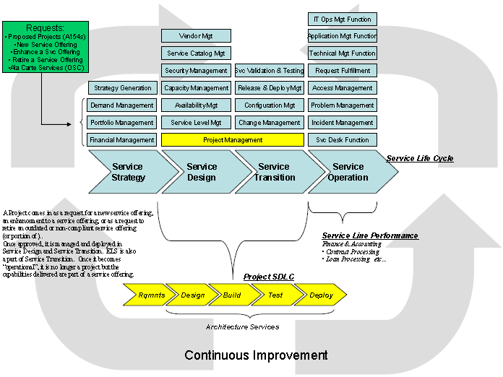

⬩**PM = Service offering** ⬩**Project = service request** (ITIL *Change Management*) ⇨ ***approved, designed, managed, deployed*** (ITIL *Service Design, Transition*) 🕮**ITIL Change Management** (➊Record RFC ➋Review RFC ➌Assess & Evaluate RFC ➍Authorize RFC ➎Plan ➏Implement & Coordinate ➐Review & Close) 🕮**ITIL Service Design** (➊Service Catalogue Management ➋Service Level Management ➌Capacity Management ➍Availability Management ➎IT Service Continuity Management ➏Information Security Management ➐Supplier Management) 🕮[**ITIL Service Transition**](#_Service_Transition_(ST)) (➊Change Management ➋Service Asset & Configuration Management ➌Release & Deployment Management ➍Minor Service Transition Processes)

#### 26 Program Management

🕮**Program Management Process (Ricardo Vargas**) **DEFINITION** – **BENEFITS** **DELIVERY** – **CLOSURE** and **9 Competencies** ➊Communication ➋Financial ➌Integration ➍Procurement ➎Quality ➏ Resource ➐Risk ➑Schedule ➒Scope

🕮[**Program Life Cycle (5)**](#_Program_Lifecycle_(5)) ➊Pre-program setup ➋Program setup ➌Program Mgt & Technical I/F ➍Benefit delivery ➎Program closure

🕮**Project Selection Criteria (9)** ➊Strategic alignment ➋ROI ➌Expected benefits ➍Urgency/ market reactive ➎Project type (new, maintenance) ➏Dependency with major project/program ➐Risk factor ➑Time to complete ➒Complexity

#### 27 Portfolio Management

🕮**Portfolio Management principles & practices (10)**

➊Strategic focus ➋Strategic initiatives ➌Portfolio Components ➍Quantifiable Components ➎Time Horizon ➏Portfolio snapshot ➐Portfolio Management Activities ➑Alignment to Organization Strategy ➒Governance ➓Balancing of conflicting demands

🕮**Portfolio Management Process Groups (5)**

➊Strategic ➋Governance ➌Performance ➍Communication ➎Risk

🕮**Portfolio Management Tools & Techniques** **(4)**

➊Analysis ➋Selection ➌ Meeting ➍Communication

**Analysis (15)** ➊Strategic alignment ➋Prioritization ➌Scenario ➍Capability & Capacity ➎Interdependency ➏Cost/benefit ➐Stakeholder ➑Readiness ➒Portfolio Organizational Structure ➓Graphical Analytical Tools ➊Quantitative & Qualitative ➋Value Scoring & Measurement ➌Benefits Realization ➍Communication Requirements ➎Gap **Selection (4)** ➊Portfolio component inventory ➋ Portfolio component categorization ➌Weighted ranking & scoring ➍Portfolio authorization **Meeting (1)** ➊Portfolio review meetings **Communication (4)** ➊Communication methods ➋Elicitation techniques ➌Portfolio Management information system ➍Integration Portfolio Management

#### 28 Contract Management

**Areas (7)** ➊Authoring & negotiation ➋Baseline management ➌Commitment management ➍Communication management ➎Contract visibility & awareness ➏Document management ➐Growth **Contract Placement Stages (4)** ➊Requirements Analysis ➋Evaluation Plan ➌Invitation to Tender ➍Proposal Evaluation **Contract Management phases (5)** ➊Initial ➋Bid ➌Development ➍Manage ➎Maintenance

#### 29 Architecture

🕮[**TOGAF**](#_TOGAF_(Open_Group) 🕮**ZACHMAN** 🕮**NET** 🕮**Mobile** 🕮**Data Architecture**🕮**Service architecture** 🕮**LIFE architecture** 🕮**Risk Architecture** 🕮**SCOTIA NFF** 🕮**SCOTIA Direct Loan** 🕮**MTO Revenue**

#### 30 DATA management

🕮**BCBS 239 (BASEL III) Requirements** 🕮**Risk Data 7 Areas 400 Requirements** 🕮 **20 Key Risk Reports** 🕮**20 Conceptual Data Models** 🕮**20 Key Risk groups** **data feeds** 🕮**8 Key Risk groups Data** 🕮**Risk Case Studies** 🕮**Risk Architecture** 🕮**SUNGARD** 🕮**CVA data requirements** 🕮**CIBC Risk** 🕮**Risk Topics** 🕮**Lexicon Risk** 🕮**DARPA Data Management** **11 Knowledge Areas**

##### Data Issue resolution

⧫**Data integrity** (resulting in inefficiency/costly rework, concerns over data shared with/ received from 3rd parties, excessive customer complaints or disputes) ⧫**Management information** for effective decisions ⧫**Significant data conversion, integration/ data cleansing** activities ⧫Potential overpayments/ revenue leakage issues ⧫**Complex spreadsheet models** support key business decisions ⧫**End-User Computing (EUC)** not supported by IT ⧫**Lack of internal skill set / capacity** to perform electronic data analytics and testing of complex business logic on a periodic bases

##### Merits of ETL and ELT

**ETL extract-transform-load** means risk is always playing catch-up **ELT extract-load-transform** continuous change and adaptation, less needs to predict exactly how information is used in the future

##### Credit scorecard development

➊**Data cleansing** **a-**Missing values/ outliers **b-**Correlation of financial characteristics **c-**Determine strength of financial characteristics **d-**Intuitive application (business / operational considerations)) ➋**Variable selection** (final set of characteristics 5 to 10) apart from other information like borrower's name, default information (# days past due) ➌**Scorecard development** ➍**Validation**

##### Data Quality Management Project example

➊Establish DQM environment ➋Scope project & implementation plan ➌Implement DQM project (define, measure, analyze, improve) ➍Evaluate DQM project

#### 31 Best Practices and Standards

⬩*Business Continuity* COBIT, ISO 27002, Business Continuity Institute (BCI) ⬩*IT Governance* COBIT⬩*Information security management system (ISMS)* ISO 27000, SANS Top 20 security controls

#### 32 RFI/RFP

10+ years selecting / managing vendors, issuing RFP, conducting Proof-of-Concept and negotiating contract for 4 enterprise initiatives of up to $80M at CIBC, CIBC Mellon and AIG

RFQ, RFP, contract negotiation, SLA, Statement of Work, vendor performance monitoring (in development and production) - **CIBC RSI 2009** ($80M project $35M annual, Industry Scan, RFP, POC, Contract) [**CIBC EUC 2008**](#_(CIBC_Control_(jan08-nov08),) ($3M, Industry Scan, RFI, POC, Contract) [**CIBC Mellon 2007**](#_(CIBC_Mellon_(ERP,) ($3M, Industry Scan, RFP) [**AIG India Vietnam 1999**](#_AIG/AIA_(sep96-apr00))

**Phases** **(6-8 months)** Scope (1 month) Preparation (1 month) RFP (2.3 months - Vendor contact 3 weeks, Vendor demo 2 weeks, Vendor Follow-up 2 weeks, Scoring/selection 2 weeks) Contract (2 months) 🕮**Vendor Selection Toolkit**

#### 33 Service Management, ITIL, IT Governance

**ITIL, COBIT capabilities** ⬩Implement KPIs with Balanced Scorecard (financial, customer, learning & growth, internal operations) ⬩Continual improvement ⬩Incident mgt ⬩Problem mgt ⬩Change mgt ⬩Configuration management ⬩Operational governance **🕮** (COBIT) ⬩**🕮**[SLA](#_SLR_(requirements),_SLA,) ⬩OLA ⬩Change advisory board ⬩Steering committee ⬩Known error database

⬩AGNICO (May – Oct13) ⬩HOOPP (Dec10 – Feb11) **🕮**ITIL Service Delivery processes **🕮**ITIL Infrastructure **🕮**ITIL Strategic questions **🕮**Lifecycle of Service Continuity Management **🕮**Resource Management Infrastructure **🕮**COBIT 4 domains **🕮**COBIT Components **🕮**COBIT Domains and Processes

#### 40 Other PM topics in this document

⮚Leading and mentoring ⮚Estimation techniques ⮚Gathering business requirements ⮚Process analysis ⮚Managing timelines ⮚Conducting technical reviews ⮚Development of Quality Management, Change Management, Issues & Risk Management plans, Communication plan, Project Charter ⮚Change requests ⮚Gating ⮚Project governance

#### 41 Techniques to manage timelines

➊**Detailed planning** (for 3-4 months ahead, up to 7-8 level deep of work breakdown structure) ➋Well-defined **milestones with ownerships** ➌Daily **review of risks and threats** ➍Visual **reports of project progress- challenges** ➎**Contingency planning** and **risk management planning**

#### 42 Techniques in conducting project meetings

**Agenda to plan project** ➊Welcome ➋Review Project Charter & Mission Statement ➌Project Scope ➍Major milestones ➎Task List and Dependencies ➏Risks and Mitigation Strategies ➐Project Communications ➑Information Repository ➒Action Plans

##### Various types of project meetings

🞟**Steering Committee for governance**, **project status** **Mthly** (HOOPP – CIBC) 🞟**Executive Committee for project status Wkly** (HOOPP – CIBC) 🞟**Project team meeting** for status, issue resolution – **Change management meeting** – all projects

#### 43 Techniques to conduct technical reviews

➊**Formulation of key questions** with the help of SMEs ➋Construction of “**evidence map**” to delimit areas for review ➌**Critical appraisal** with checklist, quality scales ➍**Audit trail** from business requirements to technical solutions ➎**Meetings and workshops management** with clear agendas, minutes and action plans

#### 44 Issues & Risk Management

For each **risk type** (organization specific, project specific, policies and procedures, technology, etc.), Identify and document the risk description, mitigation approach, contingency plan, likelihood of occurring, potential impact ($ / schedule / quality etc)

**RAID** ➊**Risks** = combined likelihood the event will occur and impact on - includes description, full analysis and plan to manage➋**Assumptions** factors assumed to be in place that will contribute to the successful result of project - includes details of the assumption, the reason it is assumed and the action needed to confirm whether the assumption is valid ➌**Issues** something going wrong – includes description, impact, seriousness and actions needed to contain and remove ➍**Dependencies** event/ work dependent on result of project, or your project will depend on - captures who you are dependent on, what they should deliver and when, who is dependent on you

#### 45 Quality assurance

**Tools** benchmarking, benefit/cost analysis, walkthroughs, audits •**Reviews** process, objectives, schedule, board/ action team, responsibilities

#### 46 Quality Management

For each phase (*initiation, planning, control/ execution, closing*), define the quality requirements and activities for the related deliverables and activities

❶ **Quality Activities**

|  |  |  |
| --- | --- | --- |
| Deliverable/Activity | Quality Activity | Comments |
| Initiation & requirements, design, construction, testing, implementation | | |

❷ **Standards and Guidelines**

|  |  |  |  |
| --- | --- | --- | --- |
| Standard | Owner & Location | Description | Exemption |

⬩Data quality management ⬩AGILE quality

#### 47 Quality processes in SDLC Phases

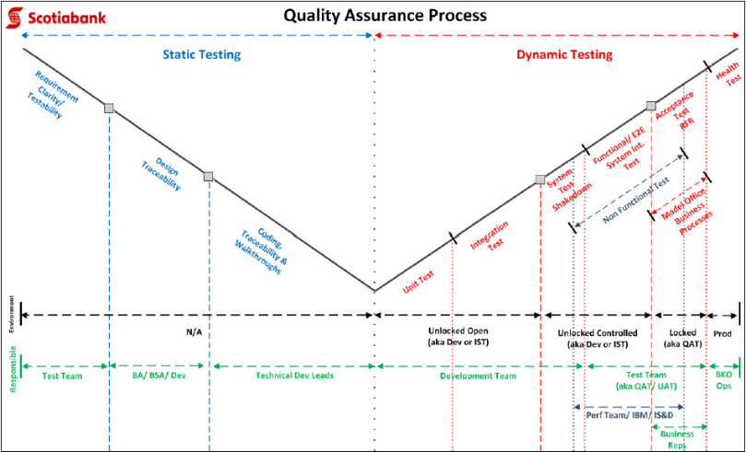

#### 48 Communication Plan

* I can get requirements for the communication Deliverable; identify the Producer, Receiver, Frequency and the Medium

🕮**Communication Plan**  🕮**Engagement/Communication Plan Structure**

#### 49 Project charter

* Key sections - project definition, business need and justification, in-scope, out-of-scope, key deliverables, tentative schedules, risks and challenges, project governance, project manager, key staff and stakeholders
* **BOSCARD** ➊**Background** (motivation, key stakeholders) ➋**Objectives** (goals linked to SMART objectives) ➌**Scope** (features/ functions of product, result) ➍**Constraints** (limits, conditions on scope) ➎**Assumptions** (for planning, to be validated) ➏**Risks** (with quick assessment of significance and mitigation) ➐**Deliverables**

#### 50 Techniques to estimate change requests

➊Itemized changes **INVEST** (Independent, Negotiable, Valuable, Estimatable, Small, Testable) ➋Inclusive of **all aspects of delivery** (analysis, design, implementation, testing, refactoring, deployment) ➌**Input from all concerned parties** including business, project team, IT ➍**Estimation methods**: affinity, wideband Delphi, ideal time, relative sizing based on experiences and history ➎**ITIL** Incident, problem, change

##### Techniques to negotiate change requests

🞟Itemized changes **INVEST** 🞟Min. 3 alternative choices of implementation 🞟Ranking based on business value and priority combined with Technology risk and difficulties 🞟Collective understanding of impact on project (time, resources and cost) 🞟**BATNA** (Best Alternative to Negotiated Agreement) 🞟Active listening 🞟Facilitation

#### 51 Business requirements

|  |  |  |  |  |
| --- | --- | --- | --- | --- |
| Situation | Task | Action | | Result |
|  | | | **McKinsey way**  **MECE** = Mutually Exclusive, Collectively Exhaustive  **80/20 rule** | | |

**🕮****Requirement Management Life Cycle**

##### Requirement types

❶**Business Requirements** enterprise goals, objectives, needs (why a project is initiated, what will achieve metrics to measure success) ❷**User Requirements** statements of stakeholder needs, how stakeholder will interact with a solution, bridge <Business Requirements> to other requirements classes ❸**Functional Requirements** behavior/ information/ capabilities to perform ❹**Quality of Service Requirements** (non-functional, supplementary requirements) ❺**Assumptions/ constraints** aspects of problem domain limiting/ impacting design but not functional requirements ❻**Implementation requirements** to transition from current to desired future state (once off) ➐**Project requirements** ➑**Quality requirements**

##### Elicitation Importance

➊**Support executive decision making** ➋**Apply influence to finish work** (backed by information that supports the goals) ➌**Assist in negotiation/ mediation** ➍**Resolve conflicts** ➎**Define real problems**

##### Requirements Elicitation

**❶**Brainstorming **❷**Document analysis **❸**Focus group **❹**Interface analysis **❺**Observation **❻**Prototyping **❼**Requirements workshop **❽**Reverse Engineering **❾**Survey/Questionnaire

##### Requirements Communication

**❶**Requirements communication plan **❷**Requirements format **❸**Requirements package **❹**Requirements presentation **❺**Conduct a formal requirements review **❻**Get signoff

##### Requirements planning and management

**PLANNING** ⬩key planning impact areas ⬩SDLC ⬩project life cycle methodology ⬩project risk, expectations & standards ⬩key stakeholder needs & location ⬩project type **REQUIREMENTS ACTIVITIES** ⬩requirements elicitation stakeholders/ activities ⬩requirements analysis/ documentation activities ⬩requirements communication activities ⬩requirements implementation activities **ESTIMATE REQUIREMENTS ACTIVITIES** ⬩milestones in requirements activities development/ delivery ⬩units of work ⬩effort per unit of work ⬩duration per unit of work ⬩identify assumptions ⬩identify risks **MANAGE REQUIREMENTS SCOPE** ⬩establish baseline ⬩structure for traceability ⬩identify impacts to external systems ⬩identify scope change resulting from requirement change (change management, maintain scope approval) **MEASURE/ REPORT ON REQUIREMENTS ACTIVITY** ⬩determine project / product metrics ⬩collect project / project metrics **MANAGE REQUIREMENTS CHANGE** ⬩plan requirements change ⬩understand requirements changes to ⬩document requirements changes ⬩analyze change requests

#### 52 Techniques to analyze process

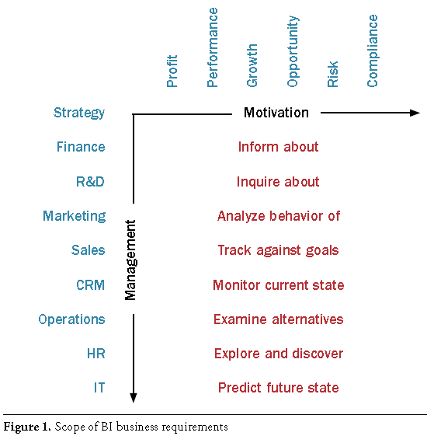**1** Who owns process **2** Who has power to change it **3** What are its objectives **4** What are success metrics **5** Who are customers **6** Who participate **7** What are inputs **8** What analytical tools **9** What events and milestones drive this process **10** What kind of decisions does this process generate **11** What decision-making criteria **12** How are decisions communicated, and to whom **13** Link to other management systems

#### 53 Risk Management

➊Identify ➋Analyze ➌Plan ➍Implement ➎Track & Control

**Step 1 – Identify**

**1-1** Identify and Collect **Candidate Risks 1-2** Identify & Provide Candidate Risk Input to Risk Manager/Analyst **1-3** Review Candidate Risks (**Table 1:** Criteria for Risk Identification - Risk? Impact? Likelihood? **Table 2:** *Risk Identification Components* – Originator, date, title, description, context) **1-4** Record Identified Risks in the Project Risk Database

**Step 2 – Analyze**

2-1 Verify/Determine **8** **Risk Classification** ➊Cost ➋Schedule ➌Scope ➍Quality ➎Human Resources ➏Communications ➐Procurement ➑Integration

**2-2** Verify/Determine **Risk Impact** (*High, Medium, Low*) **2-3** Verify/Determine **Risk Probability** (High >65% conf., Medium 35-65%, Low <35%) **2-4** Verify/Determine **Risk Timeframe** (*Short <120 days, Medium <360 days, Low*) **Risk Exposure** = Probability x Impact **2-6** Verify/Determine **Risk Severity** = *Exposure x Time Frame* **2-7** Recommended **Mitigations + Contingencies**: *Elimination, Reduction, Acceptance* **2-8** Review Risks with Project Director, Project Sponsors, and Stakeholders

**Step 3 – Plan**

**3-1** Assign **Risk Owner 3-2** Develop-Review-Approve Mitigations, Contingencies, Measurements **3-3** Develop Mitigation and **Contingency Action Plans 3-4** Update Project Risk Database

**Step 4 – Implement**

**4-1** Execute Mitigation and Contingency Action Plans **4-2** Update Project Risk Database

**Step 5 – Track and Control**

**5-1** Oversee Mitigation and Contingency Action Plan Execution **5-2** Track Action Plan Execution and Provide Feedback **5-3** Re-Assess Risks **5-4** Report Risk Status **5-5** Maintain the Project Risk Database **5-6** Escalation of Project Risk **5-7** Risk Retirement

**Table 8: Guide for Determination of Risk Escalation**

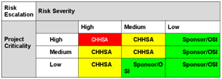

See PMI Practice Standard Risk Management

**Risk Statement** “Because of <1 or more causes>, <risk> may occur, which would lead to <1 or more effects>

#### PM Risk TOOLS

**Identify** ➊Brainstorm ➑Constraint analysis ➋Cause & Effect (Ishikawa) ➌DELPHI ➍FMEA Failure Modes Effect Analysis ➎Force Field ➏Influence diagram ➐Risk breakdown structure ➑Questionnaire ➒WBS review ➓SWOT

**Analyze** ➊Probability and Impact ➋Post-review ➌Analytic Hierarchy ➍Root-Cause ➎Decision Tree ➏Expected Monetary Value EMV ➐Monte Carlo

**Plan** ➊Brainstorm ➋Contingency planning ➌Contingency Reserve Estimation ➍Critical Chain Project Management CCPM ➎Prompt List ➏Scenario Analysis

**Track & Control** ➊ Critical Chain Project Management CCPM ➋Reserve Analysis ➌Risk Audit ➍Trend Analysis ➎Variance Analysis

**Risk Register** ➊**SUMMARY** ⬩Risk statement ⬩Risk owner ⬩Date last assessment ⬩Due date for update of risk assessment ⬩Risk category (Strategic, Project delivery, Operational) ⬩Risk classification (low, medium, high) ⬩Risk response ➋**DESCRIPTION** ⬩Title ⬩Scenario description (Actor, Threat type, Event, Asset/resource, Timing) ➌**ANALYSIS RESULTS** ⬩Frequency of scenario (# times per year) ⬩Impact on business (1 Productivity 2 Cost of response 3 Competitive advantage 4 Legal) ⬩Impact rating (average of 4 impact ratings) ⬩Rating of risk (frequency & impact ratings) ➍**RISK RESPONSE** ⬩Response (avoid, mitigate, transfer, accept) ⬩Response Justification ⬩Risk action plan status, issues ⬩Completed responses status, issues ➎**RISK INDICATORS**

🕮**CRISC IT Risk & Controls** **5 practice areas ➊**Risk Identification, Assessment, Evaluation ➋Risk Response ➌Risk Monitoring ➍IS Control Design & Implementation ➎IS Control Monitoring & Maintenance 🕮**IT Risk Scenario 5 Components** ➊Actor ➋Threat type ➌Event ➍Asset/Resource ➎Time 🕮**Risk Analysis and Response** **Risk Analysis** Top Down/ Bottom Up **5 Risk Factors** ➊External environment ➋Internal environment ➌Risk management capability ➍IT capability ➎IT-related Business Capability **4 Risk Response** ➊Avoid ➋Mitigate ➌Transfer ➍Accept **Risk response 5 parameters**➊Cost ➋Importance ➌Implementation capability ➍Response effectiveness ➎Response efficiency **36 Risk Scenarios** ➊IT program selection ➋New technologies ➌Technology selection ➍IT investment decision making ➎Accountability over IT ➏Integration of IT within business processes ➐State of I/F technology ➑Ageing of application SW ➒Architectural agility & flexibility ➓Regulatory compliance ➊SW implementation ➋IT project termination ➌IT project economics ➍Project delivery ➎Project quality ➏Selection/ performance of 3rd-party ➐IF theft ➑Destruction of IF ➒IT staff ➓IT expertise & skills ➊SW integrity ➋IF HW ➌SW performance ➍System capacity ➎Ageing of IF SW ➏Malware ➐Logical attacks ➑Information media ➒Utilities performance ➓Industrial action ➊Database integrity ➋Logical trespassing ➌Operational IT errors ➍Contractual compliance ➎Environmental ➏Acts of nature

## Agile PMI-ACP

#### Agile elements

**XP core values** ❶Simplicity ❷Communication ➌Feedback **XP core practices** ❶Whole team ❷Planning games ➌Small releases **Scrum pillars** ❶Transparency ❷Inspection ➌Adaptation **Scrum backlogs** ❶Product backlog ❷Sprint backlog

*Scrum inspection & adaptation* ❶Sprint retrospective ➌Daily scrum meeting ❹Sprint review meeting *Lean principles* ❶Eliminate waste ❷Empower team ➌In-build quality ❹Defer decisions ❺Amplify learning *Kanban principles* ❶Visualize flow ❷Manage flow ➌Make process policies explicit ❹Improve collaboratively *Manifesto* ❶Individuals & interactions over processes and tools ❷Working software over comprehensive documentation ➌Customer collaboration over contract negotiation ❹Responding to change over following a plan *Value stream mapping* ❶Identify product/service ❷Create value stream map (steps, queues, delays, information flow) ➌Review to find delays, waste, constraints ❹Create new map of desired future state, optimized to remove delays, waste, constraints ❺Develop roadmap for creating optimized state ❻Plan to revisit in future to continually tune/optimize

**Total cycle time** = Value-add + Non value-add time

**Process cycle efficiency** = Total value-add time / Total cycle time

**WIP Limits** •WIP consumes capital / only delivers return when converted to product •WIP hides bottlenecks that slow workflow •WIP represents risk (potential rework)

**Little’s law:** Cycle time (delay to earn benefits) ~ Queue size (WIP)

*Customer-valued prioritization schemes*

❶**Simple schemes** “Priority 1”, “Priority 2”, “Priority 3” ❷**MoSCoW** “Must have”, “Should have”, “Could have”, “Would like to have” ➌**Monopoly Money** ❹**100-point method** ❺**Requirements prioritization model** benefit, penalty, cost, risk on scale 1 (low) to 9 (high); customers rate benefit (have feature)/penalty (not have feature); developers rate cost/risk ❻**Kano analysis** exciters, satisfiers, dissatisfiers, indifferent

**Personas** to understand stakeholder demographics and needs

**Wire frame** for to confirm design (not detailed enough to test design)

#### User story

**User story** = role, function, benefit **Org** Feature ⮚ Epic ⮚ User story ⮚ Task

**User story** to capture high-level objectives of requirements

**User story** *INVEST* = Independent, Negotiable, Valuable, Estimatable, Small, Testable

*User Story versus Use Case*

**⬩User Stories** leave out important details. **Principles**: Develop small increments, get feedback and iterating, rather than up-front detailed documentation ⬩**Use Case** = "an end to end sequence of interactions between actor and system that yields a result of observable value to an actor, usually the instigating actor" Format: Actor does something, System does something, Actor does something else, System does something else; Use Case is made up of one main flow + alternate and/or exception flows some of which can branch back to the main flow. Use Cases are by nature fairly detailed **BDUF - Big Design Up Front**

#### Definition of “Done”

❶**User story level**: developed, documented, UAT ❷**Release level**: release X done when system Y replaced ➌**Project deliverable level**: all high + medium-priority features implemented, 2 months of trouble-free operation, satisfaction score > 70% ❹**Software level (James Shore)** •Tested all unit, integration, customer tests finished •Coded all code written •Designed all code refactored to team’s satisfaction •Integrated user story working from end-to-end (user interface to database) fit into rest of SW •Builds: build scripts including all new modules •Installs: build scripts including user story in automated installer •Migrated: build script updating database schema + installer migrating data •Reviewed: customers reviewing user story confirm expectations met •Fixed: known bugs fixed/ scheduled as own stories •Accepted: customers agree user story finished *Velocity*  measures of work done= the team’s capacity for work per iteration in hours, days, points or jelly beans – *net of* all interruptions, accounting for meetings, part-time resources and scope changes **Velocity** can be used to predict the project completion when tracked over multiple iterations **Velocity** increases with experiences but plateau with more maintenance and refactoring

#### Facilitation

**Active listening** ❶Internal listening ❷Focus listening ➌Global listening

**Facilitation methods** ❶Goals ❷Rules (use of cell phones, start time) ➌Timing (fixed duration, breaks) ❹Assisting (juniors to speak up)

#### Team Management

**Globalization, culture and team diversity**: F2F kickoff before split up, F2F release and planning, rotating secondment (temporary assignment), pairing (XP practice)

**Team decision-making tools** ❶Simple voting ❷Thumbs up/ down/ sideways ➌Decision spectrum (Jim Highsmith fully in favor, OK but with reservations, mixed feelings, not in favor but commit, veto) ❹Fist-of-five voting (similar to decision spectrum method)

**Servant leadership duties** ❶Shield team from interruptions ❷Remove impediments to progress ➌(Re)-communicate project vision ❹Carry food and water

**Modeling desired behavior** ❶Honesty-transparency, follow through, admit mistakes, add contingency ❷Forward-looking ➌Competent-not needing be specialist ❹Inspiring-explain vision and journey with

#### Principles for leading

➊Learn **team’s needs** ➋Learn **project’s requirements** ➌Act for simultaneous **welfare of team and project** ➍Create environment of functional **accountability** ➎Have **vision** of completed project - Use project vision to drive own behavior ➏Be central figure in successful team development ➐Recognize team conflict as positive step ➑Manage with **ethics** - not afterthought but integral to thinking ➒Take time to reflect ➓**Think backwards**

**Guidelines for managers** ❶Shared vision ❷Realistic goals ➌Limit team size <= 12 ❹Build team identity ❺Strong leadership **High-performance teams** ❶Self-organizing not role- or title-based ❷Empowered to make decisions ➌Believe that as a team, can solve any problems ❹Committed to team success ❺Team own decisions and commitments ❻Trust (not fear, anger) motivates them ❼Consensus-driven (full-divergence then convergence) ❽Constant constructive disagreement to generate buy-in decision

#### Coaching

**5 team dysfunctions** ❶Absence of trust ❷Fear of conflict ➌Lack of commitment ❹Avoidance of accountability ❺Inattention to results **Levels of conflict** ❶Problem to solve ❷Disagreement ➌Contest ❹Crusade ❺World war **One-on-one coaching** ❶Meet half-step ahead, don’t push to end point ❷Guarantee safety ➌Partner with managers ❹Create positive regard

#### Emotional Intelligence

**Tuckman’s 4 stages ❶**Forming ❷Storming ➌Norming ❹Performing

**Blanchard & Hersey** ❶Directing ❷Coaching ➌Supporting ❹Delegating

Emotional Intelligence pairing

|  |  |  |
| --- | --- | --- |
| **Self** | **Others** |  |
| Self-management  Self-control | Social skills  Influence | Regulate |
| Self-awareness  Self-confidence | Social awareness  Empathy | Recognize |

Start with “self-awareness” then learn “self-management” then develop “social awareness” and finally hone “social skills”

#### Planning

*Brainstorming* ❶Quiet writing ❷Round robin ➌Free-for-all *Prioritization techniques*

❶**MoSCoW** (Must, Should, Could, Won’t) for hierarchical prioritization or “1, 2, 3” or “High, Medium, Low” ❷Dot Voting or Multi Voting *Managing distributed teams* ❶Maintain a metaphor – e.g. ‘build Great wall of China” ❷Frequent communications – 2 stand-ups a day + one-on-one call ➌Intensify facilitation *Planning concepts* ❶Plan at multiple levels (Strategy, Portfolio, Product Vision, Product Roadmap, Release plan, Iteration plan, Daily commitment, Continuous) ❷Team and customer plan iterations ➌Manage expectations by frequently demonstrating progress and extrapolating velocity ❹Tailor processes to project’s characteristics ❺Update plan based on project’s priorities ❻Include estimates for risks, distractions, team availability ❼Use estimate ranges to reflect level of uncertainty in the estimate ❽Base projections on completion rates ➒Factor in diversions and outside work

**Project plan** many releases each many iterations

**Release Planning** - date driven or functionality driven (What proportion of the user story backlog can be delivered in the release?)

**Iteration Planning** - Which user stories that are high-priority items and that can be developed, tested and delivered within the iteration?

**Tailoring project processes** through cycles of regular inspection, reflection, adaptation (what is well? Where to improve? What to do differently?)

*Agile Games (Collaborative/ Innovation Games)*

❶Remember the future (vision-setting, requirements-elicitation) ❷Prune Product tree (gather and shape requirements) ➌Speedboat (identify threats and opportunities) ❹Buy a future (prioritization) ❺Bang-for-the-buck (value versus cost rankings)

#### Budgeting

**Final project cost** = (Time x rate) + other costs

*Time, Budget & Cost estimation*  (Size, effort, cost) ❶Determine project size in story points or ideal days (e.g. Size = 500 days) ❷Calculate effort in hours or person days, weeks or months (e.g. 3 developers avg availability 75% 🡪Effort= 500/0.75 = 603 days) ➌Convert to schedule (e.g. assume INVEST, 603 days/3 = 201 days or 9.6 months ❹Calculate cost

**Minimally Marketable Feature MMF** = package of functionality complete enough to be valuable but not big enough to represent the entire project

##### Estimation

**Agile estimation** team-based, collaborative, iterative **Estimation questions**: •Why do we estimate? (For sizing & approving projects, ROI and IRR, what can be done within release/iteration?) •How are estimates created? (progress through stages of determining project’s size, effort, schedule, and costs – including development, rollout, sustainment) •How should estimates be stated? (“estimates” not “predictions” because of uncertainty – provided in ranges to manage expectations (16 to 18 months)) •When do we estimate? Continuously and factoring actual costs and duration to date •Who estimates? (Project team)

**Project estimation** ➊Wideband Delphi[3] ➋Planning poker[4] (numbers based on Fibonacci sequence ➌Ideal time ➍Relative sizing/story points ➍T-shirt (Small, Medium, Large)

**Ideal Time** = assume no interruptions, i.e. all 8 hours available for work ⇨ Not realistic but more accurate sense of the effort involved **Relative Sizing / Story Points**: •Allow change upon new information about a story •Good for epics and small stories •Not time consuming •Useful information about progress and work remaining •Tolerant of imprecision in estimates •Useful to plan releases In addition, •Team owns story point (sizing) definition •Story point estimates are inclusive of all known activities (testing, etc.) •When disaggregating, totals do not need to match •Sizes are relative (2-point story is twice 1-point story) •Complexity, work effort, risk are accounted for

#### AGILE charting

*Burn-down chart*

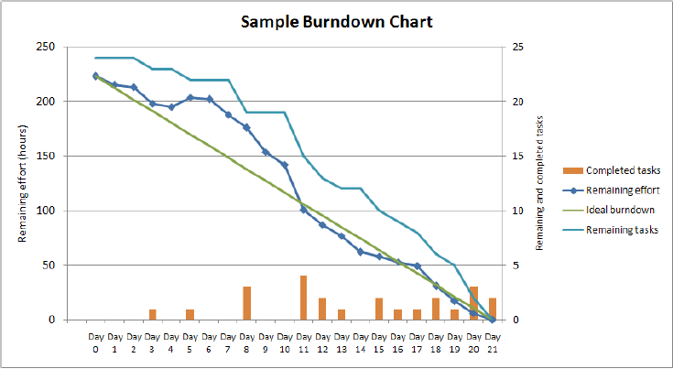

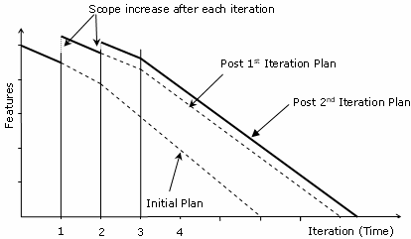

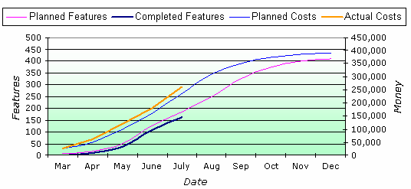

#### Value-Based Analysis

Consider business value of work items to act; understand value, consider: •Development+ delivery cost - early high-level estimate of backlog items to compare benefit-cost then determine priority •Payback frequency= value generated once or frequently

**Value-based Decomposition and Prioritization** •Elicit stakeholders’ requirements •Rank requirements •Prioritize requirements (development) **Tricks of the trade** •Refine requirements from backlog into iteration goal •Refine iteration goal requirements into iteration plan & user stories •Refine user stories requirements with discussions, stand-up

**Value-based Decomposition and Prioritization steps** ❶Design Product Box (High-level vision, align stakeholders behind common mission, goals, success criteria) ❷Feature workshops (break down vision into potential features) ➌Candidate feature list ❹Iterative development cycle for prioritized feature list **Parkinson’s Law** - Work tends to expand to fill the time available **Student Syndrome** - Given deadline, people tend to start at near deadline **Progressive elaboration -** refine plans as more details emerge

**Agile Plans** ❶Trial & demonstration uncover true requirements requiring planning ❷Agile planning less an upfront effort, more throughout project ➌Midcourt adjustments = norm

**Built-in feedbacks in planning** ❶Backlog reprioritization affects iteration/ release plans ❷Iteration feedbacks generate change request+ new requirements ➌Retrospective generate changes to processes+ techniques

**Agile Charters** ❶Project’s goal, purpose, composition, approach ❷Authorization from sponsor ➌Recognize scope change by characterizing the goals envisioned for the project ❹Describe processes and approaches for iterating toward the final product ❺Acceptance criteria to verify the project outcomes [**What** is this project about? (High-level vision, mission, goals, objectives) **Why** is it being undertaken? (Business rationale) **When** will it start and end? **Who** will be engaged? (project participants + stakeholders) **Where** will it occur? (work sites, deployment requirements) **How** to undertake? (approach, changes from traditional)]

**Business Case** •Project overview •Anticipated costs/ benefits •Business models/ indexes (ROI, IRR, NPV) •ROI assumptions/ risks associated •SWOT/PEST (Political, Economic, Social, Technical) •Sponsor’s recommendation (mandatory, critical, nice-to-have)

##### On Quality

**Reduce problem’s position** on **cost of change curve**: pair programming, test-driven development, acceptance test-driven development **Escaped defects** are not discovered during testing & validation; are top of “Cost of change” graph “**Fitness for purpose**” = Implied warranty **Monitor/assess quality of project processes** with tools: •Defect metrics •Variance and trend analysis •Root cause analysis •Corrective actions **Quality standard practices ❶**Measure product quality by tests passes and customer acceptance ❷Automate tests if possible ➌Test during each iteration ❹Fix minimum 90% defects in next iteration ❺Quality control & assurance side-by-side with developers and business ❻Testers collaborate with developers on finding defects & reproducing error ❼Only business can declare defect as fixed

*Failure and Success*

**Failure modes** **❶**Make mistakes human nature ❷Prefer to fail conservatively-revert to what they know ➌Invent rather than research ❹Creatures of habit ❺Be inconsistent

**Success modes** **❶**Good @ looking around ❷Can learn ➌Be malleable ❹Pride in work

**Strategy ❶**Counter with discipline & tolerance ❷Start with concrete & tangible ➌Copy & alter ❹Watch & listen ❺Support concentration & communication ❻Personality-matched work assignment ❼Talent ❽Rewards for long-term, self-esteem based motivators: pride-in-work, pride-in-accomplishment ➒Combine reward ➓Feedback

*Deming and Testing*

**Deming’s mistakes** **❶**React to common-cause-variation outcome as if special cause ❷Treat special-cause variations as if common cause **Solution** •Accept common-cause variations, intervene on special-cause •Avoid micromanagement, remove bottlenecks & impediments •Avoid tracking conformance, look to external indicators & daily stand-ups

**Test-driven development** red, green, refactor // write test, write code, refactor **Benefits** ❶Focus on outcome and customer ❷Good test coverage enhances quality ➌ Early defect catching ❹Small tested units ⇨ Modular, flexible, extendable **Costs** ❶Tests written by coder suffer same misinterpretations ❷Functionality types e.g. user interfaces difficult/time consuming to test ➌ Test maintenance is costly ❹False sense of security with more tests

*Acceptance Test-Driven Development (ATDD)*

Testing focus from code to business requirements 4 stages: ❶Discuss requirements ❷Distill tests in framework-friendly format ➌ Develop code and hook-up tests ❹Demo

**Investigation steps:** gather data, generate insights - decide what to do

**Control limits** = visual controls **Continuous integration** = software integrating new & changed code **Components** ❶Source code control system ❷Build tools ➌Test tools ❹Scheduler/trigger ❺Notifications **Benefits** ❶Early warning of conflicts ❷Problems fixed at integration not on release ➌ Immediate feedback on system-wide impacts ❹Frequent unit test ❺Easy reversion if problems

**Cycle time** = time for work from start to finish = WIP/Throughput

**Risk-based spike** = short period of Proof of Concept

*SMART goals* specific, measurable, attainable, relevant, timely

**Fast failure** finding fatal design flaws early

**Gather data** use **timeline** (timeline with good, problematic, significant)

**Decide about problems** short subjects, smart goals, retrospective planning games

##### Retrospectives

**Stages of executing retrospectives** set stage, gather data, generate insights, decide what to do, close retrospective **➊Set the Stage** (Check-in, Focus on/Focus off, ESVP = Explorer-Shopper- Vacationer-Prisoner, Working agreements) **➋Gather Data** (Timeline, Triple nickels, Color code dots, Mad-sad-glad, Locate strengths, Satisfaction histogram, Team radar, Like to like) **➌Generate Insights** (Brainstorm, Five whys, Fishbone, prioritize with dots, Identify themes) **➍Decide what to do** (Short subjects, SMART Goals, Circle of questions, retrospective planning game) **➎Close retrospective** (plus/delta, helped-hindered-hypothesis, return on time invested, appreciations)

##### Success, Anti-Pattern

**Continuous improvement** is core to pair programming, daily stand-ups, demos-reviews-retrospectives **Process anti-Patterns** (Bad things): ❶One size for all project (no optimal methodology) ❷Intolerant (people can choose) ➌Heavy (too much artifacts and practices divert people from real goals) ❹Embellished (get to know what people won’t do even when not admitting to) ❺Untried (better reuse, adjust, tune and create what is needed) ❻Used once (better than untried but not yet perfect) **Success process signs** ❶Projects get shipped ❷Leadership remains intact ➌People on the project work the same way **Successful methodologies** ❶Interactive, face-to-face communication is cheapest, fastest communication ❷Excess methodology weight is costly ➌Larger teams need heavier methodologies (more knowledge needs be committed to documentation with larger projects) ❹Greater ceremony for projects with greater criticality (more rigor with more critical project) ❺Increasing feedback & communication reduces the need for intermediate deliverables ❻Discipline, skills & understanding counter process, formality & documentation ❼Efficiency expendable in non-bottleneck activities: look for constraints, resolve bottleneck otherwise any improvement worthless

#### Experiences

|  |  |
| --- | --- |
| •**15 yrs** in portfolio management; **$100M portfolio of 100** programs and projects.  •**20 yrs** of program/ project management + developing/ deploying project management standards, processes, tools for project delivery and **budget** and **benefits**, **system integration**  •Manage/ report scope, time, cost, risk, resources, quality in programs exceeding **$50M** of **$15M** with **10** concurrent projects and teams **120** resources and **20** vendors  •Formulated corporate IT strategy for **CIBC**: $80M 3-yr upgrade financial risk system for $2B reduced Regulatory Capital; **CIBC Mellon**: $6M 2-yr integration financial system for revenue of $350M and 1,300 employees; and **AIG** $10B in revenues 120% explosive expansion into China, India, VN •Delivered AIG’s **4 strategic objectives** at $70M in costs per objectives, inventory of 9 regional initiatives; prepared business cases and effective ranking, prioritizing, approving and executing projects  •Created an inventory of **9 i**nitiatives supporting **4 x** **$70M** strategic objectives; established rigorous financial procedures for business cases and project ranking, prioritizing, approving and execution  •Strategy **for e-services** for 10 Australian industrials combined export of $50M to 20 countries in Asia and Middle East  •**Tier-1 consulting** projects for business transformation, process reengineering, compliance, infrastructure, development  •**Projects rescue** (Capital Markets, Credit Cards, Retail Loan, ***Wealth***, ***Treasury***, Payment, Business Intelligence, Insurance) and public services (BColumbia Corporate Accounting Services, MTO, Australia HCS)  •Implemented **Governance Methodologies** (Sarbanes-Oxley Act, COSO, COBIT, ValIT, CMM, RiskIT, ISO, ITIL); re-designed mgt processes for 5 departments (operations, middle office, back office, finance, IT) 200 members/ staff and established more than 4,000 process controls (SOX) at CIBC  **5 business units and 7 stakeholders financial/compliance** standards: IFRS (HOOPP), GAAP (MANULIFE), BASEL II&III (CIBC), SOX (CIBC, AGNICO) | •Built consensus with senior leaders, management and staff. Team motivation, mobilization, building complex relationships among business lines, internal staff and vendors. Expert in identifying stakeholders expectations, and aligning them optimally  •Set up **Project Management Office** at AIG, CIBC (Financial Risk), [CIBC Mellon](#_(CIBC_Mellon_(ERP,), SIERRA, HOOPP, CBOC •Portfolio management, **Program management**  •Within PMO, mentored and managed **15 program and project managers**  •Engaged various business units for adoption and maturity of program and project management disciplines  •Defined **PMO policies and procedures** with the focus on transparency and alignment with strategic objectives for all programs and projects in the portfolio  •Defined **governance processes** around Portfolio and Project Management tools then evaluated, deployed and institutionalized **CA Clarity** and **PLANVIEW** systems  •Established policies, procedures, processes, tools & templates for portfolios, programs, and projects Metrics, **estimation**, **Balanced Scorecards**, **Strategy Maps,** **Activity-Based Costing (ABC)** and **Earned Value Management**. Developed project accounting practices and managed Project Financials using Scotia Bank SMARTSTREAM, Project Reporting Facility  •Expert with Program, Project Management methodologies including PMI’s Standard for Portfolio/ Program/ Project Management; Ontario Public Service Unified Project Management Methodology, Oracle Application Implementation Methodology, others (Scotia, CIBC, AIG, PwC), **AGILE****,** **RUP**, **SDLC****,** **SIMCORP**  •**Project rescue missions** •**project auditing** •scope management •**vendor selection** • **vendor management** (RFQ, RFP, contract negotiation, SLA, performance monitoring) •Project governance •Business requirements  •Business process transformations, enterprise risk, change management: assessed current state, defined target state, implemented gaps for org. changes |
| •Work with clients to define/ **manage scope, strategy, and requirements** of projects  •Work with clients to manage **implementation** of projects  •Develop **cost benefit** analysis  •**Complete** projects within budget/ timelines while meeting client business objectives | •Identify and analyze project **risks**  •Mitigate, document, control project **risks**  •Develop and deliver **budgets**  •Identify **resource** needs for project  •Establish **roles, expectations, and goals** for team members  •**MS PROJECT**, **SHAREPOINT**, **EXCEL**, **ACCESS** |

##### Action Verbs

Refreshed the **PMO engagement model** - Designed and deployed - Led oversight and execution - Designed new processes - Provided a foundational baseline of - Developed cross-functional change management governance models - Set expectations, facilitated initial knowledge transfer and managed on day to day basis efforts - Managed Mutual Funds Project, resulting in updates to 100% of procedures (**80 existing procedures, 130 new procedures**), and in updates to more than **40 mutual fund products**- Defined I&IT **Project Portfolio**; Defined I&IT **Portfolio and Project Management policy**; Established I&IT **PMO strategy, guiding principles, functions, org structure, staffing and career paths, Checkpoint and Gating guidelines**, Established resource management process and supporting tools, Created a set of **43 Project Management artifacts**, including **process maps, document templates**, guidelines and process guides for **Initiation, Planning, Execution and Closeout** phases defined in the methodology. The artifacts covered Project Management (**Project Tailoring Guidelines, Project Charter, Project Schedule, Project WBS, Project Management Plan, Project Estimation Guidelines, standardized rates**, others), **Business Analysis, Solution Architecture, Quality Management** and other areas; Facilitated implementation of the **Project Intake Process** to standardize assessment / ranking of 6 new project and program requests per month

## Fighting Resistances to Changes

🕮**Types of Resistance** 🕮**Risk Management**

#### 1 Resistance: Initiative significant change for customers

➊Understand the exact nature of the change for the customers, what they will have to do that is new or different (This refers to CIBC’s external customers) ➋Involve Marketing to create a ***communication strategy*** that includes both customers and customer-facing employees ➌Identify customer- facing employee knowledge/skill gaps and get Training involved to develop an action plan.

#### 2 Resistance: Rationale hard to understand & communicate

➊Develop a ***Stakeholder Role Map*** to identify key audiences affected by the initiative ➋Develop a ***cascading communication strategy***, so that difficult to understand messages can be conveyed face-to-face by the one-up manager ➌Develop ***feedback mechanisms*** – Employees Hot Lines, Mailboxes and/or Town Hall Meetings or Workshops designed to convey the messages with time for Q&As

#### 3 Resistance: Employees must change behavior to succeed

➊Develop a ***Stakeholder Role Map*** to identify key stakeholders ➋Identify the nature of the behaviour change – discuss with sponsor/steering committee and get agreement ➌Involve Training to develop a ***strategy/plan to shift behaviour*** ➍Involve HR to determine if/how to incorporate it into ***Performance Scorecards*** ➎Identify incentives that can be introduced ➏Develop a ***cascading communication strategy***. Ensure sustaining sponsors are fully engaged (they know, understand, communicate and are prepared to deliver consequences) ➐Develop a strategy to measure the behaviour change

#### 4 Resistance: Significant knowledge & skill required

➊➋➌➍➎➏➐Above ➑Assess capability against future skill, attribute requirements

#### 5 Resistance: Expected resistance from affected employees

➊Develop a ***Stakeholder Role Map*** to identify the different stakeholder groups who will be impacted by the initiative ➋Upon completion of the ***Resistance Assessments***, develop a strategy and action plans to mitigate and track the level of resistance among the various stakeholder groups.

#### 6 Sponsorship: Accountable managers not support change

➊Develop a ***Stakeholder Role Map*** and identify the critical ***Sustaining Sponsors*** of the key targets of the change ➋Determine whether the Sustaining Sponsors are also targets of the initiative ➌Develop a strategy and action plans to mitigate and track the level of sponsorship among the various Sustaining Sponsors.

#### 7 Sponsorship: Implementation involves many people

➊Develop a ***Stakeholder Role Map*** to identify the different stakeholder groups who will be involved in the initiative. Include all relevant areas e.g. Risk Management, HR, Security, Compliance, Finance etc. as well as outside suppliers, labour unions ➋Determine the nature of their involvement ➌Identify ***critical Sustaining Sponsors*** for each of the areas identified ➍Identify ***critical change agents*** you need to enlist in those areas ➎Develop an ***advocacy strategy*** to gain and track sponsorship in the respective areas so that you can work effectively with required change agents

#### 8 Sponsorship: Sponsors not grasp time, $, HR reqmnts

#### 9 Sponsorship: Sponsors not provide resources

➊Develop ***Stakeholder Role Map***, identify ***critical Sponsor / Sustaining Sponsors*** of key targets of change ➋Develop strategy to communicate critical resource requirements to the Sponsors. ***Project Charter*** = effective vehicle to use to discuss these issues ➌Revise scope of project to reflect resource commitment that can be made by Sponsor/Steering Committee ➍Develop an ***effective working contract*** with Sponsor/Steering Committee to ensure issues can continually be addressed through ***Phase Transfer***

#### 10 Sponsorship: Coordinate various business groups

➊➋➌➍As in 8 ➎Develop an ***advocacy strategy*** to gain and track sponsorship in the respective areas so that you can work effectively with required change agents. (The Initiating Sponsor of the initiative and the Project Steering Committee will need to play an active role in enlisting the co-operation of the various business groups)

## INTERVIEW QUESTIONS

**INTERVIEW QUESTIONS TO ANTICIPATE:**

What interests you most about the company?

What interests you most about the job description?

Describe yourself.

Describe yourself in 2-3 words.

Why do you feel you would be the best candidate for this position?

What are your strengths/weaknesses?

What would your current boss say your strengths are?

What changes have you made to make yourself more effective at work?

What areas do you feel training would be beneficial?

Describe a difficult situation at work and how you handled it.

What motivates you?

Give me an example of a time you procrastinated and how you handled it.

Give me 2-3 process improvements you identified and implemented.

How do you set priorities?

Describe your most successful manager.

If you could start your career all over again, what would you do differently?

**INTERVIEW QUESTIONS TO ASK:**

What have you enjoyed most while working at XYZ company?

What have been your largest accomplishments at XYZ company?

How has turnover been within the company?

How much growth within the department and company have you seen since you have been on board?

Do you think the departments collaborate well within the organization?

Does the company typically promote from within?

What is the accounting department like?

What are the most important attributes for the person to succeed in the position?

What skills are currently missing on the team that you look for in a new hire?

What are the most important projects for this position over the next few months?

What are the biggest areas for growth within the company within the next year?

What are the biggest challenges for the company and accounting department?

Anything that concerns you about my background being a good fit for this role?

**GENERAL**

1. Tell me about a time where you had to manage change. How did you do it, and what was the outcome?
2. How would you describe your management style?
3. How would you describe your ability to communicate with senior management?
4. What qualities make a good boss or manager?
5. What are your greatest attributes as an employee?
6. What are your career goals?
7. In your last performance evaluation, where were your areas for improvement?
8. Why did you leave your previous employer, or why are you leaving your present job?
9. Where do you hope to be in five years?
10. Which of your past jobs was the most interesting?
11. Which of your past jobs was the least interesting?

**BEHAVIORAL**

1. Describe a recent situation in which you imparted your key points to a group with varying verbal skills?
2. Describe a time when you communicated something unpleasant or difficult to say to your manager. How did you assert yourself?
3. Give me an example of a time when you confronted a negative attitude successfully, which then resulted in building teamwork and morale.
4. Tell me when you had to “stand up” for a decision you made even though it made you unpopular.
5. Tell me about a time when you showed high enthusiasm and energy in order to create a positive energy in others. Give a specific example.
6. What is your viewpoint about co-workers that never speak their mind?
7. What sources of information have provided you with the best data for decision making?

**PERFORMANCE-BASED**

1. What are you looking for in a new job?
2. Why is having “x” and “y” important to you, and why do you think that this job meets that criterion?
3. Tell me about your schooling and advanced training.
4. What is your major project or accomplishment ?
5. Tell me about a major team accomplishment; consider one where you led a team and one when you were a key member of a team.
6. One major problem we are now facing is “xyz”. How would you go about addressing this? a. What would you need to know, and how would you plan it out? b. What have done that is most similar to this?
7. While I’ve seen a few other strong candidates, I’m impressed with some of the work you’ve done. What are your thoughts now about this job? Is this something that you’d consider further? Why or why not?

**FACT FINDING**

1. Describe a significant work challenge that you’ve had to overcome. Why was it significant?
2. What were the actual results?
3. When did this take place and at what company?
4. How long did it take you to complete the task?
5. What was the situation when you took on the project?
6. Why were you chosen for this role? Did you volunteer?
7. What was your actual title?
8. Who were the people on the team?
9. What was your supervisor’s title?
10. What technical skills were needed for the task?
11. What skills were learned? Describe the planning process, your role in it, and whether the plan was met. Provide details of what went wrong and how you overcame them. What was your role in this project?
12. Give me 3 examples of where you took the initiative?
13. What were the biggest changes or improvements?
14. What was the toughest decision you had to make? How did you make it? Was it the right decision? Would you make it differently looking back?
15. Describe the environment – the pace, the resources available, your boss, the level of professionalism.
16. What was the biggest conflict you faced? Who was it with and how did you resolve it?
17. Give me some examples of helping or coaching others.
18. Give me some examples of where you really had to influence or persuade others to change their opinion.
19. How did you personally grow as a result of this effort?
20. What did you like the most and least?
21. In retrospect, what would you do differently?
22. What type of recognition did you receive for this project? Was it appropriate in your mind?

**INTERPERSONAL SKILL**

1. **Emotional Self-Awareness** – the ability to recognize and understand one’s feelings and emotions, differentiate between them and know what caused them and why.

•Benefit in the Workplace? Good emotional self-awareness promotes conflict resolution and leads to improved interaction between staff. Is it easy for you to know when you are getting anxious, scared, annoyed, or angry? Can you give me an example or explain to me how you know this? What things do you feel really happy about? Why? What things do you feel really sad about? Why?

**2. Assertiveness** – ability to express feelings, beliefs and thoughts and defend one’s rights in non-destructive manner.

•Benefit in the Workplace? Proper assertiveness helps individuals to work more cohesively and to share ideas effectively. When you disagree with someone, what do you typically do? Give me an example of when you did that? Do you have difficulty standing up for your rights? Give me an example of when you did. When someone’s behavior consistently bothers you, how do you usually react? Can you give me an example of when you dealt with this situation and how you handled it?

**3. Self-Regard** – To respect and accept oneself as good.

•Benefit in the Workplace? Employees who have a high self-regard have better work attitudes and behaviors. Better self-confidence means better performance. What are your strengths, and how do you use them to your advantage? Can you give me an example? What are your weaknesses and what are you doing to improve them? Can you give me an example? Describe what kind of person others would say you are. Why?

**INSIGHT INTO BEHAVIORAL-BASED QUESTIONS**

4. **Self-Actualization** – To realize potential capabilities and to strive to do that which one wants to do and enjoys doing.

•Benefit in Workplace? High self-actualization is connected with good motivation + team performance. Your short-term goals and long-term goals? What are you doing to accomplish these goals? How actualized do you feel you are? Why? What things interest you and why?

5. **Independence** – The ability to be self-reliant and self-directed in one’s thinking and actions and to be free of emotional dependency.

•Benefit in the Workplace? Independence increases productivity and efficiency in work flow and the ability to meet milestones + goals in a timely manner. How do you make difficult decisions? Give me an example of a difficult decision that you had to make and the process you used for making it? Do you need people more than they need you, or the opposite? Why? What interest you and why?

6. **Empathy** – the ability to be aware of, to understand, and to appreciate the feelings of others. It is “tuning in” to what, how and why people feel the way they do.

•Benefit in the Workplace? This creates a more cohesive, functioning team and better team players. How difficult or easy is it for you to understand how people feel? Do you usually know when you have said or done something that has offended someone? How do you know? What do you do about it? Can you give me an example of a time when you felt you might have offended someone? What did you do?

7. **Interpersonal Relationships** – to establish and maintain mutually satisfying relationships that are characterized by intimacy and by giving and receiving kind gestures.

•Benefit in the Workplace? Good interpersonal relations translate into effective communication within and between departments and groups. When you are in a social situation with people you don’t know, what do you typically do? What is the basis for a good relationship in your opinion? What are the ingredients that go into it? Tell me about a relationship that is meaningful to you and what do you do to try and maintain it?

8. **Social Responsibility** – To demonstrate oneself as a cooperative, contributing, and constructive member of one’s social group. This involves acting in a responsible manner although one may not benefit personally.

•Benefit in the Workplace? Social responsibility means recognizing departmental and company goals and contributing to these goals. Can you give me an example of a situation where you considered the needs of others, possible to your own detriment? Give me an example of how you behave as a team member?

**ADAPTABILITY SKILLS**

9. **Problem Solving** – to identify & define problems as well as to generate and implement potentially effective solutions.

•Benefit in the Workplace? The method used for problem solving is critical: viable alternative solutions must be considered, including cost / benefit analysis and long term implications, as examples. Can you give me a step-by-step example of a difficult situation that you handled at work or at home? Is it generally easy or difficult for you to come up with a number of possibilities for approaching a problem? How easy or difficult is it for you to decide on the best solution and implement it? Can you give me an example?

10. **Reality Testing** – the ability to assess the correspondence between what is experienced (the subjective) and what in the reality exists (the objective).

•Benefit in the Workplace? It is important to focus on practicality and not on unrealistic expectations. Do you usually assume things and jump to conclusions, or do you check things out before acting? Can you give me an example? Would others say you are realistic or idealistic and why? Can you give me an example of that?

11. **Flexibility** – to adjust emotions, thoughts, behavior to changing situations and conditions.

•**Benefit in the Workplace?** Employees perform better in positions where tasks are dynamic and changing. Low flexibility resources perform better in more well-defined tasks requiring reliability and consistency. Can you give me an example of when your opinion about a person or situation was clearly wrong and what you did? Give me an example of how well you deal with change in general? If you were forced to leave your home, how would handle it?

**STRESS MANAGEMENT SKILLS**

12. **Stress Tolerance** – the ability to withstand adverse events and stressful situations without “falling apart” by actively and positively coping with stress; the ability to weather difficult situations without getting too overwhelmed.

•Benefit in the Workplace? Effective stress tolerance has to do with managing reasonable workloads, establishing clear priorities and meeting realistic deadlines. What tactics do you use to cope with everyday stress? Give me an example of a stressful situation that you coped with effectively?

13. **Impulse Control** – the ability to resist or delay an impulse, drive, or temptation to act. It entails the capacity for accepting one’s aggressive impulses, being composed, and controlling aggression, hostility and irresponsible behavior.

•Benefit in the Workplace? Rash actions can be costly. Mistakes can often be avoided simply taking the time to stop and think things through. Can you give me an example of a situation in which you were very angry and what you did in that situation? How do you typically deal with an impulse or temptation to act prematurely?

**GENERAL MOOD**

14. **Happiness** – the ability to feel satisfied with life, to enjoy others and to have fun.

• Benefit in the Workplace? Positive moods lift spirits, create resonance and help overall performance of individuals and teams. If I were to ask your friends how you make them feel when they are around you, what would they say? Why? Are you generally satisfied with the way things are presently going in your life? Why?

15. **Optimism** – to look at the bright side of life and to maintain a positive attitude, even in the face of adversity.

•Benefit in the Workplace? An optimistic attitude helps ward off stress while creating resonance that increases one’s productivity. How do you typically deal with failure? Can you give me an example of a time where, in your opinion, you failed? How did you deal with the situation? How do you cope with your pessimistic feelings?

#### NASA Shared Voyage

•Projects usually present a bundled set of challenges demanding that people operate in both known and new domains at the same time. The known domains are amenable to technical expertise and managerial authority. The new challenges - ***adaptive challenges -*** require leadership that can handle the conflict and messiness of ongoing structural tensions across different organizations and groups as they strive for collective innovation.

➊**Adaptive leadership is active and reflective**: constantly alternate between participating and observing; be part of the action and yet also rise above it to analyze more clearly changing landscapes requiring ongoing corrective action; be able to “get off the dance floor and get on the balcony.” •**Adaptive processes in evolutionary biology are experimental**. Rather than investing the knowledge in high authority, which makes sense for technical problems, adaptation is more likely to succeed with a distributed intelligence.

➋**Adaptive work generates tough trade-offs between legitimately competing claims**, “the difference between ‘desirements’ and requirements.” •Discovering which trade-offs to make requires drawing out divergent perspectives, orchestrating conflicting views and interests, and listening for the crystallization of a good idea rather than reaching too quickly for decision. •But trade-offs are painful. Jobs are lost, people are let go. Casualties are often necessary. Have the stomach to deliver bad news, and the heart to deliver it well.

➌**Leadership is a political activity, even in projects**. When people make the classic leadership error of treating adaptive challenges like technical problems, they end up assuming too much about the relevant stakeholders and then step on toes unwittingly. Everybody has a piece of the turf, and you’d best respect that. You never know how much your lack of respect may cost you.

➍**Leadership is about challenging people to take far-reaching responsibility.** The task is to put the creative work back in people’s laps when parochial views inhibit new thinking and necessary collaboration. “I don’t know how you’re going to figure this out, but I have confidence that you will, and if you don’t, we all fail.”

➎**Adaptive work takes time**. Within days, we can complete the analysis that was the technical part of the problem-solving. The implementation, on the other hand, took months because implementation consists of changing people’s hearts, minds, and habits of behavior. People will either sustain the direct loss of their own job, the indirect loss associated with a friend or colleague losing their job, or the loss of competence for a period of time during which they must learn new competencies. Closer to where the tire hits the road, implementation is more than execution, it demands of people that they face some losses and learn new ways.

➎**Leadership infuses the work with meaning**. People are willing to take risks, and even pay dearly, if the stakes are sufficiently meaningful. Money is only part of it

#### Anecdotes

Fred Kavli, NTH Physics, Kavli foundation for astrophysics, nano-sciences, neurosciences – CDS of AIDC more +ve than BHP

# AIG AUDIT

## FCU

⬩**ELC** (Entity Level Control) ⬩**OSP** (Outside Service Providers) Oversight ⬩**LU**= Least (privileged) User Access ⬩**NTE**= nature, timing and extent ⬩**SSAE16 SOC1, SOC2** ⬩**Audit Writing 5C’s**: Criteria (what should be), Condition (the current state), Cause (the reason for the difference), Consequence (effect), Corrective action plans/recommendations.

## PWC

#### Key Reports

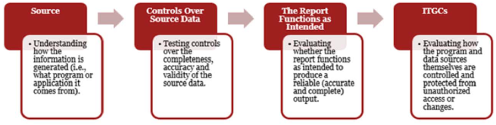

##### Accuracy & Completeness Procedures

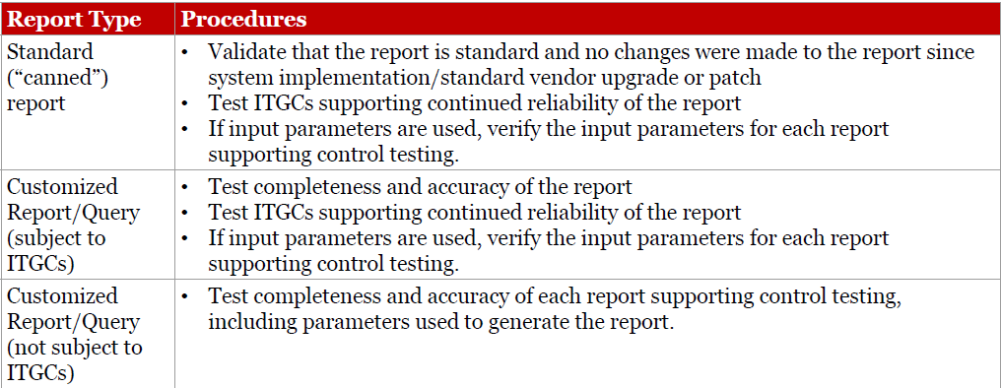

##### Full/False Accept/Reject Testing

• To assess whether the data included in the report is accurate, select a sample of items from the report and agree key attributes within the report to the underlying system.

• To assess whether the data in the report is complete, select a sample of items (different to the one used to test accuracy) from the system and confirm that those items are included in the report using unique key attributes.

##### Using a data extract, reperform the report/query

• Obtain an understanding of the logic used to generate the report.

• Observe the extraction of the data and confirm that the extraction is complete and apply the logic obtained

• Compare the result to the contents of the report used in management’s control to replicate the output by running independent queries on the extracted data on the back end database and match to the output on the report.

##### Perform an independent code review

• Assess the technical report logic to determine whether the report is generated as intended (i.e. combination or exclusions)

• Utilize sufficient technical ability and knowledge to formulate an independent point of view on the sufficiency of the code to satisfy the intended purpose, including both simple query languages (i.e. SQL) and complex mainframe programming languages (i.e. COBOL)

• Even code written in a simple query language may be complex, affecting the ability to efficiently perform a code review

#### System Interfaces

##### Interfaces Considerations

• What are the ways in which data flows from source system to target system, including pass through systems?

• What is the type of data being sent over the interface, and any specific key attributes? Is the data being modified (e.g. filtered, excluded, aggregated) during the transmission?

• How often is the job executed/its frequency for the purposes of the control?

• Where is the job configuration held, either in the source or destination application, or in a job scheduler like AutoSys? Is it subject to relevant ITGCs?

##### Interface – Interface Job Testing

• Identify the interface job and obtain job details and configurations

• Identify and test controls for handling job abends for the job

• Perform procedures over continued operation of the interface during the period

##### Interfaces – Testing Completeness

• Extract from source application of the file(s) being sent to destination application, including completeness considerations (e.g. script review and analysis)

• Extract from the destination application of the file(s) received from source application, including completeness considerations (e.g. script review and analysis)

• Reperform the interface by comparing the source file (e.g. total entries, total balance) to the file received in the destination application

##### Interfaces – Testing Accuracy

For a sample line item(s) selected from the destination extract:

• Obtain transaction details/key fields in the destination system

• Compare those key fields to the transaction details in the source system for accuracy

#### Automated Controls Considerations

• What are the various iterations in which the control can be configured and which ones are in use (e.g. calculation methods, validation checks, etc.)?

• What is the process for periodic validation of the system functionality?

• How and who can overwrite system functionality? And what is the process for implementing the changes?

##### Testing Automated Controls

• Gain an understanding and evaluate the underlying logic/functionality

• Perform a walkthrough of transactions to demonstrate the operation of the functionality is consistent with business purpose.

• Perform positive and negative scenario testing for each functionality

• Perform testing over each iteration of the functionality

#### Testing Automated Reconciliations

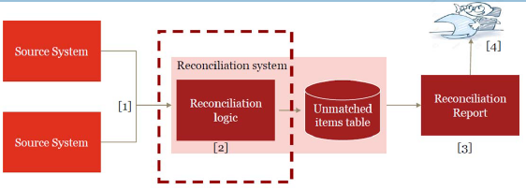

##### Reconciliations Considerations

• How the reconciliation is performed (automated vs manual)?

• What is being reconciled (i.e. cash, positions, balances, etc.)?

• What are the key fields being matched?

• Is the source data, including filtering criteria and exclusions, appropriate?

• How many iterations on the matching logic exist?

• What is defined as a break (tolerances/thresholds)?

• How are the results of reconciliation displayed (i.e. exception only, etc.)?

• What is the process for aging & resolution of the reconciling items?

• What is the monitoring over aged items?

##### Testing Automated Reconciliations

###### Method 1: Using source data/inputs

• Define Expectation: Obtain source data/inputs & apply necessary filters/exclusions based on systematic logic

• Define Outcome: Obtain results of reconciliation performed by the system (report, dashboard, etc.)

• Reperform Reconciliation: Compare the expectation from #1 vs outcome from #2

Testing Automated Reconciliations

###### Method 2: System Validation

1. Perform walkthrough to gain an understanding of the systems, feeds, and logic associated with the reconciliation

2. Define Expectation - Obtain Positive iterations and Negative iteration (data that matches/ does not match) and submit it into the application/reconciliation tool for processing

3. Define Outcome - Obtain results of reconciliation performed by system for both Positive iterations (which do not create reconciling items) and Negative iterations (which do create reconciling items)

4. Reperform Reconciliation - Compare results of expectation in #2 vs outcome in #3

5. Generation of Key Report - Test that reconciliation results appears completely and accurately Note: consider the effectiveness of ITGCS & test the continued operation of the control throughout the period

## Inshoring SOX functions



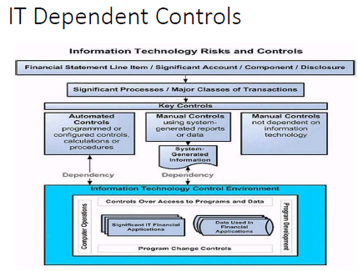



## RPA

⬩Initiated from Accounts Payable (NJ), DBA <Tax, FIS Billing, FP&A Planning&Analysis, Comptrollers> ⬩Consultant: GENPACT ⬩Process 1: Batch creation + Monies moving ⬩Process 2: VOID/STOP Payment (Reversal) ⬩Systems AWD (Automated Work Distributor Imaging & Workflow), OASYS PrC (Fixed annuity Admin) ⬩ RPA: OPENSPAN PEGASYSTEMS

## SOX Controls

NON-CLEARWATER; CLEARWATER

## SOC for Service Organizations

SOC for Service Organizations reports are designed to help service organizations that provide services to other entities, build trust and confidence in the service performed and controls related to the services through a report by an independent CPA.

#### SOC 1 ICFR

*Report on Controls at a Service Organization Relevant to User Entities’ Internal Control over Financial Reporting* - These reports, prepared in accordance with AT-C section 320, *Reporting on an Examination of Controls at a Service Organization Relevant to User Entities’ Internal Control Over Financial Reporting,* are specifically intended to meet the needs of entities that use service organizations (user entities) and the CPAs that audit the user entities’ financial statements (user auditors), in evaluating the effect of the controls at the service organization on the user entities’ financial statements. Two types of reports:

* Type 2 - report on the fairness of the presentation of management’s description of the service organization’s system and the suitability of the design and operating effectiveness of the controls to achieve the related control objectives included in the description throughout a specified period.
* Type 1 – report on the fairness of the presentation of management’s description of the service organization’s system and the suitability of the design of the controls to achieve the related control objectives included in the description as of a specified date.

Use of these reports is restricted to the management of the service organization, user entities, and user auditors.

#### SOC 2 Trust Services Criteria

*Report on Controls at a Service Organization Relevant to Security, Availability, Processing Integrity, Confidentiality or Privacy* - These reports are intended to meet the needs of a broad range of users that need detailed information and assurance about the controls at a service organization relevant to security, availability, and processing integrity of the systems the service organization uses to process users’ data and the confidentiality and privacy of the information processed by these systems. Roles:

* Oversight of the organization
* Vendor management programs
* Internal corporate governance and risk management processes
* Regulatory oversight

Similar to a SOC 1 report, there are two types of reports: A type 2 report on management’s description of a service organization’s system and the suitability of the design and operating effectiveness of controls; and a type 1 report on management’s description of a service organization’s system and the suitability of the design of controls. Use are restricted.

#### SOC 3 Trust Services Criteria for General Use Report

These reports are designed to meet the needs of users who need assurance about the controls at a service organization relevant to security, availability, processing integrity confidentiality, or privacy, but do not have the need for or the knowledge necessary to make effective use of a SOC 2 Report. Because they are general use reports, SOC 3 reports can be freely distributed.

|  |  |  |
| --- | --- | --- |
| Key Question | Response | SOC Report Type Required |
| Will the report be used by your customers and their auditors to plan and perform an audit or integrated audit of your customer’s financial statements? | Yes | SOC 1® Report |
| Will the report be used by your customers or stakeholders to gain confidence and place trust in a service organization’s systems? | Yes | SOC 2® or SOC 3® Report |
| Do your customers have the need for and ability to understand the details of the processing and controls at a service organization, the tests performed by the service auditor and results of those tests? | Yes | SOC 2® Report |

***AICPA Toolkit for SOC for Service Organizations****To help service organizations better understand SOC for service organizations examination engaagements and educate current and potential customers on the reports on their controls, the AICPA has developed the*[*SOC Toolkit for Service Organizations*](https://www.aicpa.org/interestareas/frc/assuranceadvisoryservices/soctoolkit-serviceorgs.html)*. All materials are available as free downloads.* The AICPA has developed the "[Information for Management of a Service Organization](https://www.aicpa.org/content/dam/aicpa/interestareas/frc/assuranceadvisoryservices/downloadabledocuments/infoformanagementofsvcorg.pdf)" document to assist management of a service organization in preparing its description of the service organization’s system, which serves as the basis for a SOC 2**®**examination engagement. It is also intended to familiarize management with its responsibilities when it engages a service auditor to perform a SOC 2**®** engagement. This document was adapted from the AICPA Guide, *SOC 2****®****Reporting on Controls at a Service Organization Relevant to Security, Availability, Processing Integrity, Confidentiality, or Privacy (January 1, 2018)*.

# AUDIT SKILLS

## IIA standards

#### Standard 1210 – Proficiency

Internal auditors must possess the knowledge, skills, and other competencies needed to perform their individual responsibilities. The internal audit activity collectively must possess or obtain the knowledge, skills, and other competencies needed to perform its responsibilities.

**1210.A3 –** Internal auditors must have sufficient knowledge of key information technology risks and controls and available technology-based audit techniques to perform their assigned work. However, not all internal auditors are expected to have the expertise of an internal auditor whose primary responsibility is information technology auditing.

#### Standard 2010 – Planning

The chief audit executive must establish a risk-based plan to determine the priorities of the internal audit activity, consistent with the organization’s goals.

**2010.A1 –** The internal audit activity’s plan of engagements must be based on a documented risk assessment, undertaken at least annually. The input of senior management and the board must be considered in this process.

**2010.A2** – The chief audit executive must identify and consider the expectations of senior management, the board, and other stakeholders for internal audit opinions and other conclusions.

**2010.C1 –** The chief audit executive should consider accepting proposed consulting engagements based on the engagement’s potential to improve management of risks, add value, and improve the organization’s operations. Accepted engagements must be included in the plan.

#### Standard 2030 – Resource Management

The chief audit executive must ensure that internal audit resources are appropriate, sufficient, and effectively deployed to achieve the approved plan.

#### Standard 2100 – Nature of Work

The internal audit activity must evaluate and contribute to the improvement of the organization’s governance, risk management, and control processes using a systematic, disciplined, and risk-based approach. Internal audit credibility and value are enhanced when auditors are proactive and their evaluations offer new insights and consider future impact.

#### Standard 2110 – Governance

The internal audit activity must assess and make appropriate recommendations to improve the organization’s governance processes for:

* Making strategic and operational decisions.
* Overseeing risk management and control.
* Promoting appropriate ethics and values within the organization.
* Ensuring effective organizational performance management and accountability.
* Communicating risk and control information to appropriate areas of the organization.
* Coordinating the activities of, and communicating information among, the board, external and internal auditors, other assurance providers, and management.

**2110.A2 –** The internal audit activity must assess whether the information technology governance of the organization supports the organization’s strategies and objectives.

#### Standard 2130 – Control

The internal audit activity must assist the organization in maintaining effective controls by evaluating their effectiveness and efficiency and by promoting continuous improvement.

#### Standard 2200 – Engagement Planning

Internal auditors must develop and document a plan for each engagement, including the engagement’s objectives, scope, timing, and resource allocations. The plan must consider the organization’s strategies, objectives, and risks relevant to the engagement.

#### Standard 2201 – Planning Considerations

In planning the engagement, internal auditors must consider:

* The strategies and objectives of the activity being reviewed and the means by which the activity controls its performance.
* The significant risks to the activity’s objectives, resources, and operations and the means by which the potential impact of risk is kept to an acceptable level.
* The adequacy and effectiveness of the activity’s governance, risk management, and control processes compared to a relevant framework or model.
* The opportunities for making significant improvements to the activity’s governance, risk management, and control processes.

**2201.C1 –** Internal auditors must establish an understanding with consulting engagement clients about objectives, scope, respective responsibilities, and other client expectations. For significant engagements, this understanding must be documented.

#### Standard 2210 – Engagement Objectives

Objectives must be established for each engagement.

**2210.A1 –** Internal auditors must conduct a preliminary assessment of the risks relevant to the activity under review. Engagement objectives must reflect the results of this assessment.

**2210.A2 –** Internal auditors must consider the probability of significant errors, fraud, noncompliance, and other exposures when developing the engagement objectives.

**2210.C1 –** Consulting engagement objectives must address governance, risk management, and control processes to the extent agreed upon with the client.

**2210.C2 –** Consulting engagement objectives must be consistent with the organization's values, strategies, and objectives.

#### Standard 2220 – Engagement Scope

The established scope must be sufficient to achieve the objectives of the engagement.

**2220.A1 –** The scope of the engagement must include consideration of relevant systems, records, personnel, and physical properties, including those under the control of third parties.

#### Standard 2230 – Engagement Resource Allocation

Internal auditors must determine appropriate and sufficient resources to achieve engagement objectives based on an evaluation of the nature and complexity of each engagement, time constraints, and available resources.

#### Standard 2240 – Engagement Work Program

Internal auditors must develop and document work programs that achieve the engagement objectives.

#### Standard 2310 – Identifying Information

Internal auditors must identify sufficient, reliable, relevant, and useful information to achieve the engagement objectives.

## Audit Metrics

#### Frequency

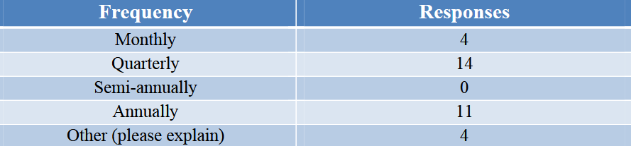

#### Environment

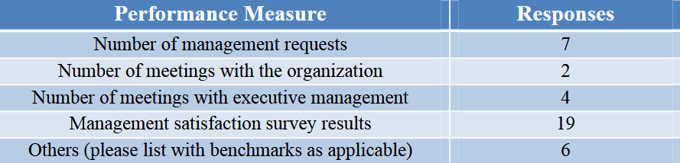

#### Output

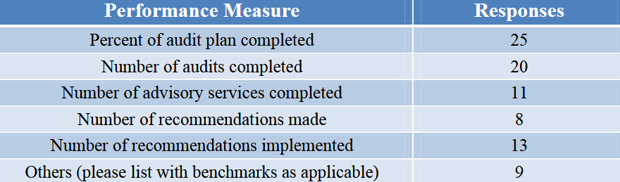

#### Quality

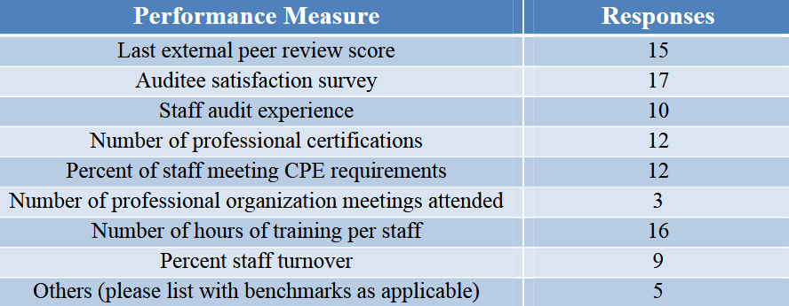

#### Efficiency

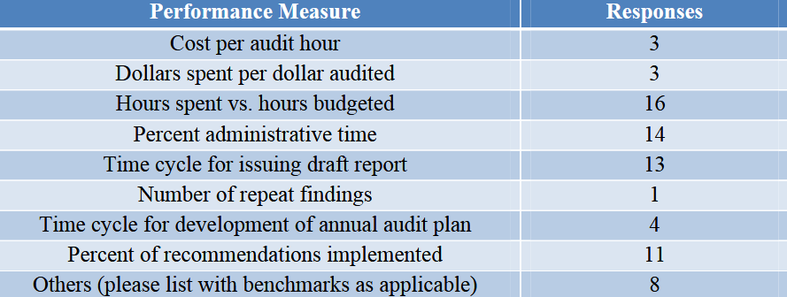

#### Impact

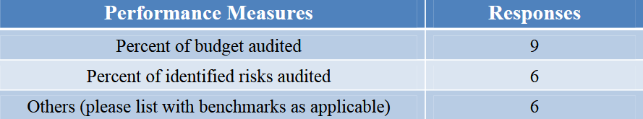

## Audit Acquisitions

#### Life Cycle

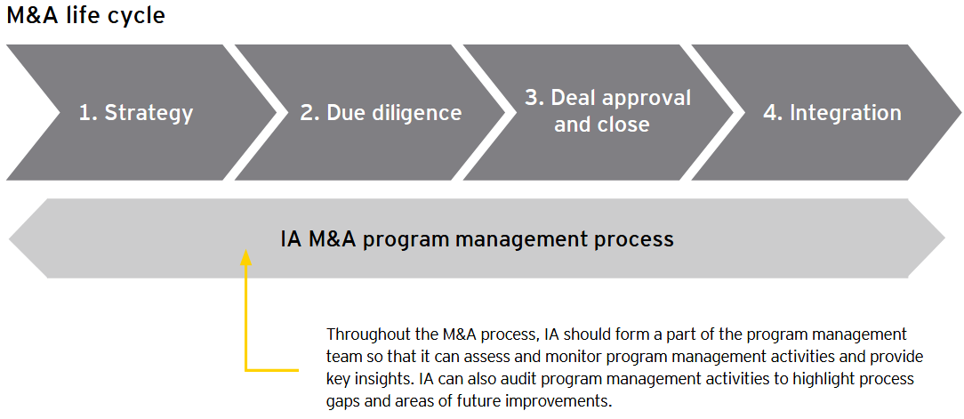

#### Strategy

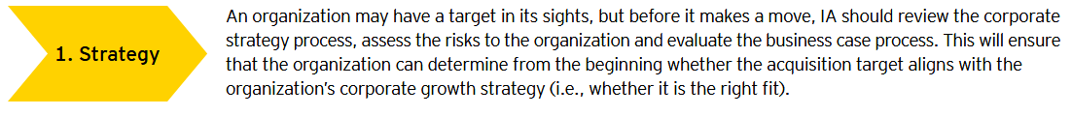

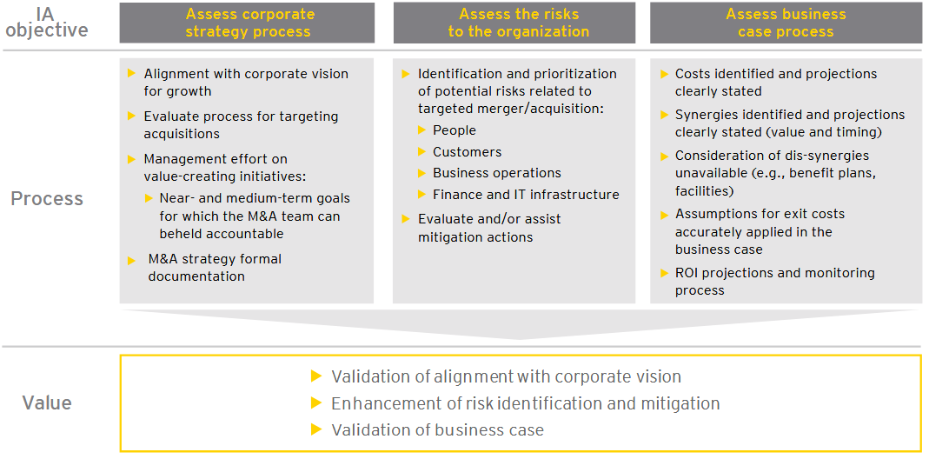

#### Due Diligence

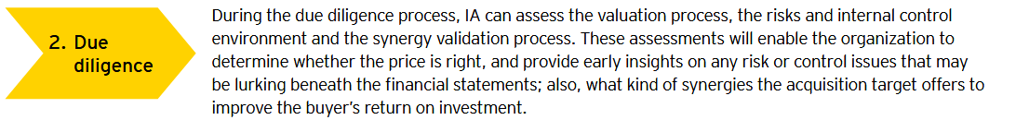

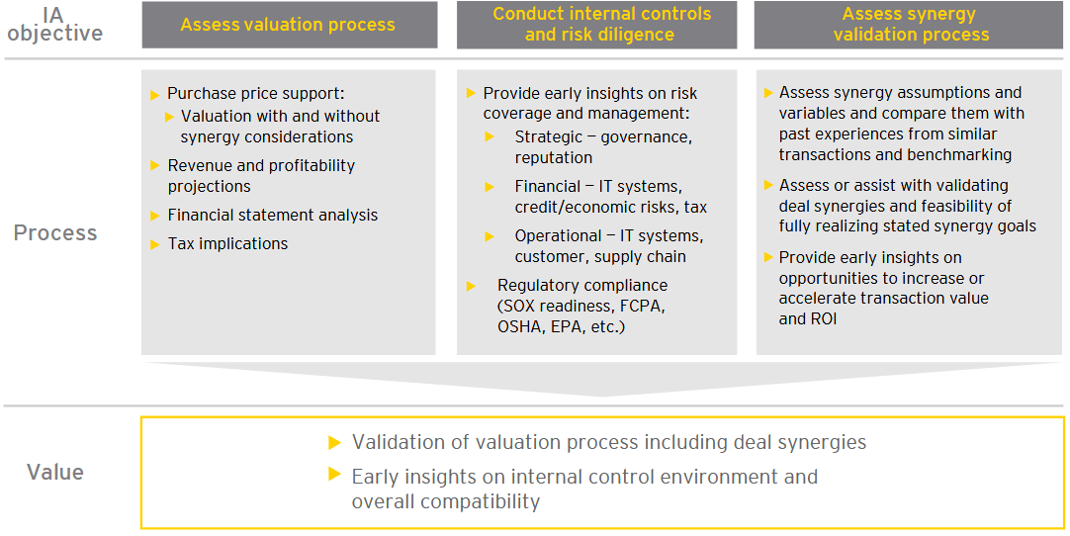

#### Deal Approval and Close

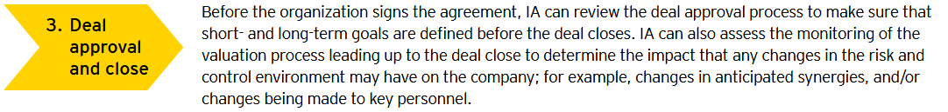

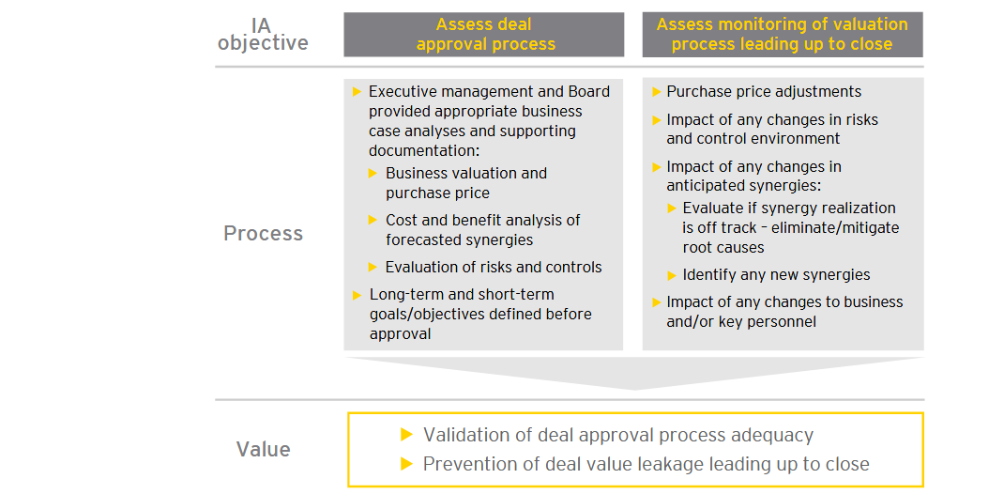

#### Integration

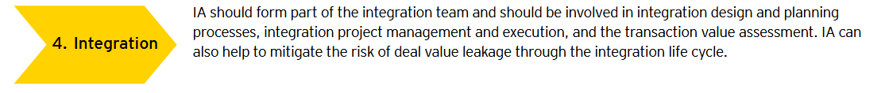

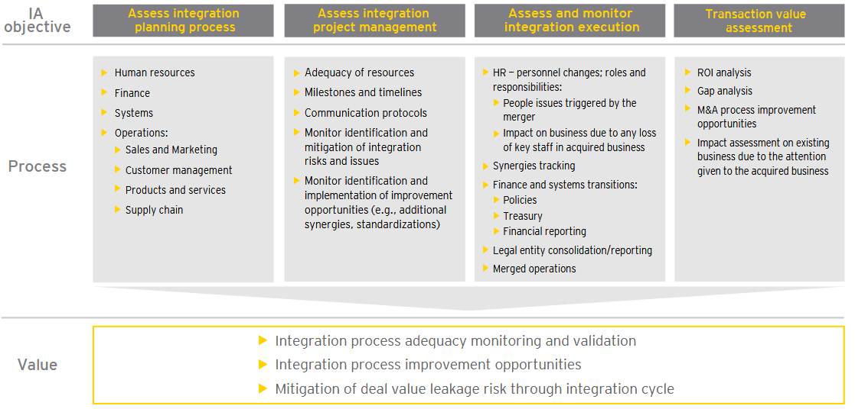

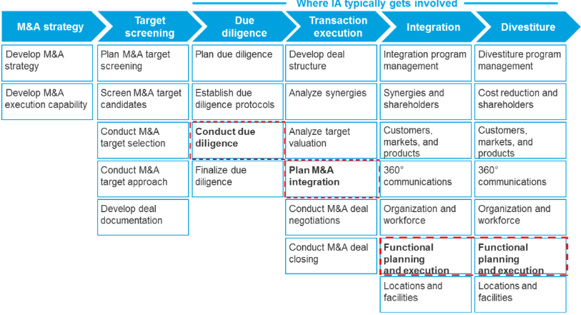

## Audit Agile Projects

**Audit data**: ➊**Development**. Ensure it is planned using agile planning / continuous integration; changes are communicated across teams; environments appropriate & available timely; watch rework following redesign / after bug fixing; watch process to get customer or business change into an assessment: how fast? barriers and points where project fails to perform ➋**Design**. Ensure there IS a design process, no programming hacking without design considerations, design is shared, is performed in agile, change is performed, change is welcomed and encouraged where necessary, daily meetings record element of design changes sufficient for audit ➌**Management**. Ensure delivered using agile approach, commitments are examined, daily meetings taking place, assessments being performed, teams engaged, manager regularly examining team, coaching taking place, all management stakeholders are in place, communicating their commitment, and team is delivering in high performance manner ➍**Process**. Understand if commitments made at the outset are being maintained. Examine how well the agile approach is improving the performance of the project delivery environment and therefore the organisation. **Auditing Guidelines** ➊Audit be non-intrusive ➋Audit not trigger creation of for-Auditor-only documents ➌Generic Scrum checklist tailored to project requirements as basis for audit ➍Auditor is assigned to an entire Sprint per Internal Audit Plan ➎Auditor silent observer of Sprint ➏Auditor added to team mailing list to receive all communications; provided access to all artifacts; attends Sprint Planning, a few Daily Scrum meetings, Sprint Review, Sprint Retrospective meetings. ➐Auditor not schedule formal audit meetings with team members but seek clarifications from ScrumMaster and/or Product Owner during Sprint. ➑Auditors prepare audit report recording their observations and findings against the items in the checklist. Encouraged to go beyond checklist and provide suggestions for improvement. Audit Report presented to Team preferably immediately after Sprint Retrospective meeting. ➒Non-conformances are addressed in forthcoming Sprints and verified by the Auditor.

## Audit AI

**Framework Strategy**: Does the organization have a defined strategy? Is it investing in AI research and development? Does it have plans in place to identify and address AI threats and opportunities? **AI Components** ➊**AI Governance**: structures, processes, procedures implemented to direct, manage, and monitor the AI activities ➋**Data Architecture and Infrastructure**: how data is accessed data is accessible (metadata, taxonomy, unique identifiers, naming conventions)? Information privacy and security throughout the data lifecycle (data collection, use, storage, destruction)? Roles and responsibilities for data ownership & use throughout the data lifecycle? ➌**Data Quality**: completeness, accuracy, and reliability of the data on which AI algorithms are built ➍**AI Performance** ➎**Human Factor**: Risk of unintended human biases factored into AI design is identified and managed ? AI tested to ensure that results reflect the original objective? AI technologies can be transparent given the complexity involved? AI output is being used legally, ethically, responsibly ➏**Black Box Factor**: Type III/Type IV AI technologies — utilizing machines or platforms that can learn on their own or communicate with each other

## Audit Big Data

#### Stakeholders



#### Risk and Control

##### Program governance

**Key Risk:** Lack of appropriate management support, funding, and/or governance over big data program can expose org. to undue risk or failure to meet strategic goals

**Control Activities**

* Funding should be adequate to support business needs.
* Program objectives should support enterprisewide strategy initiatives.
* Management should receive metrics that demonstrate achievement of goals.
* The organization should establish a governing entity to manage the big data strategy.
* There should be agreed-upon SLAs between the business and IT to describe and measure performance expectations.
* Business and technical requirements should be documented, analyzed, and approved.
* Executive management should develop big data strategy that provides solutions across org.
* Prior to approving the business case, management should conduct a proof of concept to validate that the systems designs align with strategic goals.
* Roles and responsibilities should be clear and well defined.
* Organization should provide necessary resources to deploy and maintain the big data strategy.
* Third-party vendor management best practices should be used to manage big data suppliers.

##### Technology availability and performance

**Key Risk:** Ineffective technology solutions and/or configurations may result in a negative customer experience, reduced system availability, and/or degraded performance.

**Control Activities**

* IT operations should be structured in a manner that supports big data service level expectations.
* Data lifecycle policies and procedures should be documented and followed.
* Big data systems should be part of the maintenance strategy.
* Big data systems should be part of the change management strategy.
* Big data systems should be included in the patch management strategy.
* Big data systems should be procured, built, and/or configured in alignment with the complexity and demands documented in the business case.
* Systems and support tools should be configured to provide automatic notifications to support personnel.
* Reporting tools should be configured to be flexible, intuitive, and easy to use; and training aids should be provided.
* Big data systems should be configured to allow flexibility and scalability without sacrificing performance.
* Periodic performance testing should be conducted and weaknesses should be remediated.
* The big data systems lifecycle should be managed properly.
* IT general controls should be assessed periodically

##### Security and privacy

**Key Risk:** Ineffective information security standards and configurations may result in unauthorized access to/ theft of data, inappropriate modifications of data, and regulatory compliance violations

**Control Activities**

* Information security management should be part of the big data strategy.
* Data security management should be part of the big data strategy.
* Third-party access should be managed properly.
* Data privacy should be part of the big data strategy

##### Data quality, management, and reporting

**Key Risk:** Data quality issues and/or inaccurate reporting may lead to inaccurate management reporting and flawed decision making.

**Control Activities**

* Policies and procedures should be established to ensure data quality.
* Policies and procedures should be established to ensure that data obtained from third parties complies with data quality standards.
* Policies and procedures should be established to ensure reporting accuracy.
* Access to reports should be granted based on business needs.
* Reporting tools and procedures should allow for flexibility and ad-hoc reporting.
* Users should be trained periodically to maximize report utility.
* Selection of vendors who provide reporting products & services should align with business needs

## Audit Cloud





#### Security Controls



#### Auditing SAAS

•Customisable reports •Application Functionality Configuration options •Application Security configuration options (aka ERP configurable controls) •User driven data export /interface capabilities •Limited or nil involvement in application development life cycle •CAAT development is challenging •Logs for access controls, Transaction activity, Change management etc. •Existence of myriad of logs •Need automation to map controls to Key Risk Indicators – KRIs •Opportunities to leverage cloud infrastructure - it is more cost effective and efficient to develop on demand , elastic audit databases, implement audit automation





#### Context



#### Risks

➊Account lock-out/resource hijacking? ➋Misconfiguration leading to breach (e.g. S3)? ➌Loss of control? ➍Asymmetries between the provider and customer? ➎Comingling of data / multi-tenancy? ➏Jurisdictional? ➐Who should make risk decisions?

#### Service Layer

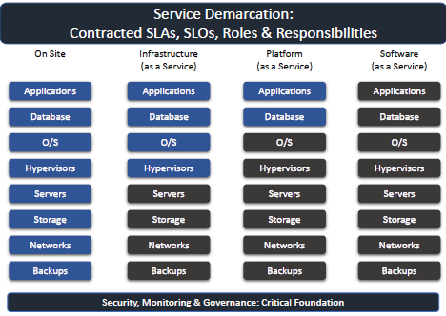

#### IT Functions

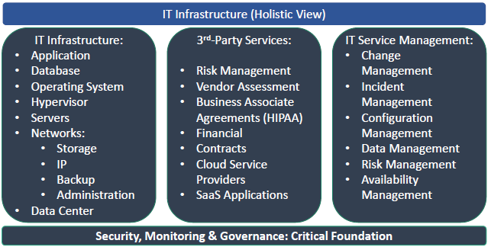

#### Incident Management

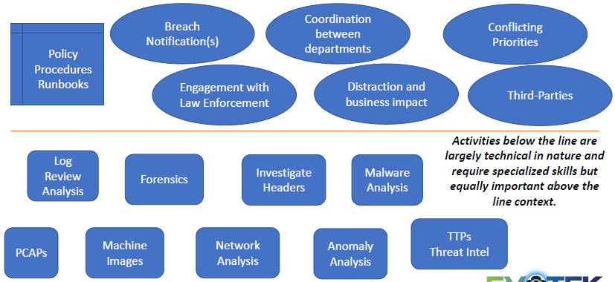

## ISACA Audit Cloud

#### 1. PLANNING AND SCOPING THE AUDIT

**1.1 Define audit/assurance objectives (high level and describe the overall audit goals)**

1.1.1 Review the audit/assurance objectives in the introduction to this audit/assurance program.

1.1.2 Modify the audit/assurance objectives to align with the audit/assurance universe, annual plan and charter.

**1.2 Define the boundaries of review. The review must have a defined scope. Understand the core business process and its alignment with IT, in its noncloud form and current or future cloud implementation.**

1.2.1 Obtain a description of all cloud computing environments in use and under consideration.

1.2.2 Obtain a description of all cloud computing applications in use and under consideration.

1.2.3 Identify the types of cloud services (IaaS, PaaS, SaaS) in use and under consideration, and determine the services and business solutions to be included in the review.

1.2.4 Obtain and review any previous audit reports with remediation plans. Identify open issues, and assess updates to the documents with respect to these issues.

**1.3 Identify and document risk.** The risk assessment is necessary to evaluate where audit resources should be focused. The risk-based approach assures utilization of audit resources in the most effective manner.

1.3.1 Identify the business risk associated with cloud computing of concern to business owners and key stakeholders.

1.3.2 Verify that the business risk is aligned, rated or classified with cloud computing security criteria such as confidentiality, integrity and availability.

1.3.3 Review previous audits of cloud computing.

1.3.4 Determine if the risk identified previously has been appropriately addressed.

1.3.5 Evaluate the overall risk factor for performing the review.

1.3.6 Based on the risk assessment, identify changes to the scope.

1.3.7 Discuss the risk with IT management, and adjust the risk assessment.

1.3.8 Based on the risk assessment, revise the scope.

**1.4 Define the change process.** The initial audit approach is based on the reviewer’s understanding of the operating environment and associated risk. As research and analysis are performed, changes to the scope and approach may result.

1.4.1 Identify the senior IT assurance resource responsible for the review.

1.4.2 Establish the process for suggesting and implementing changes to the audit/assurance program and the authorizations required.

**1.5 Define assignment success.** The success factors need to be identified. Communication among the IT audit/assurance team, other assurance teams and the enterprise is essential.

1.5.1 Identify the drivers for a successful review (this should exist in the assurance function’s standards and procedures).

1.5.2 Communicate success attributes to the process owner or stakeholder, and obtain agreement.

**1.6 Define the audit/assurance resources required.** The audit/assurance resources required for a successful review need to be defined. (Refer to the Minimum Audit Skills section in section V.)

1.6.1 Determine the audit/assurance skills necessary for the review.

1.6.2 Estimate the total audit/assurance resources (hours) and time frame (start and end dates) required for the review.

**1.7 Define deliverables.** The deliverable is not limited to the final report. Communication between the audit/assurance teams and the process owner about the number, format, timing and nature of deliverables is essential to success.

1.7.1 Determine the interim deliverables, including initial findings, status reports, draft reports, due dates for responses or meetings, and the final report.

**1.8 Communications.** The audit/assurance process must be clearly communicated to the customer/client.

1.8.1 Conduct an opening conference to discuss: • Review objectives with the stakeholders • Documents and information security resources required to effectively perform the review • Timelines and deliverables

#### 2. GOVERNING THE CLOUD

##### 2.1 Governance and Enterprise Risk Management (ERM)

2.1.1 Governance - Audit/Assurance Objective: Governance functions are established to ensure effective and sustainable management processes that result in transparency of business decisions, clear lines of responsibility, information security in alignment with regulatory and customer organization standards, and accountability.

2.1.1.1 Governance Model - Control: The organization has mechanisms in place to identify all providers and brokers of cloud services with which it currently does business and all cloud deployments that exist across the enterprise. The organization ensures that customer, IT, information security and business units actively participate in the governance and policy activities to align business objectives and information security capabilities of the service

provider with those of the organization.

2.1.1.1.1 Determine if the IT, information security and key business functions have defined integrated governance framework and monitoring processes.

2.1.1.1.2 Determine if the IT, information security functions and key business units are actively involved in the establishment of SLAs and contractual obligations.

2.1.1.1.3 Determine if the information security function has performed a gap analysis of the service provider’s information security capabilities against the organization’s information security policies and threat and vulnerabilities/IT risk emanating from the transition to cloud computing.

2.1.1.1.4 Determine if the cloud provider has identified control objectives for the provided services.

2.1.1.1.5 Determine if the organization maintains an inventory of all services provided via the cloud.

2.1.1.1.6 Determine that the business cannot procure cloud services without the involvement of IT and information security.

2.1.1.2 Information Security Collaboration - Control: Both parties define reporting relationship and responsibilities.

2.1.1.2.1 Determine if governance responsibilities documented & approved by service provider & customer.

2.1.1.2.2 Determine if reporting relationships between the service provider and customer are clearly defined, identifying the responsibilities of both organizations’ governance processes.

2.1.1.3 Metrics and SLAs - Control: SLAs that support the business requirements are defined, accepted by the service provider and monitored.

2.1.1.3.1 Obtain the SLAs; determine if the SLAs reflect the business requirements.

2.1.1.3.2 Determine that the SLAs can be monitored using measurable metrics and that the metrics provide appropriate oversight and early warning of unacceptable performance.

2.1.1.3.3 Determine if SLA contains clauses for services when vendor acquisition/ changes in management

2.1.2 Enterprise Risk Management - Audit/Assurance Objective: Risk management practices are implemented to

evaluate inherent risk within the cloud computing model, identify appropriate control mechanisms, and ensure that residual risk is within acceptable levels.

2.1.2.1 Identification of Risk - Control: The risk management process provides a thorough assessment of the risk to the business by implementing the cloud processing model and is aligned to ERM if applicable.

2.1.2.1.1 Determine if the organization has an ERM model.

2.1.2.1.2 If an ERM model has been implemented, determine if the cloud computing risk assessment is in alignment with the enterprise ERM.

2.1.2.1.3 Determine if the services provided by the service provider and the processing model selected will limit the availability or execution of required information security activities: • Restrictions on vulnerability assessments and penetration testing • Availability of audit logs • Access to activity monitoring reports • Segregation of duties

2.1.2.1.4 Determine if the risk management approach includes the following: • Identification and valuation of assets and services • Identification and analysis of threats and vulnerabilities with their potential impact on assets • Analysis of the likelihood of events using a scenario approach • Documented management approval of risk acceptance levels and criteria • Risk action plans (control, avoid, transfer, accept)

2.1.2.1.5 Determine if, during the risk assessment, the identified assets include both service-provider- and customer-owned assets and if the information security classifications used in the risk assessments are aligned.

2.1.2.1.6 Determine if the risk assessment includes the service model and the service provider’s capabilities and financial condition

2.1.2.2 Integration of Risk and SLAs - Control: SLAs are aligned and developed in conjunction with the results

of the risk assessment.

2.1.2.2.1 Determine if the results of the risk action plans are incorporated into the SLAs.

2.1.2.2.2 Determine if a joint service provider/customer risk assessment was conducted to verify if all reasonable risk has been identified and if risk remediation alternatives were identified and documented.

2.1.2.2.3 Where the risk assessment of the service provider has identified risk management that is either ineffective or not comprehensive, determine if the organization has performed an analysis of their compensating controls and if such controls will address the service provider’s control shortcomings.

2.1.2.3 Acceptance of Risk - Control: Risk acceptance is approved by a member of management with the authority to accept the risk on behalf of the organization and who understands the implications of the decision.

2.1.2.3.1 Determine if management has performed an analysis of their quantification and acceptance of residual risk prior to implementing a cloud solution.

2.1.2.3.2 Determine if the individual accepting such risk has the authority to make this decision.

2.1.3 Information Risk Management - Audit/Assurance Objective: A process to manage information risk exists and is integrated into the organization’s overall ERM framework. Information risk management information and metrics are available for the information security function to manage risk within the risk tolerance of the data owner.

2.1.3.1 R isk Management Framework and Maturity Model - Control: A risk management framework and a maturity model have been implemented to quantify risk and assess the effectiveness of the risk model.

2.1.3.1.1 Determine if a risk framework has been identified and approved.

2.1.3.1.2 Determine if a maturity model is used to assess the effectiveness.

2.1.3.1.3 Review the results of the maturity model results, and determine if the lack of maturity materially affects the audit objectives.

2.1.3.2 Risk Management Controls - Control: Risk management controls are in effect to manage risk-based decisions.

2.1.3.2.1 Identify the technology controls and contractual requirements necessary to make fact-based information risk decisions. Consider: • Information usage • Access controls • Security controls • Location management • Privacy controls

2.1.3.2.2 For SaaS, determine that the organization has identified analytical information required from the service provider to support contractual obligations relating to performance, security and attainment of SLAs.

2.1.3.2.3 Obtain the analytical data requirements, and determine if the organization routinely monitors and evaluates the attainment of SLAs.

2.1.3.2.4 For PaaS, determine that the organization has identified the information available and the control practices necessary to manage the application and development processes effectively that address availability, confidentiality, data ownership, concerns around e-discovery, privacy and legal issues.

2.1.3.2.5 Determine if the organization has established monitoring practices to identify risk issues.

2.1.3.2.6 For IaaS, determine that the organization has identified and monitors the control and security processes necessary to provide a secure operating environment.

2.1.3.2.7 Determine if the service provider makes available metrics and controls to assist customers in implementing their information risk management requirements.

2.1.4 Third-party Management - Audit/Assurance Objective: The customer recognizes the outsourced relationship with the service provider. The customer understands its responsibilities for controls, and the service provider has provided assurances of sustainability of those controls.

2.1.4.1 Service Provider Procedures - Control: The service provider makes available to customers independent

third-party assessments, using generally accepted audit procedures, to describe the control practices in place at the service provider’s operating locations.

2.1.4.1.1 Determine if the service provider routinely has independent third-party assessments performed and issued.

2.1.4.1.2 Determine if the scope of the third-party assessment includes descriptions of the following service provider processes: • Incident management • Business continuity and disaster recovery • Backup and co-location facilities

2.1.4.1.3 Determine if the service provider routinely performs internal assessments of conformance to its own policies, procedures and availability of control metrics.

2.1.4.2 S ervice Provider Responsibilities - Control: The service provider has established processes to align its

operations with requirements of the customer.

2.1.4.2.1 Determine if the service provider’s information security governance, risk management and compliance processes are routinely assessed and include: • Risk assessments and reviews of facilities and services for

control weaknesses • Definition of critical service and information security success factors and key performance indicators • Frequency of assessments • Mitigation procedures to ensure timely completion of identified issues • Review of legal, regulatory, industry and contractual requirements for comprehensiveness • Cloud service provider’s oversight of risk from its own critical vendors • Terms of use due diligence to identify roles, responsibilities and accountability of the service provider • Legal review for local contract provisions, enforceability and laws pertaining to jurisdictional issues that are the responsibility of their service provider

2.1.4.3 Customer Responsibilities - Control: The customer performs due diligence processes to ensure sustainability and compliance with regulatory requirements.

2.1.4.3.1 Determine if the customer has performed due diligence with respect to the service provider’s information security governance, risk management and compliance processes as described under 2.1.4.2 Service Provider Responsibilities.

2.1.4.3.2 Determine if the customer has prepared for the loss of service provider services: • A business continuity and disaster recovery plan for various processing interruption scenarios • Tests of business continuity and disaster plan • Inclusion of the business users and their business impact analysis in the continuity plan

##### 2.2 Legal and Electronic Discovery

2.2.1 Contractual Obligations - Audit/Assurance Objective: The service provider and customer establish bilateral agreements and procedures to ensure contractual obligations are satisfied, and these obligations address the compliance requirements of both the customer and service provider.

2.2.1.1 Contract Terms - Control: A contract team representing customer’s legal, financial, information security and business units has identified and included contractual issues in the contract from the customer’s perspective, and the service provider’s legal team has provided contractual assurance to the satisfaction of the customer.

2.2.1.1.1 Determine if the contractual agreement defines both parties’ responsibilities related to discovery searches, litigation holds, preservation of evidence and expert testimony.

2.2.1.1.2 Determine that the service provider contract requires assurance to the customer that their data are preserved as recorded, including the primary data and secondary information (metadata and logs).

2.2.1.1.3 Determine that service providers understand their contractual obligations to provide guardianship of the customer’s data. Review contracts to determine this is specifically addressed.

2.2.1.1.4 Determine that the customer’s duty of care includes full scope of contract monitoring, including: • Precontract due diligence • Contract term negotiation • Transfer of data custodianship • Contract termination or renegotiation • Transition from processing

2.2.1.1.5 Determine that the contract stipulates and both parties understand their obligations for both expected and unexpected termination of the relationship during and after negotiations and that the contract and/or precontract agreement provides for the orderly and timely return or secure disposal of assets.

2.2.1.1.6 Determine that the contractual obligations specifically identify suspected data breach responsibilities of both parties and cooperative processes to be implemented during the investigation and any follow-up actions.

2.2.1.1.7 Determine that the agreement provides for the customer to have access to the service provider’s performance and tests for vulnerabilities on a regular basis.

2.2.1.1.8 Determine that the contract establishes rights and obligations for both parties during transition at the conclusion of the relationship and after the contract terminates.

2.2.1.1.9 Determine if the contract establishes the following data protection processes: • Full disclosure of the service provider’s internal security practices and procedures • Data retention policies in conformance with local jurisdiction requirements • Reporting on geographical location of customer data • Circumstances in which data can be seized and notification of any such events • Notification of subpoena or discovery concerning any customer data or processes • Penalties for data breaches • Protection against data contamination between customers (compartmentalization)

2.2.1.1.10 Encryption requirements for data in transit, at rest and for backup are clearly identified in the cloud contractual agreement.

2.2.1.2 Implementation of Contractual Requirements - Control: The customer has implemented appropriate monitoring controls to ensure contractual obligations are satisfied.

2.2.1.2.1 Determine that the customer has considered and established controls within the contractual obligations to ensure retention of data and intellectual property ownership and the privacy of personal data contained within its data.

2.2.1.2.2 Determine that the customer has developed appropriate issue monitoring processes to oversee the service provider’s performance of contract requirements.

2.2.1.2.3 Determine that the customer has established internal issue monitoring to identify customer contractual compliance deficiencies.

2.2.2 L egal Compliance - Audit/Assurance Objective: Legal issues relating to functional, jurisdictional and contractual requirements are addressed to protect both parties, and these issues are documented, approved and monitored.

2.2.2.1 Legal Compliance - Control: Legal compliance to local and cross-border laws are defined as a component of the contract.

2.2.2.1.1 Determine if cross-border and local laws are defined and considered in the contract

2.2.2.1.2 Determine if the service provider and customer have an agreed-upon unified process for responding to subpoenas, service of process, and other legal requests.

##### 2.3 Compliance and Audit

2.3.1 Right to Audit - Audit/Assurance Objective: The right to audit is clearly defined and satisfies the assurance requirements of the customer’s board of directors, audit charter, external auditors and any regulators having jurisdiction over the customer.

2.3.1.1 Audit Rights per Contract - Control: The audit rights, as agreed in the contract, permit the customer to conduct professional control assessments.

2.3.1.1.1 Review the audit rights in the contract, and determine if audit activities can be restricted or curtailed by the service provider.

2.3.1.1.2 If audit rights issues are identified, prepare an appropriate summary of the findings and escalate to service provider relationship management. If necessary and appropriate, escalate to the audit committee.

2.3.1.2 Third-party Reviews - Control: The service provider submits third-party reviews that satisfy the professional requirements of being performed by a recognized independent audit organization. The report describes the controls in place by the service provider and certifies that the controls have been tested using recognized selection criteria. A test period previously agreed upon provides a description of recommended customer and service provider responsibilities and controls.

2.3.1.2.1 Obtain the third-party report.

2.3.1.2.2 Determine that the report addresses the control environment utilized by the customer.

2.3.1.2.3 Determine that the descriptions and processes are relevant to the service provider’s customers.

2.3.1.2.4 Determine that the report has described the key controls necessary for the reviewer to assess compliance with appropriate control objectives.

2.3.1.2.5 Determine that the report and testing will satisfy the customer’s assurance charter and compliance requirements of all regulators having jurisdiction over the customer.

2.3.1.2.6 Using the approved customer audit universe, compare the scope of the audit universe to the scope of the third-party report; identify gaps in the latter requiring additional assurance coverage.

2.3.1.2.7 Determine if the service provider relationship crosses international boundaries and if this affects the ability to rely upon the third-party report.

2.3.2 Auditability - Audit/Assurance Objective: The service provider’s operating environment should be subject to audit to satisfy the customer’s audit charter, compliance requirements and good practice controls without restriction.

2.3.2.1 Customer Assurance Reviews of Service Provider Processes - Control: The customer performs appropriate reviews to supplement and/ or replace third-party reviews as required by their audit universe and audit charter.

2.3.2.1.1 Determine if supplementary assurance assessments (if a third-party review has been provided) or primary assurance assessments are required

2.3.2.1.2 Generate appropriate requests to the service provider, and schedule reviews. Note: Utilize appropriate audit/assurance programs for these reviews.

2.3.3 Compliance Scope - Audit/Assurance Objective: The use of cloud computing does not invalidate or violate any customer compliance agreement.

2.3.3.1 Feasibility of Data Security Compliance - Control: Data regulations are identified by compliance topic and are mapped to the regulator’s requirements. Gaps are evaluated to determine if the cloud computing platform will invalidate or breach compliance requirements.

2.3.3.1.1 Determine if the customer has identified the legal and regulatory requirements of which it must comply (i.e., EU Data Directive, PCAOB AS5, PCI DSS, HIPAA).

2.3.3.1.2 Determine if the customer has aggregated requirements to minimize duplication.

2.3.3.1.3 Using the documentation assembled in the Governance and Enterprise Risk Management, Legal and Electronic Discovery, and Right to Audit sections, perform a gap analysis against the data regulations to determine if there are any regulatory requirements that cannot be satisfied by the cloud computing model.

2.3.3.2 Data Protection Responsibilities - Control: The deployment scenario (IaaS, PaaS, SaaS) defines the data

protection responsibilities between the customer and service provider, and these responsibilities are clearly established contractually.

2.3.3.2.1 Determine that the responsibilities for data protection are based on the risk for the deployment scenario.

2.3.3.2.2 Review the contract to determine the assignment of responsibilities.

2.3.3.2.3 Based on the contract, determine if the customer and service provider each have established appropriate data protection measures within the scope of their responsibilities.

2.3.4 ISO 27001 Certification - Audit/Assurance Objective: Service provider security assurance is provided through ISO 27001 Certification.

2.3.4.1 ISO Information Security Certification - Control: ISO 27001 certification provides assurance of the service

provider’s adherence to best-practice security processes.

2.3.4.1.1 Determine if the service provider has received ISO 27001 certification. If so, adjust the scope of the audit/assurance program to reflect this certification.

##### 2.4 Portability and Interoperability

2.4.1 Service Transition Planning - Audit/Assurance Objective: Planning for the migration of data, such as formats

and access, is essential to reducing operational and financial risk at the end of the contract. The transition of services should be considered at the beginning of contract negotiations.

2.4.1.1 Portability - Control: Procedures, capabilities and alternatives are established, maintained and tested, and a state of readiness has been established to transfer cloud computing operations to an alternate service provider in the event that the selected service provider is unable to meet contractual requirements or ceases operations.

2.4.1.1.1 All cloud solutions

2.4.1.1.1.1 Determine that the hardware and software requirements and feasibility for moving from the existing service provider (legacy provider) to another provider (new provider) have been documented for

each cloud computing initiative.

2.4.1.1.1.2 Determine that an alternate service provider for each legacy service provider has been identified and that the feasibility for transferring processes has been evaluated.

2.4.1.1.1.3 Determine if the feasibility analysis includes procedures and time estimates to move large volumes of data, if applicable.

2.4.1.1.1.4 Determine if the portability process has been tested.

2.4.1.1.2 IaaS cloud solutions

2.4.1.1.2.1 Determine if the feasibility analysis of transferring from the IaaS legacy service provider involves

any proprietary functions or processes that would preclude or delay the transferring of operations.

2.4.1.1.2.2 Determine if the portability analysis includes processes to protect the intellectual property and

data from the legacy service provider once the transfer has been completed.

2.4.1.1.3 PaaS cloud solutions

2.4.1.1.3.1 Determine if the feasibility analysis includes identification of application components and modules that are proprietary and would require special programming during transfer.

2.4.1.1.3.2 Determine if the portability analysis includes: • Translation functions to a new service provider • Interim processing until a new service provider is operational • Testing of new processes before promotion to a production environment at the new service provider

2.4.1.1.4 SaaS cloud solutions

2.4.1.1.4.1 Determine if the portability analysis includes:

• A plan to back up the data in a format that is usable by other applications • Routine backup of data • Identification of custom tools required to process the data and plans to redevelop • Testing of the new service provider’s application and due diligence before conversion

#### 3. OPERATING IN THE CLOUD

##### 3.1 Incident Response, Notification and Remediation

Audit/Assurance Objective: Incident notifications, responses, and remediation are documented, timely, address the risk of the incident, escalated as necessary and are formally closed.

3.1.1 Incident Response - Control: The contract SLAs describe specific definitions of incidents (data breaches, security violations) and events (suspicious activities) and the actions to be initiated by and the responsibilities of both parties.

3.1.1.1 Obtain and review the SLAs per the contract to determine that incidents and events are clearly defined and responsibilities assigned.

3.1.1.2 Review cooperation agreements, and evaluate the responsibilities for the investigation of incidents.

3.1.1.3 Notification procedures according to local laws are incorporated into the incident and event process.

3.1.2 Service Provider Issue Monitoring - Control: Issue monitoring processes are implemented and actively used by the service provider to document and report all defined incidents.

3.1.2.1 Obtain and review the service provider’s issue monitoring procedures.

3.1.2.2 Determine if the monitored reporting requirements are aligned with the customer’s incident reporting policy.

3.1.2.3 Obtain the incident monitoring reports for a representative period of time.

3.1.2.3.1 Determine that the: • Customer was notified of the incident within the SLA requirements • Remediation was timely based on the scope and risk of the incident • Remediation was appropriate • Issue was escalated, if appropriate • Issue was closed and the customer notified in a timely manner

3.1.3 Customer Issue Monitoring - Control: The customer has established an issue monitoring process to track internal and service provider incidents.

3.1.3.1 Obtain the customer incident monitoring procedure.

3.1.3.2 Determine if the incident monitoring procedure tracks both internal and service provider incidents.

3.1.3.3 Select a sample of incidents, and determine that: • The service provider notified the customer on a timely basis within scope of the contract. • The remediation was timely based on the scope and risk of the incident. • The remediation was appropriate. • The issue was escalated within the service provider’s hierarchy. • The issue was closed by the service provider. • The issue was monitored and reported to customer management. • Customer procedures were modified to recognize the increased risk. • Internal customer incidents were recorded by the customer, appropriately reported, remediated and closed.

##### 3.2 Application Security

3.2.1 Application Security Architecture - Audit/Assurance Objective: Applications are developed with an understanding of the interdependencies inherent in cloud applications, requiring a risk analysis and design of configuration management and provisioning process that will withstand changing application architectures.

3.2.1.1 Application Security Architecture - Control: The design of cloud-based applications includes information security and application security architecture subject matter experts, and the process focuses on the interdependencies inherent in cloud applications.

3.2.1.1.1 Obtain the application design documentation, and review the policies for subject matter expert involvement in the system design.

3.2.1.1.2 Determine that information security and architecture specialists have been fully engaged during the planning and deployment of cloud applications.

3.2.1.1.3 Select recent implementations, and review the project and development plans for evidence of information security and subject matter expert involvement.

3.2.1.2 Configuration Management and Provisioning - Control: Configuration management and provisioning procedures are segregated from the service provider, limited to a security operations function within the customer’s organization and provide audit trails to document all activities.

3.2.1.2.1 Obtain the configuration management and provisioning security architecture.

3.2.1.2.2 Determine if the service provider is prevented from configuring or provisioning users (both administrative and standard users), which may affect data integrity, access or security.

3.2.1.2.3 Determine if logs and audit trails exist, record these activities and how they are monitored and reviewed.

3.2.2 Compliance - Audit/Assurance Objective: Compliance requirements are an integral component of the design and implementation of the application security architecture.

3.2.2.1 Compliance - Control: The SDLC includes processes to ensure compliance requirements are identified, mapped to the cloud-based application, and included in the final product. Compliance gaps are escalated to appropriate senior management for waiver approval.

3.2.2.1.1 Obtain compliance analysis utilized as basis for authorizing the initiation of a cloud-based application.

3.2.2.1.2 Determine if a formal compliance review is performed and if senior management authorization is required where internal information security policies require a waiver to allow the implementation of the cloud-based application.

3.2.3 Tools and Services - Audit/Assurance Objective: Use of development tools, application management libraries and other software are evaluated to ensure their use will not negatively impact the security of applications.

3.2.3.1 Tools and Services - Control: All tools and services used in the development, management and monitoring of applications are itemized and the ownership documented, and their effect on the security of the application is explicitly analyzed. High-risk tools and services are escalated to senior information management for approval.

3.2.3.1.1 Obtain an analysis of tools and services in use.

3.2.3.1.2 Determine if the ownership of each tool and service has been identified.

3.2.3.1.3 Determine if information security risk was evaluated for each tool and service. If one is deemed a security risk, determine the disposition (escalation, waiver to use or disallow use of software in a cloud environment).

3.2.3.1.4 Examine examples of escalated requests, and determine the adherence to procedures.

3.2.4 Application Functionality - Audit/Assurance Objective: For SaaS implementations, the application outsourced to the cloud contains the appropriate functionality and processing controls required by the customer’s control policies within the processing scope (financial, operational, etc.).

3.2.4.1 Application Functionality - Control: The application functionality is subject to an assurance review as part of the customer’s application process assurance audit.

3.2.4.1.1 Refer to a standard application audit program for specific steps.

##### 3.3 Data Security and Integrity

3.3.1 Encryption - Audit/Assurance Objective: Data are securely transmitted and maintained to prevent unauthorized access and modification.

3.3.1.1 Data in Transit - Control: Data in transit are encrypted over networks with private keys known only to the customer.

3.3.1.1.1 Obtain the encryption policies and procedures for data in transit

3.3.1.1.2 Evaluate if the encryption processes include the following: • Classification of data traversing cloud networks (top secret, confidential, company confidential, public) • Encryption technologies in use • Key management (see key management analysis in section 3.3.2) • A list of external organizations of the customer that have decryption keys to data in transit

3.3.1.2 Data at Rest - Control: Data stored in live production databases on cloud systems are encrypted, with knowledge of the decryption keys limited to the customer.

3.3.1.2.1 Obtain the encryption policies and procedures for data stored on cloud systems.

3.3.1.2.2 For SaaS implementations, determine if the service provider has implemented data at rest encryption.

3.3.1.2.3 Determine if sensitive data need to be exclusively stored on customer systems to satisfy customer policy, regulatory or other compliance requirements.

3.3.1.2.4 Evaluate if the encryption processes include the following: • Classification of data stored on cloud networks (top secret, confidential, company confidential, public) • Encryption technologies in use • Key management (see key management analysis section 3.3.2) • A list of external organizations of the customer that have decryption keys to data at rest

3.3.1.3 Data Backup - Control: Data backups are available encrypted.

3.3.1.3.1 Obtain data backup policies and procedures for data backups of cloud-based data.

3.3.1.3.2 Determine if data are encrypted to prevent unauthorized access and disclosure of confidential data.

3.3.1.3.3 Determine if the encryption key structure provides adequate data confidentiality.

3.3.1.3.4 Assess if backup processes provide the ability to restore configurations and data for a predetermined period to allow for forensic and other evaluation activities.

3.3.1.3.5 Determine if tests of data restoration are performed on a routine basis.

3.3.1.4 Test Data Confidentiality - Control: Test data do not contain and are prohibited from using copies of any current or historical production data containing sensitive/confidential information.

3.3.1.4.1 Obtain testing policies and standards.

3.3.1.4.2 Determine if policies specifically exclude the use of any current or historical production data.

3.3.1.4.3 Perform sampling procedures to determine compliance with the test data prohibition policy.

3.3.2 Key Management - Audit/Assurance Objective: Encryption keys are securely protected against unauthorized access, separation of duties exists between the key managers and the hosting organization, and keys are recoverable.

3.3.2.1 Secure Key Stores - Control: The key stores are protected during transmission, storage and back up.

3.3.2.1.1 Obtain an understanding of how the key stores are protected.

3.3.2.1.2 Evaluate access controls, transmission controls and backup to ensure that the key stores are in the possession of the key managers.

3.3.2.1.3 Identify potential access breaches to key stores, and identify compensating controls.

3.3.2.2 Access to Key Stores - Control: Key stores access is limited to the key managers whose jobs are separated from the process the key stores protect.

3.3.2.2.1 Identify the key store managers.

3.3.2.2.2 Perform a separation of duties analysis to determine the specific functional transactions to which the key store managers have access.

3.3.2.2.3 Evaluate if the positions of key store managers and their access to key stores creates a vulnerability to data confidentiality or integrity.

3.3.2.2.4 Determine if the service provider has access to the keys and has the procedures and oversight to ensure the confidentiality of customer data.

3.3.2.2.5 Determine if appropriate controls protect the keys during generation and disposal.

3.3.2.3 Key Backup and Recoverability - Control: Key backup and recoverability have been established and tested

to ensure continued access to data keys.

3.3.2.3.1 Obtain the backup and recovery policies and procedures.

3.3.2.3.2 Perform a risk assessment, with known vulnerabilities, to determine that the key backups would be available and recovery would be assured.

3.3.2.3.3 Determine if a key recovery test process exists and is routinely executed.

3.3.2.3.4 Review recent key recovery tests. Evaluate the validity of each test, the analysis and remediation process used, and the preparedness for key restoration.

##### 3.4 Identity and Access Management

3.4.1 Identity and Access Management - Audit/Assurance Objective: Identity processes assure only authorized users have access to the data and resources, user activities can be audited and analyzed, and the customer has control over access management.

3.4.1.1 Identity Provisioning - Control: User provisioning (on-boarding), deprovisioning (termination) and job function changes of cloud-based applications and operating platforms are managed in a timely and controlled manner, according to internal user access policies.

3.4.1.1.1 Obtain internal provisioning/deprovisioning policies.

3.4.1.1.2 Analyze provisioning/deprovisioning policies in relation to procedures implemented for cloud systems.

3.4.1.1.3 Using the identity management section of the ISACA Identity Management Audit/Assurance Program, identify gaps in controls that require additional focus.

3.4.1.2 Authentication - Control: Responsibility for user authentication remains with the customer; single sign on and open authentication (as opposed to service provider proprietary authentication technologies) should be used.

3.4.1.2.1 For SaaS and PaaS, determine if the customer can establish trust between the internal authentication system and the cloud system.

3.4.1.2.2 Determine, where there is an option, that the nonproprietary authentication process has been implemented at the service provider.

3.4.1.2.3 If a proprietary authentication process is the only option, determine if appropriate controls are in place to: • Prevent shared user IDs • Provide adequate separation of duties to prevent service provider staff from obtaining customer identities • Provide forensic and logging functions to provide history of activities

• Provide monitoring functions to alert customer of unauthorized authentication activities

3.4.1.2.4 For IaaS: • If dedicated VPNs are implemented between the service provider and customer installations, determine if the users are authenticated at the customer network before passing transactions through the VPN. Dedicated VPNs are implemented between the service provider and customer installations to authenticate users at the customer network before passing transactions along through the VPN. • Where a dedicated VPN is not feasible, determine if recognized standard authentication formats are in use (e.g., SAML, WS-Federation) in conjunction with SSL.

3.4.1.2.5 For IaaS and private, internal cloud deployments, verify that third-party access control solutions operate effectively in virtualized and cloud environments and that event data can be aggregated and correlated effectively for management review.

3.4.1.2.6 Using the authentication section of the ISACA Identity Management Audit/Assurance Program, identify gaps in controls that require additional focus.

##### 3.5 Virtualization

3.5.1 Virtualization - Audit/Assurance Objective: Virtualization operating systems are hardened to prevent cross-contamination with other customer environments.

3.5.1.1 Virtualization - Control: Operating system isolation and security controls are implemented by the service provider to prevent unauthorized access and attacks.

3.5.1.1.1 Identify the virtual machine configuration in place.

3.5.1.1.2 Determine if additional controls have been implemented, including the following: • Intrusion detection • Malware prevention • Vulnerability scanning • Baseline management and analysis • Virtual machine image validation prior to placement in production • Preclude bypassing security mechanisms by the identification of security-related APIs in use • Separate production and testing environments • Internal organization identity management for administrative access • Timely isolation intrusion reporting

## Audit Cyber Security

#### NIST Cybersecurity Framework

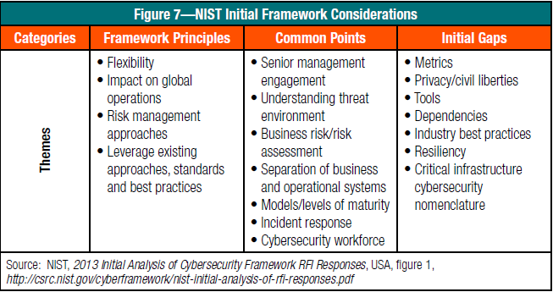

#### CSF vs. COBIT

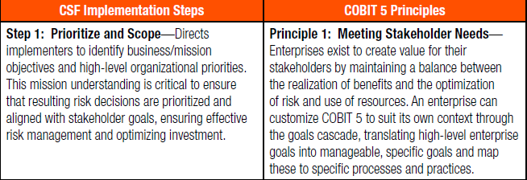

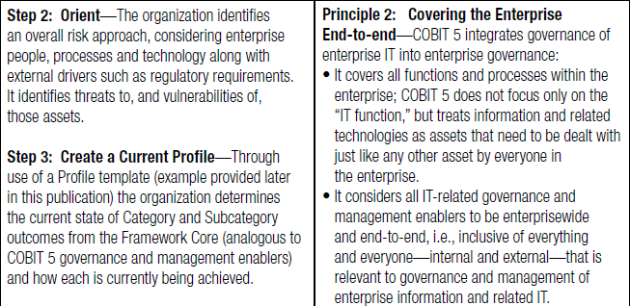

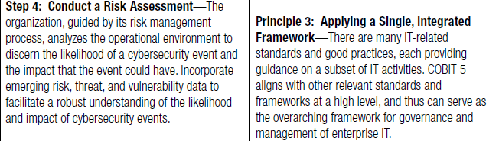

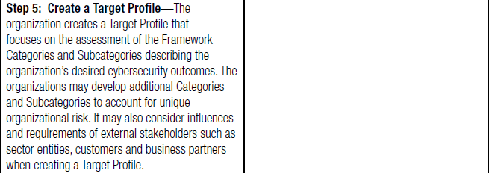

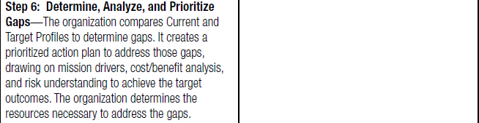

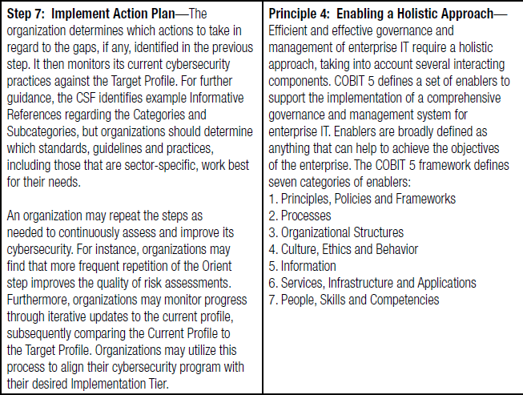

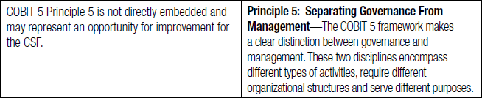

#### Three Lines of Defence

##### 1st Line of Defense (Management Controls)

* Administer security procedures, training, and testing
* Maintain secure device configurations, up-to-date software, security patches
* Deploy intrusion detection systems and conduct penetration testing
* Securely configure the network to adequately manage and protect network traffic flow
* Inventory information assets, technology devices, and related software
* Deploy data protection and loss prevention programs with related monitoring
* Restrict least-privilege access roles
* Encrypt data where feasible
* Implement vulnerability management with internal and external scans
* Recruit and retain certified IT, IT risk, and information security talent

##### 2nd Line of Defense (Risk Control & Compliance Oversight)

* Design cybersecurity policies, training, and testing
* Conduct cyber risk assessments
* Gather cyber threat intelligence
* Classify data and design least-privilege access roles
* Monitor incidents, key risk indicators, and remediation
* Recruit and retain certified IT risk talent
* Assess relationships with third parties, suppliers, and service providers
* Plan/test business continuity, and participate in disaster recovery exercises and tests

##### 3rd Line of Defense (Independent Assurance)

* Provide independent ongoing evaluations of preventive and detective measures related to cybersecurity
* Evaluate IT assets of users with privileged access for standard security configurations, problematic websites, malicious software, and data exfiltration
* Track diligence of remediation
* Conduct cyber risk assessments of service organizations, third parties, and suppliers (note: first and second lines of defense share this ongoing responsibility)

##### Red Flags Signal Potential Governance Gaps

* Disparate, fragmented governance structure
* Incomplete strategy
* Delays of cybersecurity effort
* Budget cuts and attrition
* Unclear resolve to enforce accountability

##### Cybersecurity Risk Assessment Framework

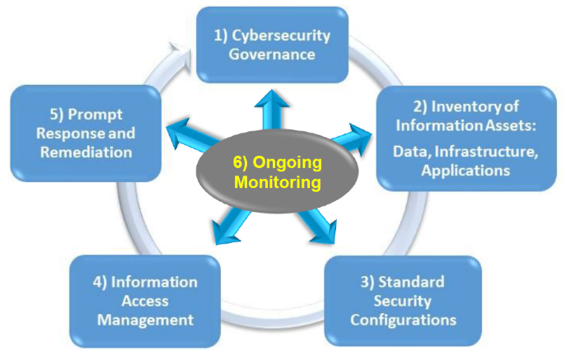

#### Cybersecurity Vulnerabilities, Threats and Risks

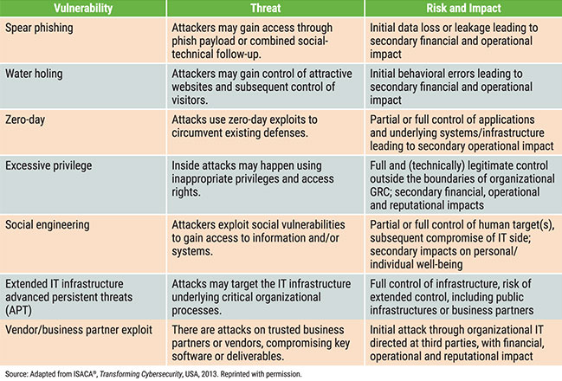

#### Cybersecurity Audit Objectives

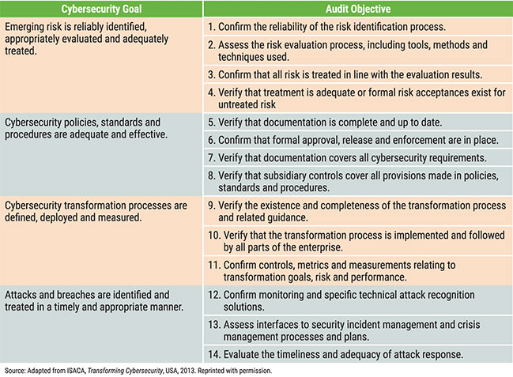

## AUDIT APP CONTAINER

* Risk analysis and management
* Security awareness and training
* Images
* Registry
* Orchestrator
* Application security during development
* Secure connections
* Hardening
* Container destruction

## Audit DEVOPS-CI/CD

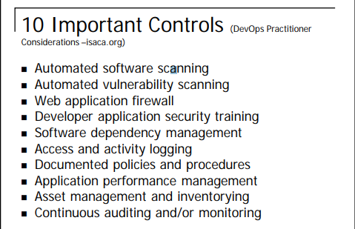

|  |  |  |  |
| --- | --- | --- | --- |
| Control | Purpose | Implementation | Assessment Criteria |
| Automated  software  scanning | A fast release cycle can make it harder to review developed software for security or coding issues. An automated scan during the release process can look for these issues without interrupting the release path | Implement via an automated dynamic or static scanning that triggers as part of the build, testing or release process. Severe issues may warrant further review while lower-priority issues (based on risk tolerance) might be flagged for mitigation in  subsequent releases. | • Observe that application code scanning software is in place and kept current as new attacks are discovered.  • Examine evidence such as log files to ensure that automated code scans are completed as part of release process. |
| Automated  vulnerability  scanning | Tools s.a. Puppet and Chef provide automated configuration anagement  functionality. Changes to configuration can impact the security of production platforms. An automated scan as part of the release process can locate those issues without introducing  a bottleneck. | Implement via an automated vulnerability assessment that triggers as part of the release process. Severe issues may warrant further review while lower-priority issues (based on risk tolerance) might be flagged for mitigation in subsequent releases. | • Observe that vulnerability assessment software is in place and kept current as new attacks are discovered.  • Examine evidence such as log files to ensure that automated vulnerability scans are completed as part of the release process |
| Web application firewall (WAF) or other layer 7 firewall | In situations where application vulnerabilities occur that cannot be remediated quickly, a WAF or other layer 7 firewall (e.g., extensible markup language (XML) firewall or Java virtual machine (VM) firewall) can provide a stopgap to mitigate the onsequences while the underlying issue is remediated. | Implement via use of an in-line proxy filter (e.g., reverse proxy or web server filter) on the web server or in the communication path. | • Observe network architecture diagrams or other documentation to ensure that a WAF or other layer 7 firewall is in place.  • Examine evidence such as log files to ensure that inbound requests are inspected by the WAF or layer 7 firewall. |
| Developer application security training | Because the path between software development and production is streamlined and automated, training can help developers avoid the inadvertent introduction of vulnerabilities | Train developers on secure coding techniques and commonly occurring application vulnerabilities such as the Open Web Application Security Project (OWASP) Top Ten | • Observe the record of attendance or participation in developer focused application security training.  • Observe training materials to ensure that commonly occurring software vulnerability issues are covered.  • Perform a periodic review of software to ensure that developers adhere to recommendations such as OWASP recommendations |
| Software dependency management | Moving to a faster pace of release and automation of build and other intermediate release processes can sometimes make it easier for developers to introduce new dependencies—e.g., new open source or other supporting libraries, new supporting components and middleware or other dependencies | Implementing a process to track these can help offset issues should security or other issues impact supporting components  and libraries. Implement tools and/or processes to inventory, track and/or otherwise manage supporting libraries and underlying application components that might be newly introduced. | • Observe that a process is in place to offset unexpected dependencies.  • Validate that a record of dependencies exists and newly introduced dependencies can be identified. |
| Access and activity logging | Separation of duties under DevOps can be fully realized by automated means (in fact, in some cases with more assurance). However, this depends on logging being enabled and logs being retained. | Implement via logging of access and developer activity that results in changes to production code. Logs should contain, at a minimum, the individual responsible for changes and the time that those changes were made. | • Observe log files to ensure that logging is enabled.  • For a sample of production changes, observe that the change can be mapped back to specific developers.  • Review a sample of historical production changes to ensure that log files are retained |
| Documented policies and procedures | DevOps processes, while automated and alacritous, should still employ rigor and discipline to ensure that security and risk  management goals are met. Having documented policies and procedures describing the release flow is advantageous. | Develop policies and procedures that outline the development and release life cycle. Include policies and procedures in developer training programs. | Review policies to ensure that they exist and cover all aspects of the production release process. |
| Application performance management (APM) | As development and operations processes become more fluid, it is important that applications continue to perform as expected and remain available to stakeholders. | Application performance management tools can help both provide metrics about application performance and flag potential problem areas when/if they occur. Establish a mechanism for tracking application performance and availability. This can encompass APM specific tools (such as commercial or open source APM products) in conjunction with processes that leverage those tools to collect metrics and drive operations tasks. | • Review operations tools to ensure that application performance and availability issues can be identified.  • Review documented processes and procedures to ensure that appropriate personnel are notified or appropriate activities are conducted in light of an issue. |
| Asset management and inventorying | As DevOps accelerates the development process, consider implementing automated or manual methods to retain a record of applications and important information about them:  • Business owner/ purpose  • Domain and subject matter experts  • Physical or virtual location  • Supporting controls and countermeasures | Utilize either an automated tool or manual processes to maintain a record of applications and supporting information about them. Establish tools and/or processes to ensure that this information is kept current and updated. | • Observe tools and/or processes used in support of the application asset management goals to ensure that they are operational.  • Review the master inventory for accuracy; e.g., review a sample of applications on the inventory to ensure that entries are accurate and complete. |
| Continuous auditing and/ or continuous monitoring | Moving to a more real-time and ongoing validation of controls can enable the organization to ensure that controls continue proper operation and that ountermeasures are performing as expected. | Establish a process and supporting tools to continuously validate proper operation of controls. | • Observe mechanisms used to collect information about the control operation.  • Validate that coverage is sufficient to address all applications and environments in scope.  • Observe a record of data collected to ensure that output is complete and accurate. |

## Analytics for Internal Audit

#### BADIR Framework

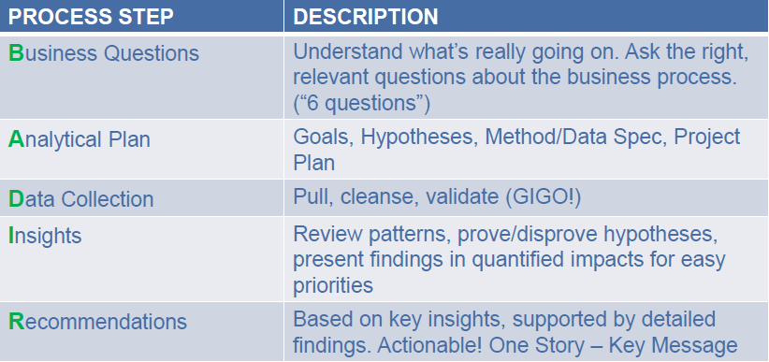

#### Common Methodologies

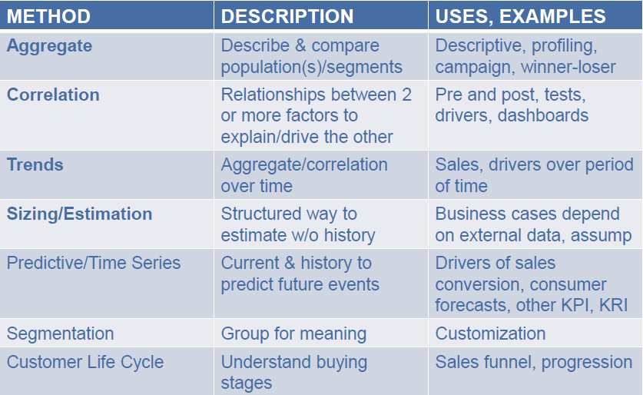

#### Data Source

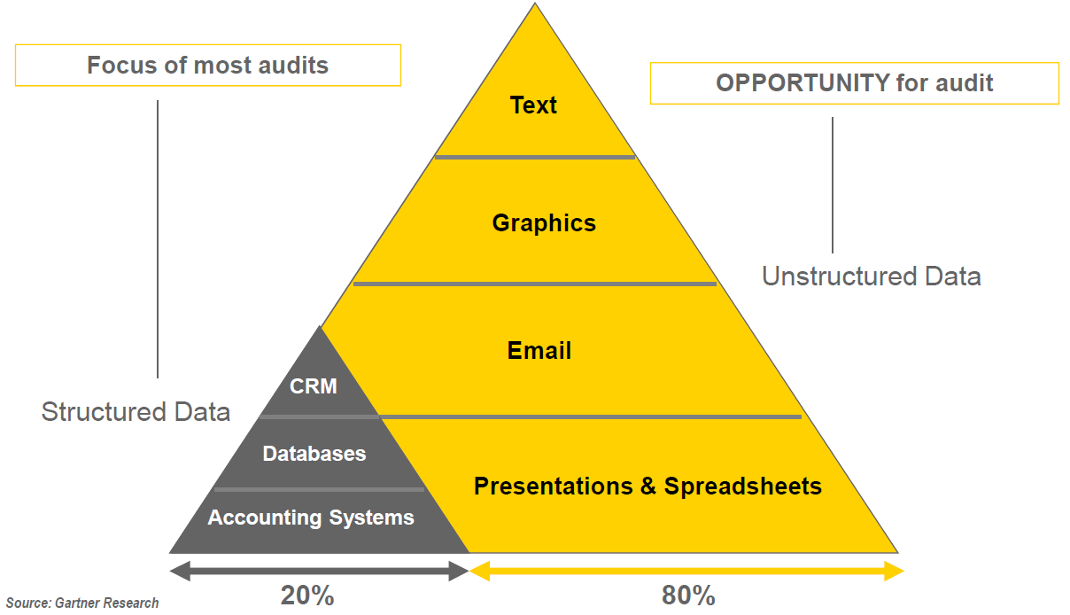

#### ML + Analytics Techniques

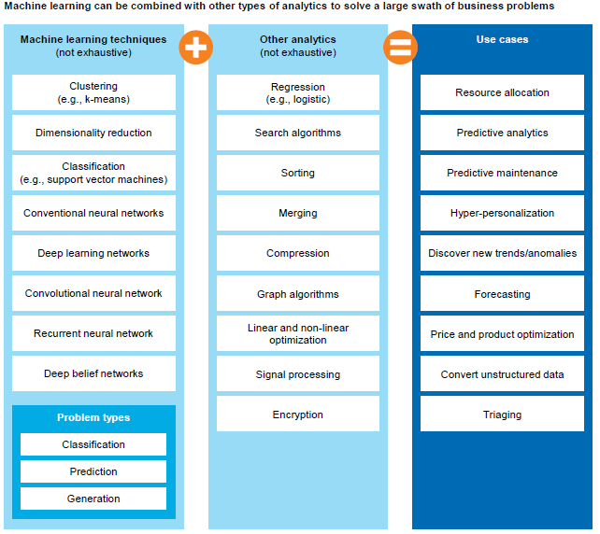

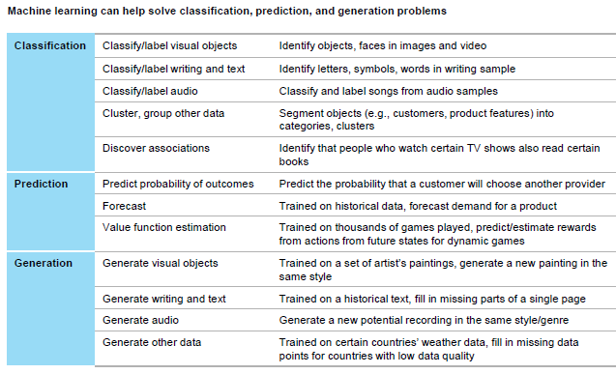

#### IA Transformation

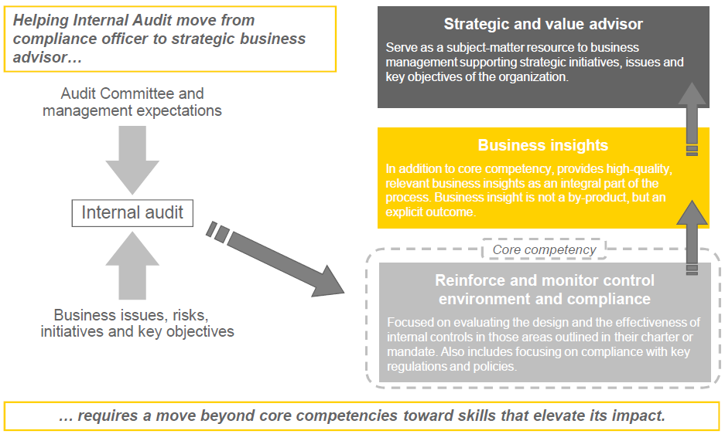

#### Audit Opportunities

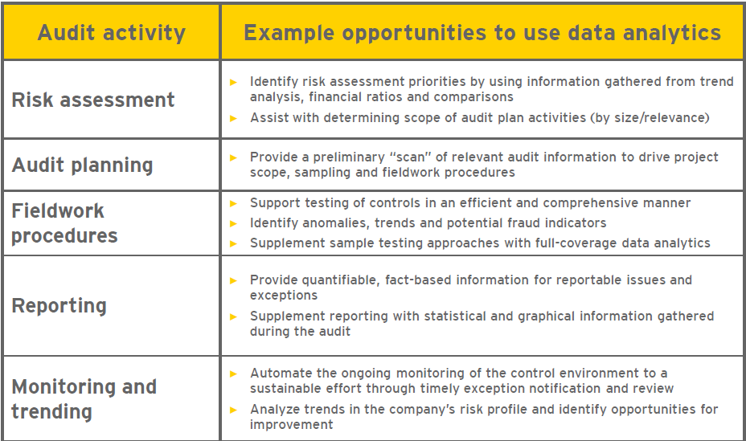

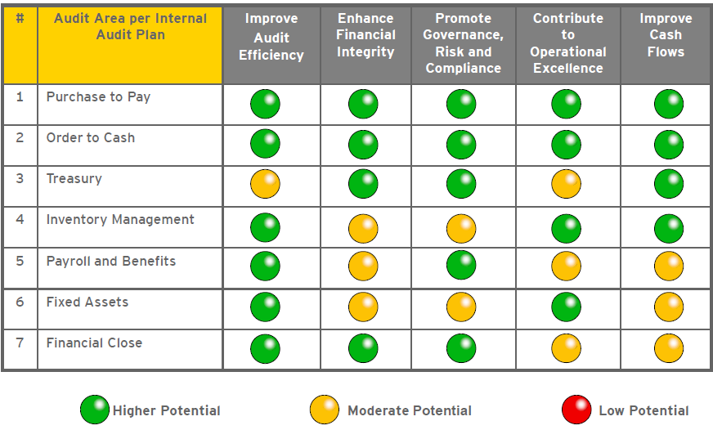

#### Case Study Payroll - Fraud detection case study

**Audit Scenario**

► A life insurer suspected fraudulent payroll activity. Insurer wanted to assess the payroll information to identify suspicious activity and develop process measures which could be used on a periodic basis as input to business and audit management reports and dashboards.

► The objective was to develop payroll and employee master data analytics initially analyzing the prior two years. Then, implement a periodic retest and reporting process for:

• Employee identification number of deceased individuals

• Employees missing key data points (address, ID, etc.)

• Stratification of payments to employees after termination

• Employees paid not on the EMP master file

• Employees with no or minimal deductions

• Employees hired on irregular days (weekends and holidays)

**Results**

► Reduced potential exposure to fraud risk

► Reduced erroneous payments and increased cash recovery

• Identified bonus payments incorrectly made to terminated employees

• Eliminated duplicate employees resulting in US$100,000 of payroll over-payments

► Identified process improvement opportunities to reduce fraudulent entries (i.e., ghost employees, payments to terminated employees, etc.)

► Increased management confidence and control through the development of ongoing monitoring reports and management dashboards, including suspicious activities

#### Case Study Accounts Payable - Process insights case study

**Audit Scenario**

► E&Y was requested to provide internal audit assistance in providing data analysis

testing procedures to facilitate purchasing audits at 15 “in-scope” business units and a

centralized accounts payable audit for a $7B medical diagnostics company.

► The objectives of the data analysis testing procedures were to expand the audit coverage by testing full populations and to reduce audit costs by automating manual efforts and reducing the time required in the field. In addition, the procedures aggregate findings in a single view to identify opportunities to enhance the process.

**Results**

► Pricing consistency – Identified an opportunity to save $3.4M if prices per product were

consistent across all business units.

► Missed discounts – Identified over 5k invoices with 10-day or 15-day discount terms that had been paid after the discount period, resulting in $1.3M in lost savings.

► Payments issued to employees set up as vendors – Identified 346 payments that had been issued to vendors with addresses matching an employee’s.

► Requisitions created and approved by same person – There were 5 requisitions created and approved by the same person totaling $114K of unauthorized spend.

► As a result of the findings, analytical testing now occurs on a periodic basis for both coverage and audit planning purposes

#### Case Study Unstructured data analysis case study

**Audit Scenario**

► A global oil and gas company had large volumes of unstructured data (sales presentations, contracts, competitive advantage material etc) stored on a shared drive. Client was concerned about “what” high-risk data was on the drive, “when” the data was created, and “who” had access to the data

► Objective : perform a business risk assessment to determine what high risk business units use the shared drive and identify the types of high-risk documents stored there. High-risk documents and access controls were analyzed to determine the “who”, “what” and “when” around the data to gain a deeper understanding of the chain of communication.

**Results**

• Identified areas of high-risk information within this shared drive that did not have the appropriate level of controls to protect the sensitive information and other inefficiencies.

► Storage inefficiency- 20% of documents were duplicates (1/2 Word or Excel)

► Unauthorized applications - 36% of the space taken

► Records retention - Documents outside retention policy

► Privacy - Credit card, SS#, bank account information

► Intellectual property - 25% key word hits on “sensitive” terms

#### Access monitoring analytics

► Segregation of duties assessment

► Key configuration changes

Financial statement computer assisted audit techniques

► Journal entry analytics

► Accounts receivable analytics

#### Contract audit analytics

► Royalty payment recalculations (incorrect sales figures, royalty rates)

► Invoicing inaccuracies (overpayments, duplicate transactions)

#### Payment stream analytics (AP, T&E, Procurement Cards)

► Duplicate payments

► Data irregularities and unusual transactions

► Purchasing control violations (split PO’s, expenditures above policy limits)

#### Master file analytics (Vendor, Customer, Employee)

► Missing or unusual information

► Duplicate records

► Conflicts of interest

#### Unstructured data analytics (i.e., email and text based files)

► Recurring content themes and relationship communication patterns

► Contextually valid references to key words or phrases

# MICROSOFT AGILE (FORBES)

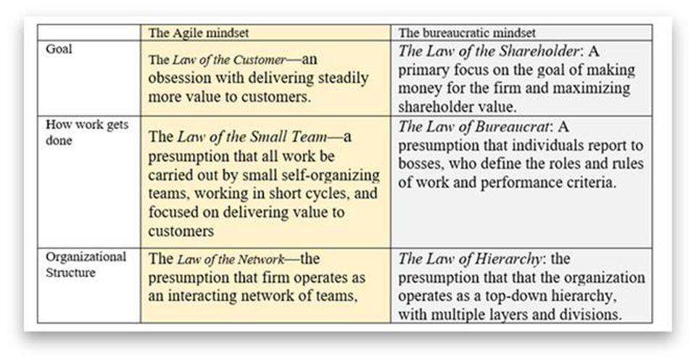

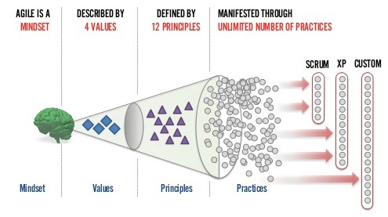

#### ➊Pursue “Agile at Scale,” not “Scaling Agile”

Tight focus on delivering continuous value to customers, not merely generating quarterly profits or boosting the current stock price. It also rests on a deep respect for the talents and capacities of those doing the work, and the teams in which they work, not treating workers as “resources" that are assignable, optimizable and ultimately disposable.

#### ➋Take Care of Planning and Coordination

Planning begins with an overall vision for the product. Then a program manager like Aaron develops and owns what is called a “scenario,” which is the goal for the product for the next 18 months. It’s a story of where the program wants to be 18 months from now. The story can include other teams. The group has about a 60% confidence in its ability to predict what the customers want to and to deliver that. The year is broken up into two seasons, called “spring” and “fall”. At all times, each team maintains and owns a thoughtful and detailed three-sprint plan, each sprint comprising three weeks. The team always has a good idea what’s in store for the next three sprints.

#### ➌Get the Right Balance of Alignment and Autonomy

Alignment at the top and autonomy at the bottom. The teams need autonomy. That’s what drives them to come to work and deliver great stuff. But at the same time, their work has to be aligned with the business.

#### ➍Master The New Role of the Manager

What happens when a team misses a sprint? A manager doesn’t monitor a teams’ burn-down charts. The burn-down charts are for the teams. If they get behind, guess what they do? They talk about what to do. That’s the behavior the manager wants

#### ➎Handle Dependencies At The Team Level

Every three months, there's a standing meeting across all of the teams. It’s called “a feature team chat.” Every team comes in and shares their plan.

#### ➏Ensure Continuous Integration

Continuous delivery has meant more modularity in design and a change in architecture. The teams use what they call “feature flags.” Here's a high level description of how it works. If they are going to do something new, the very first thing that they do is to isolate the code that they are changing and build a switch into the code. It is powered by a flag in the database. It’s a configuration change. When the team writes code, they write it behind the safety of the flag. At some point, when they feel it’s ready, they can turn it on just for the team. That switch is not a global switch. It’s a switch for an account in the system just for the team. If that goes well, then the team can turn it on for certain customers. Those customers can see it and try it. They help the team find bugs and problems. When the team gets through all that, and the team thinks it’s really ready, they prepare the release notes and an announcement that they are going to flip the switch for everybody. Then they go back and refactor the old code out. This enables the teams to work alongside each other on the same code without breaking one another’s work. At the end of every sprint, the team sends out an email to all 450 people in the Visual Studio Online group and the leadership team. They talk about what they accomplished that sprint and what their plan is for the next sprint. And they record a 3-5 minute video. (Warning: the videos can get fancy, if the teams have aspiring Hollywood directors.) The video replaces the sprint demo.

#### ➐Keep On Top Of Technical Debt

“Now the bugs never grow. There 's a Key Performance Indicator (KPI) we call 'the bug cap.' It’s the number of engineers on your team times four. So if you have ten engineers, your bug cap is 40. If you get to 40 bugs, the team needs to stop work on new features and the next sprint, get the bug count back down below 40. It’s self-managing.

#### ➑Embrace DevOps and Continuous Delivery

Development and operations merge. The teams own the planning of each new feature. They own the execution of the feature. They own the delivery the feature. And they own the operation of the feature. The change in time frame makes a big difference. A deadline now is three weeks. Three weeks is no big deal. Before you had only two opportunities., and if you missed it, you had to wait two years. Now if it’s not high quality, you don’t push it out. You hold it. It’s disappointing that you didn’t get it out. You talk about it in your retrospective. Did you do something wrong? Or did you just underestimate the level of complexity? Did you miss something? It’s better to have that conversation than to have a fire-drill and punish the team for not delivering what they promised, or worse, pushing out a poor-quality product.

#### ➒Continuously Monitor Progress

The teams do a great deal of monitoring how the features are being used. The results flow into the aspirational backlogs, which are called scenarios. Every month, the program manager reports out on metrics, on the accounts using different aspects of the service. So the group is learning to become a data-informed business. They don’t call it “data driven” because that would run the risk of missing the big picture. They use their brain and their gut feel as well as being informed by the data. The data isn’t an after-thought though. It’s often the first part of the conversation. Part of the very definition of “done” is having the right telemetry. The teams see this data and monitor it both when they are testing it and as soon as it goes live. It’s not something they do in the sprint after they ship it. It’s part of the acceptance criteria to ship.

#### ➓Listen To Customer Wants, But Meet Their Needs

The teams don’t blindly follow what customers say. They have what they call "the cookie principle." If you have a plate of cookies and you ask people if they want one, they will say yes. No one turns down a cookie.

#### ➊Deal With Directions from Above

There is very little load balancing among teams. If a team gets behind, they don’t break up the team or move individuals to the team to fix it. They ask the team itself to fix the problem. They try to keep the teams together for 12 or 18 months. That’s what the teams themselves like. The firm is making an investment in the team for at least nine months or a year.

#### ➋Use Self-forming Teams To Encourage Team Ownership

Managers let people choose which team to work on. People can reshuffle every 18-24 months. Around two thirds of the team members decide to stay where they are. As a result, there are not many brand new teams. But the team members have the choice. The result is a significant investment in persistent teams. Quite apart from team well-being, it leads to higher performance. The team owns the backlog. Of course, there is a lot of discussion about priorities. But a manager doesn’t tell the team what should be next on the Kanban board.

#### ➌Recognize that The Team is the Product

Microsoft has an advantage: it had teams, long before they went Agile. There was already a strong team culture. It’s more difficult for firms going Agile that don’t have a history of teams.

#### ➍Build Quality From The Beginning

In the first sprints, there was agreement on 3 week sprints. The leadership signed off on the idea of Agile and Scrum, but they were a little worried as to how it was going to work. So they planned for "a stabilization sprint" after five sprints. The goal is to avoid the sequence: write code in the first sprint. Test it in the second sprint. Fix bugs in the third sprint. The rules of the road are: deliver finished product every sprint.

#### ➎Use Coaching Carefully

External coaches and trainers at Microsoft were noticeable in the site visit by their absence.

#### ➏Ensure Top Level Support

To achieve Agile at scale, the support of corporate vice-president, Brian Harry, has been central. Aaron has had the benefit of living in the Developer Division where Scrum and Agile practices now have a deep foothold. The Visual Studio group is leading the charge for Microsoft as a whole. It owns the “first party engineering system charter” (IES) and is driving that across the company. There are monthly scorecards on how the big divisions are doing in adopting it.

## ISACA AUDIT IF

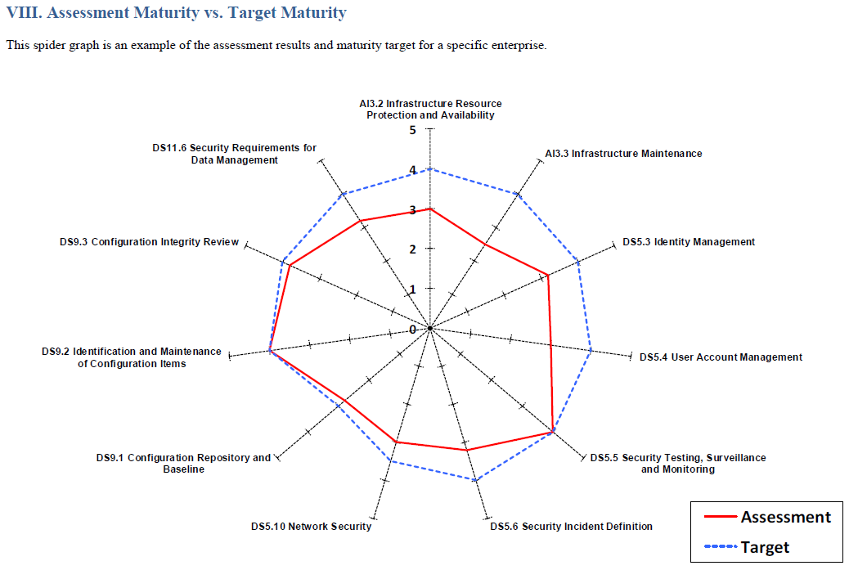

## COBIT

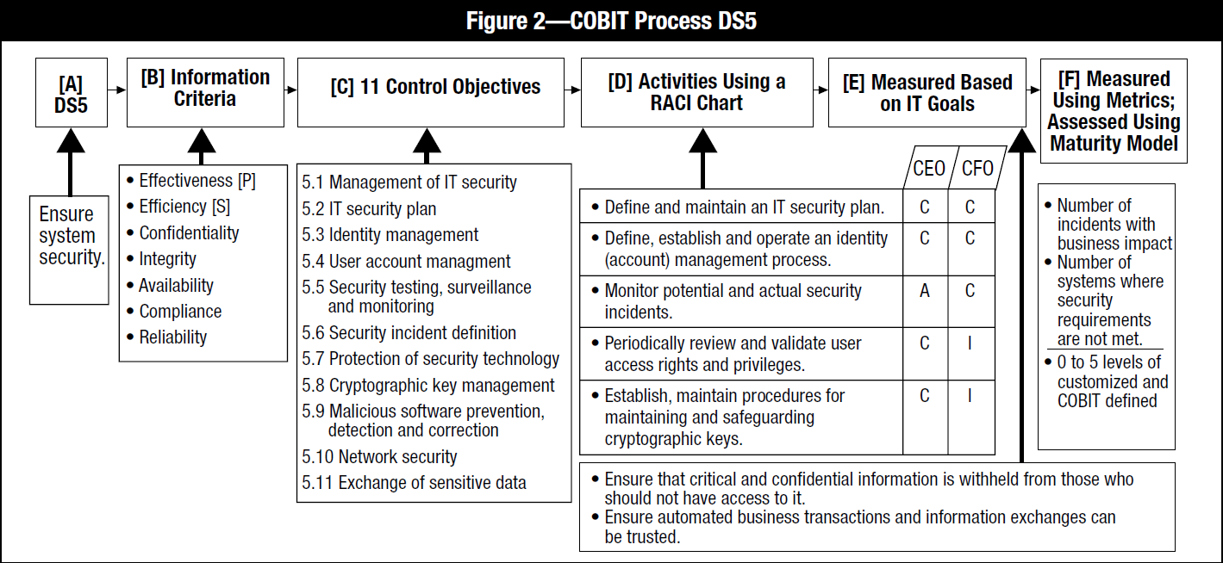

## PCI-DSS

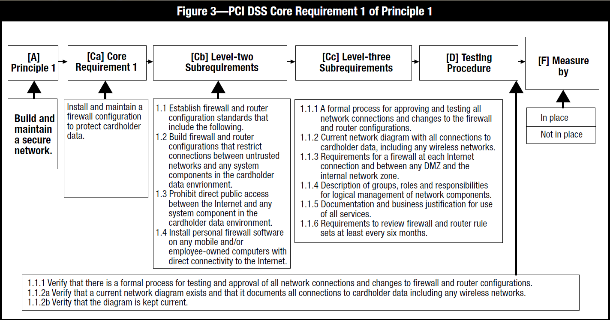

## AWS PCI-DSS WORKBOOK

|  |  |  |
| --- | --- | --- |
| REQUIREMENT | AWS RESPONSIBILITY | CUSTOMER RESPONSIBILITY |
| Requirement 1: Install and maintain a firewall configuration to protect cardholder data. | • All In-Scope Services: AWS maintains instance isolation for host operating systems and the AWS Management Environment including host operating system, hypervisor, firewall configuration, and baseline firewall rules.  • AWS meets all requirements for implementing and managing firewalls for the AWS management environment.  • Amazon EC2 and Amazon ECS: Amazon VPC Security Groups and network ACLs implement stateful inspection network access control and are suitable for compliant network segmentation | • Amazon EC2 and Amazon ECS: AWS customers are responsible for security group definitions and network access control rules. |
| Requirement 2: Do not use Supplier-supplied defaults for system passwords and other security parameters. | • All In-Scope Services: AWS develops and maintains configuration and hardening standards for the AWS Management Environment that provides the virtualization technologies and applications for providing cloud services.  • AWS maintains configuration and hardening standards for the underlying operating systems and platforms for these services. | • Amazon EC2 and Amazon ECS: AWS customers are responsible for changing default vendor configurations, security controls, and vendor default passwords.  • All In-Scope Services: AWS customers are responsible for secure and compliant configuration for all customer-configurable items. This may include OS configuration for Amazon EC2 and Amazon ECS instances, logging and log retention for data base services, or permissions for AWS management functions. |
| Requirement 3: Protect stored cardholder data. | • All In-Scope Services: AWS Key Management Service (AWS KMS) secures keys using hardware security modules and provides functions to use and manage keys.  • AWS CloudHSM secures keys and provides cryptographic functions using customer-dedicated hardware security modules. | • Amazon EC2 and Amazon ECS: AWS customers are responsible for changing default vendor configurations, security controls, and vendor default passwords.  • All In-Scope Services: AWS customers are responsible for implementing encryption on all applicable internal and external network connections. (This may require use of AWS optional API encryption).  • AWS KMS and AWS CloudHSM: AWS customers are responsible for the creation, usage, and management of encryption keys in accordance with PCI Data Security Standards. |
| Requirement 4: Encrypt transmission of cardholder data across open, public networks. | • All In-Scope Services: AWS encrypts access and manages encryption within the AWS Management Environment. | • All In-Scope Services: AWS customers are responsible for implementing encryption on all applicable internal and external network connections. (This may require use of AWS optional API encryption). |
| Requirement 5: Use and regularly update anti-virus software or programs. | • All In-Scope Services: AWS manages anti-virus software for the AWS Management Environment and, where appropriate, for identified services. | • Amazon EC2 and Amazon ECS: AWS customers are responsible for implementing anti-virus software on customer-managed OS instances commonly subject to malware. |
| Requirement 6: Develop and maintain secure systems and applications. | • All In-Scope Services: AWS maintains security patching, development, and change control of the applications that support the services included in the assessment including web interfaces, APIs, access controls, provisioning, and deployment mechanisms.  • AWS develops and manages changes to applications that support the services included in the assessment including web interfaces, APIs, access controls, provisioning, and deployment mechanisms. | • Amazon EC2 and Amazon ECS: AWS customers are responsible for monitoring published OS and application vulnerabilities and patching on instances.  • Customers are required to use documented change control for all configurations and customer code.  • Customers who develop custom code that is used to transmit, process, or store credit card data must comply with requirements for secure development and testing.  • AWS Web Application Firewall (AWS WAF): Customers are responsible for protecting their web applications from common web exploits. This includes (but not limited to) configuring access control lists and web application firewall rules for filtering traffic to and from their web applications. |
| Requirement 7: Restrict access to cardholder data by business need-to- know. | • All In-Scope Services: AWS maintains the access controls related to underlying infrastructure systems and the AWS Management Environment. | • Amazon EC2 and Amazon ECS: AWS customers are responsible for access control within all OS instances.  • All In-Scope Services: AWS customers are responsible for configurable access controls within the services such as database users within Amazon RDS.  • AWS IAM & AWS Credentials: AWS customers are responsible for managing access to all AWS services that are included in their CDE. AWS IAM can be used to configure resource management and AWS configuration roles and permissions. Customers are responsible for configuring AWS account and session controls to meet PCI requirements. Customers must be aware of AWS guidelines for credentials and access control for AWS resource management. |
| Requirement 8: Assign a unique ID to each person with computer access. | • All In-Scope Services: AWS provides each user in the AWS Management Environment a unique ID.  • AWS provides additional security options that enable AWS customers to further protect their AWS Account and control access: AWS Identity and Access Management (AWS IAM), Multi-Factor Authentication (MFA), and Key Rotation. | • Amazon EC2 and Amazon ECS: AWS customers are responsible for access control within all OS instances.  • All In-Scope Services: AWS customers are responsible for configurable access controls within the services such as database users within Amazon RDS.  • AWS IAM & AWS Credentials: AWS customers are responsible for managing access to all AWS services that are included in their CDE. AWS IAM can be used to manage resource management and AWS configuration roles and permissions. Customers are responsible for configuring AWS account and session controls to meet requirements. Customers must be aware of AWS guidelines for credentials and access control for AWS resource management. |
| Requirement 9: Restrict physical access to cardholder data. | • All In-Scope Services: AWS maintains the physical security and media handling controls for the services included in the assessment. | • All In-Scope Services: Any media created outside of the AWS environment is the sole responsibility of the customert |
| Requirement 10: Track and monitor all access to network resources and cardholder data. | • All In-Scope Services: AWS maintains and monitors audit logs for the AWS Management Environment and AWS service infrastructure. | • Amazon EC2 and Amazon ECS: AWS customers are responsible for logging within all OS instances.  • AWS IAM & AWS Console: User activity logs of resource management activities via the console and command line are available to users via Amazon AWS CloudTrail. Amazon AWS CloudTrail must be used to record and monitor AWS resource management activities.  • Amazon S3: Users are responsible for configuring bucket logging and monitoring logs.  • Amazon RDS & Amazon Redshift: Users are responsible for configuring database access logging and monitoring logs.  • Amazon EMR: Customers using Amazon EMR to store cardholder data are responsible for logging access.  • Amazon SimpleDB & Amazon DynamoDB: Customers using these databases are responsible for access logging.  • AWS Config: Customers using AWS Config to store configuration data and resource inventory are responsible for access logging and monitoring logs.  • AWS WAF: Customers using AWS WAF to protect public facing applications including application databases that store cardholder data are responsible for logging access and monitoring logs.  • Elastic Load Balancing: Customers using Elastic Load Balancing can monitor applications in real time integrating with Cloud Watch.  • All In-Scope Services: AWS customers are responsible for configuration of logging within the services. AWS CloudTrail can be used to log all AWS API calls.  • Customers are responsible for monitoring logs for security events. Log monitoring may be implemented with CloudWatch or 3rd party services. |
| Requirement 11: Regularly test security systems and processes. | • All In-Scope Services: AWS manages rogue wireless access point detection, vulnerability and penetration testing, intrusion detection, and file integrity monitoring for the AWS Management Environment and the identified services.  • AWS implements and monitors IDS/IPS on networks that implement AWS services. | • Amazon EC2 and Amazon ECS: AWS customers are responsible for internal and external scanning and penetration testing of their instances and virtual networks. Customers must follow AWS processes for scanning and penetration testing: http://aws.amazon.com/security/penetration-testing/.  • AWS customers are responsible for implementing IDS functionality typically using Host-based IDS (HIDS) on network segments they implement and manage. |
| Requirement 12: Maintain a policy that addresses information security for employees and contractors. | • All In-Scope Services: AWS maintains security policies and procedures, security awareness training, security incident response plan, and human resource processes that align with PCI requirements. | • All In-Scope Services: AWS customers are responsible for all policies and procedures. AWS customers should include AWS as an infrastructure provider for Req. 12.8. Alerts from AWS should be part of the IRP for Req. 12.10. |
| Requirement A1: Shared hosting providers must protect the cardholder data environment. | • All In-Scope Services: AWS customer instances and data are protected by instance isolation and other security measures in the AWS Management Environment. | • All In-Scope Services: AWS customers may also be considered a shared hosting provider if they run applications or store data for their customers. In this case, customers are responsible for protecting their customer’s data within AWS services. |
| Appendix A2: Additional PCI DSS Requirements for Entities using SSL/Early TLS for Card-Present POS POI Terminal Connections | • This appendix concerns on-premise, point-of-sale terminals and is not applicable to AWS.  • However, the use of TLSv1.1 and/or v1.2 is required, and AWS fully supports these protocols. | • All In-Scope Services: AWS maintains TLSv1.1 or greater to support customer's PCI workloads. AWS provides a minimum-security policy of TLSv1.0 for customers with non-PCI workloads that still require it. AWS customers are responsible for initiating TLS connections that use TLSv1.1 or greater for PCI compliance. |

## ON-BOARDING

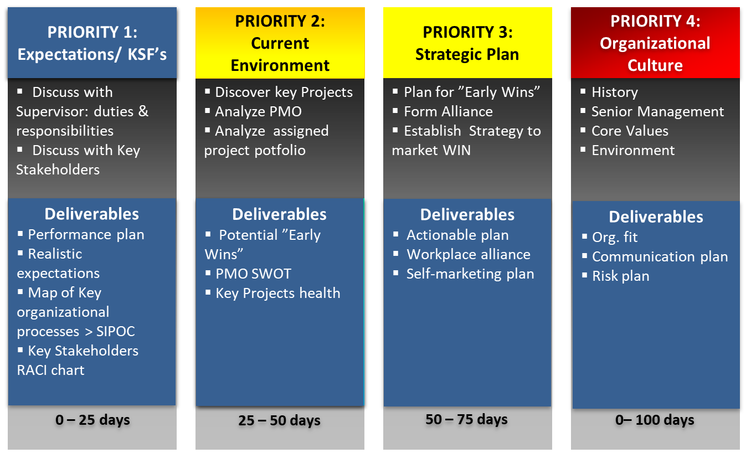

# CIBC Control

## CIBC 20 Services (Financial)

|  |  |
| --- | --- |
| AUDIT | Admin of Non-Core loans. |
| FINANCE | Advertisement Costs |
| GLOBAP OPS | AR, AP |
| HR | Business Analysis |
| LEGAL | Call Centre Supports products for Commercial Banking |
| MARKETING | Compliance |
| RETAIL | Fees (Directors, OSFI) |
| RISK | Financial Analysis |
| TECH SERV | Financial Ombudsman |
| WORLD MARKETS | Financial Risk Support |
| WEALTH | HR - Compensation |
|  | HR - Compliance |
|  | Management Costs |
|  | Project Management |
|  | Resource Centre - reports (M&A, Green sheets, Prospectus') and internet searches |
|  | Stock services |
|  | TI/TS Application Support Cost |
|  | TI/TS Technology Services Cost |

## CIBC Processes (FCU)

|  |  |
| --- | --- |
| **BUSINESS_PROCESS** | **SUB_PROCESS** |
| A/P | Accrual |
| Interco loan | Account for loan payable to treasury |
| Outstanding Cheques Clearing | Accounting Outstanding Cheques |
| Accrue Liabilities | ID significant individual liabilities |
| Accrue Obligations related to Securities | Record Repos Position |
| Record Securities Sold Short Position |
| Calculate/ Collect Mortgage Income | Originate a mortgage - recording of acquisition costs on mortgage origination |
| Income Taxes Note Disclosure | Compilation of Note Disclosure |
| Note Disclosure Aging of Deposits | Demand, Notice & Term Deposits |
| Note Disclosure IR Sensitivity | Loans & Deposits Aging & yields |
| Note Disclosure Mortgage and customer Loans | Mortgages & Consumer Loans |
| Note Disclosure Segment info | Establish customer CIF (name, address, & permanent information) |
| Defer Acquisition Cost on Mortgages | Calculate/invoice acquisition cost |
| Prepare amortization schedule |
| Defer Payments to Loblaws | Defer Acquisition Cost of acquiring credit products and points |
| EUC Applications | General Controls |
| Financial Statements Preparation | Compilation of Notes to the Financial Statements |
| Get a mortgage loan on the books | Funding Mortgages |
| Get the Loans on the books | Attach credit - PLC |
|  | Disburse Funds for Personal Loans |
| GL/source system balancing | Automatically compare ICBS and GL:M balances |
| HR | Bi-weekly review of payroll register (Including New Hire, Transfers, and Terminations) |
| ICBS Application Controls | AS400 Recovery |
|  | Change Management |
|  | ICBS Incident & Problem Management Process |
| ICBS Information Security | Security Administration |
| Maintain customer demand (chequing) deposit | Calculate and accrue daily interest |
| Maintain interest rates |
| Transaction Cheque Clearing |
| Transaction processing - EFT |
| Transaction processing - POS, ABM, Internet, TB - on Tandem |
| Maintain customer loan | Maintain interest rates in ICBS |
|  | Recognize interest calc & accrual |
|  | Transaction Processing - Payments or PLC cheques |
| Maintain customer notice (RSP) deposits | RSP Renewal |
| Maintain customer notice(savings) deposit | Transaction processing - Internet, ABM, TB (transfers only) - on Tandem |
| Maintain residential mortgages | All sub-process |
|  | Apply payments to Int. income and principal / Accrue Int. at month-end |
|  | Determine mortgage interest rates |
| Manage Bank Accounts | Balance & Settle A/P Bank Account |
|  | Balance & Settle ABM Unpostable, All EFT Return Bank Accounts |
|  | Balance & Settle ABM, POS, RB, SCD, Plus, Outbound EFT Bank Accounts |
|  | Balance & Settle Cheque Clearing |
|  | Balance & Settle EFT Bank Account |
|  | Balance & Settle General Operating, Treasury, Mortgage, EFT, USD Bank |
|  | Balance & Settle Guarantee Payments Bank A/C Drafts & MO |
|  | Balance & Settle Guarantee Payments, Cheq Clr Bank A/C Loans |
|  | Balance & Settle Payroll Bank |
|  | Balance & Settle Treasury Bank A/C |
| Manage Suspense Accounts | Manage Operating Suspense A/C |
| Other Misc Suspense Accts | Accounting Items in Suspense A/C |
| Purchase & pay for non interest expenses | Pay Outside Services (Amortized Trailer fees / Commissions) |
| Pay Other Misc Expenses |
| Purchase & pay other expenses | Pay Other Expenses |
| Recognize deferred taxes | Book Monthly Tax Recovery |
|  | Determine monthly tax rate - Acct |
| Recognize fee income | Recognize Amicus ABM Surcharge |
|  | Recognize Interac Charges (convenience fee auto charged for each customer txn) |
|  | Recognize Returned Cheque Fees |
| Recognize FOREX non-trading income | Recognize other income |

## CIBC 26 Processes (OPC) – 113 Sub-processes

|  |  |
| --- | --- |
| **Process** | **Sub Process** |
| Brokerage & Trade | Broker Services - Cash Processing |
| Broker Services- Collateral Management |
| Cash Management |
| Cash Management - Collection of Foreign Cheques |
| Cash Management-Cheque Issuance |
| Cash Management-Incoming wire payments/Cheque deposits |
| Cash Management-ISI Liasion Desk/Bank Reconciliation-Break Resolution |
| CP Issuance - Billing |
| CP Issuance - Book Based Maturity |
| CP Issuance - Physical Maturity |
| CP Issuance-DCS Settlement |
| CP Issuance-Physical Settlement |
| Domestic Equity /Bonds Settlements |
| Equity Arbitrage |
| Futures & Options Settlements |
| GIC Settlements |
| Institutional Equity Settlements - Equity Arbitrage |
| International Settlements |
| Money Market |
| Money Market DTC/FED Settlements |
| Money Market US Settlements- Physical Trades |
| Over The Counter Receipt of Securities |
| Over The Counter/Branch Receipt of Securities |
| Safekeeping |
| Security Lending and Borrowing |
| Segregation Management |
| Stock Transfers |
| UK Securities Lending |
| Compliance | COB Disclosure |
| Credit Mgt | Monitor Credit |
| Customer Satisfaction | Customer Complaints Management |
| Customer Restitution |
| Derivatives Settlement Operations | Confirmations |
| Post-Settlement Investigations |
| Pre-Settlement Investigations |
| Settlements |
| Foreign Exchange | Booking |
| Maintenance | Account Information Maintenance |
|  | Customer Information Maintenance |
|  | Operator Profile Maintenance |
|  | Suspense Account Maintenance |
| Manage and Monitor the Imperial vehicles | Execute Transactions |
| Identify Substitute and Replacement Assets |
| Reporting |
| Management Processes | Investments |
| Lending |
| Procedures Information |
| Regulatory Compliance |
| Sales Management |
| Origination | Adjudication |
|  | Application Processing |
|  | Funding & Disbursement |
| Origination (Commercial) | Adjudication (Commercial) |
| Funding & Disbursement (Commercial) |
| Outsourcing | Outsourcing - ADP |
| Payments Processing | Cash Settlements |
| Credit Administration |
| Investigations |
| Reports Balancing |
| Sanction Filtering |
| Validation & Message Repair |
| Portfolio Management | Credit Derivative Hedging |
| Credit Derivative Trading |
| Establish Portfolio Strategy |
| Hedging |
| Portfolio Management |
| Proprietary Products | Account Maintenance (CM, Talvest and SI only) |
| Account Opening (PPS) |
| Account Opening/Closing/Transfers (CM/Talvest only) |
| Client Tax Reporting / Tax filing |
| Financial Transactions/ Adjustments |
| Trust Accounting |
| Registered Products | 3rd Party Settlements - Brokerage |
| 3rd Party Settlements-Fixed Term |
| Account Transfers (Internal)-Fixed Term |
| Adjustments - Brokerage |
| Adjustments-Fixed Term |
| Client Support-Fixed Term |
| Deposits-Fixed Term |
| GL Reporting-Fixed Term |
| Monitoring & Compliance - Brokerage |
| Tax Reporting - Brokerage |
| Tax Reporting (GIC Withdrawals)-Fixed Term |
| Transfers - Brokerage |
| Withdrawals- Brokerage |
| Withdrawals-Fixed Term |
| Sales Fulfillment | Lending - Personal Loan Products |
|  | Lending - Small Business Loan Products |
|  | Small Business Account |
| Sales Origination | Account Open - Personal Deposits |
|  | Account Open - Small Business Deposits |
| Security &Control | CSP Application Processing |
|  | Database Control |
| Service - Inventory Control | Ordering |
| Servicing | Annual Statement |
| Call Center |
| Discharge |
| Early Renewals |
| Product Changes |
| Renewals |
| Taxes |
| Transaction Processing |
| Servicing (Commercial) | Annual Portfolio Review |
| Renewals (Commercial) |
| Transaction Processing (Commercial) |
| Technology Mgt | IT Access Control |
| 3rd Party Mutual Funds | Processing |
| Trade Finance | Documentation Verification |
| Transaction Processing | Centralized Instruments Processing |
| Cheque Processing |
| Deposit Processing |
| Inter Branch Payments (IBP) Processing |
| Withdrawal Processing |
|  |  |

# Audit Lifecycle

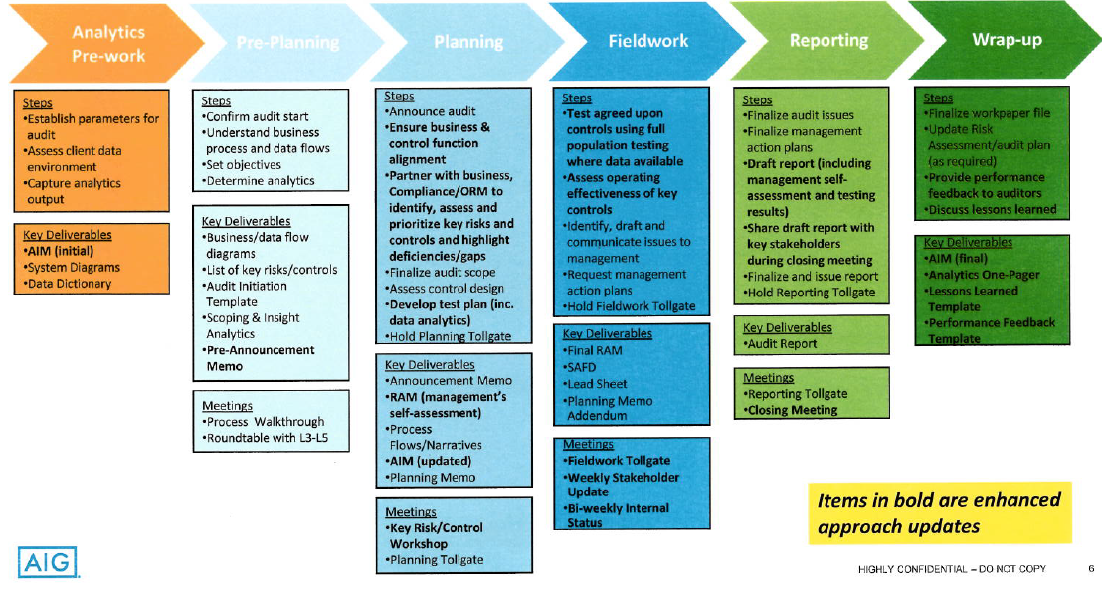

# STAR AUDIT

|  |  |  |  |
| --- | --- | --- | --- |
| Situation | Task | Action | Result |
| Investments IT Audit 100% | Insourcing 100% in 6 months | - Handover - Priority - Training staff | - Completed 2015 End-of-Year audit - 100% autonomous in 6 months - Confidence from clients, PwC and Internal Audit |
| Year 2: Increase PwC reliance from 50% to 100% | In addition to ITGC, ITD testing | - Finalize backlog of ITD with PwC and counterpart in Finance - Negotiate test scope, procedures and approach - Define templates, test steps - Get buy-in from business, IT, team | - 89 ITD benchmarked and accepted by PwC in 8 months  - 100% turnover in offshore team - 100% changes in ITGC scope - Major IT outsourcing underway |
| Year 3: Increased application complexity coupled with 100% change in IT Architecture (cloud computing) | In addition to standard Full/False Accept/Reject testing (plain vanilla) code review | - Classify backlog in buckets: "simple"/"complex" - Finalize test procedure for each bucket - Estimate resources - Get buy-in from business, IT and IA management - Train and conduct test | - Underway code review of 50 Itd (including 5 interfaces, 5 Mainframe) |

|  |  |  |  |
| --- | --- | --- | --- |
| Situation | Task | Failure | Lessons Learned |
| Year 2: Increase PwC reliance from 50% to 100% | In addition to ITGC, ITD testing | - Get offshore to test 100% ITGC, onshore 100% ITD - High turnover offshore, including 1 star tester - Testing goes into Feb plus onshore reinforcement | - Miscalculate offshore challenges - Did not consult - Did not address the cahllenges as a team |
| Year 3: Increased testing challenge requires better coordination | - Champion AGILE - Intro 3 weeks SPRINT - Stand-up meeting thrice a week | - Test quality went down => re-work - Pushback from business and IT on 3 weeks SPRINT | - AGILE practices in place (corporate-wide) but not mindset - Seek buy-in (immediate feedback on exceptions => avoid deficiency report - Better embedding of audit into IT - 3-week sprint instead of 3-week deadline => aim for finished product |

# STAR PROGRAM/PROJECT MANAGEMENT

|  |  |  |  |
| --- | --- | --- | --- |
| Situation | Task | Action | Result |
| Manual work in audit | Automate | - Strategic alignment - ROI - Expected benefits - Urgency/ market reactive - Project type (new, maintenance) - Dependency with major project/program - Risk factor - Time to complete - Complexity | - Benefits communicated and demonstrated  - Buy-in from IT, business and management |

|  |  |  |  |
| --- | --- | --- | --- |
| Situation | Task | Failure | Lessons Learned |
| Year 2: Huge backlog of tests starting Q3 | - Monthly test starting January | Initiative significant change for external customers 🢥 Resistance from IT (supported by business) | - Understand the exact nature of the change for the customers, what they will have to do that is new or different (This refers to CIBC’s external customers)  - Involve Marketing to create a communication strategy that includes both customers and customer-facing employees  - Identify customer- facing employee knowledge/skill gaps and get Training involved to develop an action plan. |
| Year 3: Increased testing challenge requires better coordination | - Standardize control library | Rationale difficult to understand & communicate  New controls too generic/ not correctly reflect the actual controls in-place | Develop a Stakeholder Role Map to identify key audiences affected by the initiative  Develop a cascading communication strategy, so that difficult to understand messages can be conveyed face-to-face by the one-up manager  Develop feedback mechanisms – Employees Hot Lines, Mailboxes and/or Town Hall Meetings or Workshops designed to convey the messages with time for Q&As |

1. The Internet Control Message Protocol (ICMP) is a supporting protocol in the Internet protocol suite. It is used by network devices, including routers, to send error messages and operational information indicating, for example, that a requested service is not available or that a host or router could not be reached. The ICMP packet does not have source and destination port numbers because it was designed to communicate network-layer information between hosts and routers, not between application layer processes
2. **TCP (Transmission Control Protocol)** is connection oriented, whereas **UDP (User Datagram Protocol)** is connection-less. ... UDP does not use acknowledgments at all, and is usually used for protocols where a few lost datagrams do not matter. Because of acknowledgments, TCP is considered a reliable data transfer protocol.
3. **Wideband Delphi** **Steps**: ❶Break a problem into manageable chunks ❷Define problem specification, assumptions, constraints ➌Outline process for *next rounds* of estimation
4. **Planning Poker**: card showing the Fibonacci sequence, representing sizing units (to reflect the inherent uncertainty in estimating larger items) including a zero: 0, 1, 2, 3, 5, 8, 13, 21, 34, 55, 89; other decks use similar progressions or the sequence: 0, ½, 1, 2, 3, 5, 8, 13, 20, 40, 100, and? (unsure)